Occupational Therapy

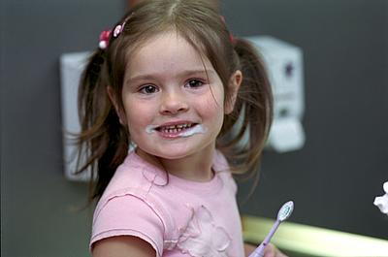
What is Occupational Therapy (OT) for children?

Occupational Therapist’s (OTs) work with children and young people who have difficulties with daily activities e.g. going to the park, scribbling and drawing, playing with toys, getting dressed, having a bath. We call these ‘occupations’. OTs help children and young people to carry out activities they need or want to do in areas of self-care, school work and play. Our aim is to support children to learn new skills to help them become more independent. We do this together with the parent, child, teacher or other professionals the child may be known to.

What happens if you think your child needs to be assessed by an OT?

The Swansea Bay University Health Board OT service now operates an open referral policy. This means that anyone who is affected by a child’s difficulty in managing daily activities can complete a referral form. This could include the parents, another family member, the child’s teacher or another professional that works with them. A referral from anyone other than the person with parental responsibility will not be accepted without consent from that person. You can download a referral form using the links below but please read our referral guidelines before completing the form to avoid unnecessary delays.

Swansea Referral Form
Neath Port Talbot Referral Form

All the referrals we receive are screened to ensure they are both appropriate and contain enough information for us to make a decision on how to proceed. Once accepted, a qualified OT will telephone the person most affected by the child’s difficulty. The purpose of this call is to gather some more information to help us decide whether we can help. Where possible we want to avoid putting children through any unnecessary assessments.

Our discussion may include the following types of questions and may take up to 30 minutes:


Questions
- How do you think Occupational Therapy can help?
- What things have you already tried to help this child manage better?
- Is this child receiving any additional support, including any other services involved?
- What does this child like to do and what are they good at?
- Do you have any other questions?

What happens after our telephone conversation?

Having spoken about the difficulties you or the child is experiencing, we will agree the most appropriate Occupational Therapy service. Our aim will be to help you find possible solutions to assist you in managing the child’s needs. This may include health promotion through provision of advice, strategies and activity ideas or signposting towards community resources, including our colleagues in social services.

If we agree that the child concerned would benefit from seeing an OT an appointment will be offered in due course and a letter advising you of this will be sent. It may also be agreed that Occupational Therapy is not appropriate for the child, in which case you will be told during our telephone conversation.

What will happen if you come to meet us?
If we agree that an appointment with an OT is necessary, we will invite you and the child to come and meet with us at one of our centres or we may come to see them at home or in school. This could be just OT or with other professionals such as physiotherapists or speech and language therapists, depending on their difficulties.

Having discussed the child’s difficulties in carrying out everyday activities on the telephone, the OT will then look at.....
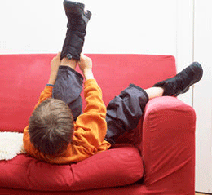
- What the child is doing? (their occupation)
- Where the child is doing it? (their environment)
- How the child is doing it? (their performance)

This means we may need to watch the child carrying out activities they find difficult and in different settings e.g. at home or in school. This could be writing, playing, using a knife and fork or getting dressed.

We sometimes have to use assessments that look in more detail at the skills they need to learn and develop but we will explain what we are doing if we need to do these assessments. This will help us work out with you and the child the best way to make things easier.

What happens next?

If we have not done so already, it is most likely we will give you advice and ways of doings things that will be helpful to use every day. We may also:

- invite you to attend some therapy sessions
- recommend equipment to help you or the child carry out the activity you’re finding difficult
- refer onto our specialist splinting clinic

For change to happen it is important that the strategies and advice that we agree on are carried out. This will help you and the child to achieve the goals you have set and may help them achieve their goals in the future.

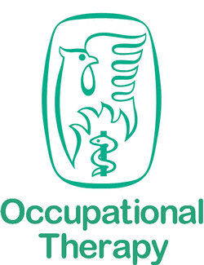
The College of Occupational Therapy provide more information on paediatric Occupational Therapy in their leaflet Helping Children to Develop and Thrive.

If you are unhappy about care or treatment provided by the Paediatric Occupational Therapy Service of Swansea Bay University Health Board, please let us know so that we can look at what went wrong and try to make it better. You can find further information about how to do this via the Putting Things Right section of the Swansea Bay UHB website.

