Children & Young People’s Therapy Service
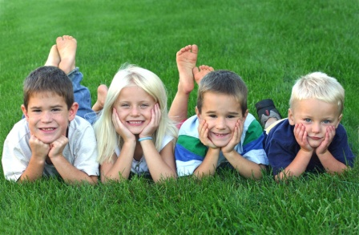
Children and Young People’s Therapy Services include Occupational Therapy (OT), Physiotherapy, Speech and Language Therapy (SALT) and Nutrition and Dietetics. Our services are delivered across the Swansea Bay University Health Board (SB UHB), which covers Swansea and Neath Port Talbot (NPT).
Our therapists work in a variety of locations including our Children’s Centres, nurseries, schools, colleges, patient’s homes, health centres and hospitals. We provide a service for children and young people from birth to their 19th birthday.

Our Children’s Centres

Swansea Bay University Health Board is made up of two main localities: Swansea and Neath Port Talbot. Each locality has a purpose built Children’s Centre which is based on the site of their main local hospital. With close links to Education and Social Services, they provide an all-round community service for children aged 0-19 years with additional needs and their families.

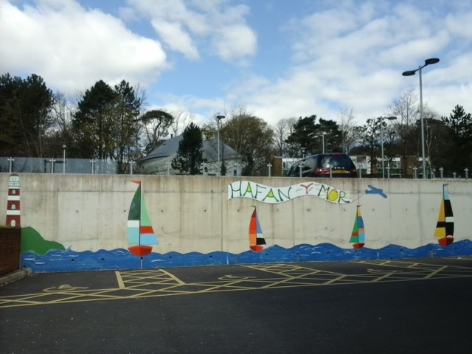
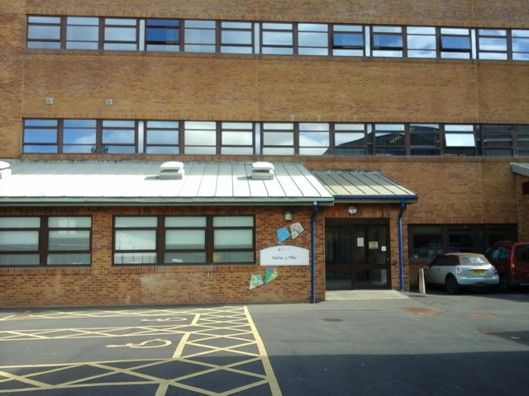
Swansea - Hafan Y Mor
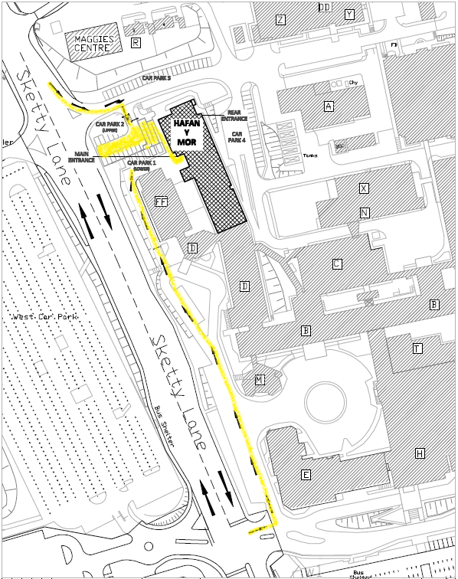

Hafan Y Mor Children’s Centre is a newly refurbished one stop shop for children with additional needs, based at Singleton Hospital. The services available here include Nurses, Occupational Therapists, Paediatricians, Physiotherapists and Speech and Language Therapists. The centre also provides a base for:
- Multi-disciplinary clinics
- Orthopaedic clinics
- Orthotics Clinics
- Toy library
- Upper limb splinting clinics

Please print our referral form and return it by post to this address:

Singleton Hospital
Hafan y Mor
The Children’s Centre
West Ward Block
Level 2
Sketty Lane
Sketty
Swansea
SA2 8QA

Tel. 01792 200400

Parking: there is free barrier controlled parking directly in front of Hafan Y Mor Children’s Centre.

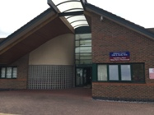
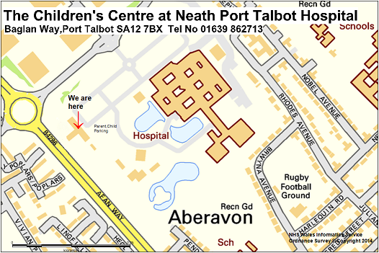
Neath Port Talbot

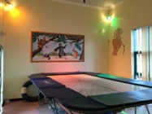
The Neath Port Talbot Children’s Centre is based at Neath Port Talbot Hospital. It is a successful partnership between NHS and Social Services. The services here include Child and Adolescent Mental Health Services, Paediatricians, Occupational Therapists, Physiotherapists, Speech and Language Therapists and Neurodevelopmental Disorders Service. The centre also provides a base for:
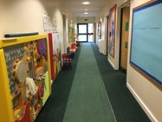
- Multi-Disciplinary Clinics
- Orthopaedic Clinics
- Orthotists Clinic
- Disability Health Visitors
- Upper limb splinting clinics
- Building Blocks Playgroup

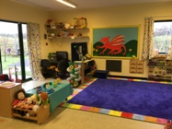
Please print our referral form and return it by post to this address:

Neath Port Talbot Hospital
The Children’s Centre,
Baglan Way,
Port Talbot
SA12 7BX

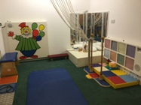
Tel: 01639 862713

Parking: there is free parent/child parking next to the Children’s Centre.
