Difficulties and Conditions Commonly Seen By Paediatric Therapists

The paediatric therapy team work with a wide range of difficulties and conditions. Here is an alphabetical list of those conditions we commonly see with a brief description of the condition, how the relevant therapist might be able to help your child and a list of useful contact numbers, organisations or charities where relevant.

Asthma | Autism | Cerebral Palsy including Hemiplegia | Cystic Fibrosis | Developmental Co-ordination Difficulties (DCD)
Down's Syndrome  and other syndromes | Juvenile Idiopathic Arthritis | Muscular Dystrophy | Orthopaedic Conditions | Spina Bifida

Asthma

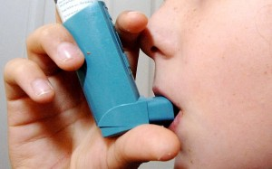
What is Asthma?

Asthma is a condition that affects the airways, that is the small tubes that carry the air in and out of the lungs. Children with asthma have airways that are extra sensitive to certain substances, often called ‘triggers’. Common triggers include colds and flu, cigarette smoke, exercise and also allergies to things such as pollen, furry or feathery animals or house dust mites.

For more information see the Asthma UK website.

How a Physiotherapist can help?

Children with Asthma are regularly reviewed in a specialist multi-disciplinary clinic and may receive specialist advice from a respiratory Physiotherapist which may include advice on;
- positioning
- exercise
- inhaler technique and appropriate use of medication

Useful Contacts

Asthma UK Advice Line - Ask an asthma nurse specialist
08457 01 02 03 www.asthma.org.uk/adviceline
9.00am-5.00pm Mon-Fri

The British Lung Foundation
78, Hatton Garden
London
Tel 020 7831 5831

Paediatric Respiratory Nurse Specialist
Singleton/ Morriston Hospital
Tel: 07875228737
9.00am-5.00pm Mon-Fri

Paediatric Respiratory Nurse Specialist
Neath & Port Talbot
Tel: 0781 300 3032

Back to top

Autism

Autism and Asperger syndrome are both part of a range of related developmental disorders known as autistic spectrum disorders (ASD). They begin in childhood and last through adulthood. ASD can cause a wide range of symptoms, which are grouped into three categories:

- Problems and difficulties with social interaction – including lack of understanding and awareness of other people's emotions and feelings
- Impaired language and communication skills – including delayed language development and an inability to start conversations or take part in them properly
- Unusual patterns of thought and physical behaviour – including making repetitive physical movements, such as hand tapping or twisting (the child develops set routines of behaviour and can get upset if the routines are broken)
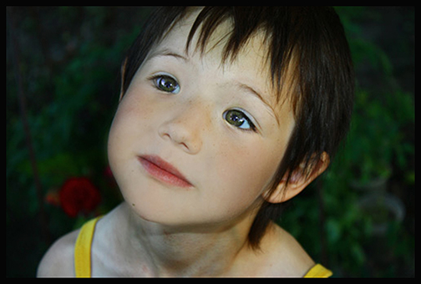
There is currently no cure for ASD. However, a wide range of treatments, including specialist education, a sensory integration approach and behavioural programmes can help improve symptoms.

For more information on Autism see the NHS Choices website.

How an Occupational Therapist may help?

Working closely with families and schools, Occupational Therapy (OT) aims to help a child/young person with an ASD to participate in activities within their daily lives that they need to do and/or want to do. OT may recommend any of the following interventions depending on the individual’s and family’s needs and goals:
- Sensory Assessment- Advice and equipment to help develop attention and concentration, address sensitivities and improve their ability to process sensory information for improved participation in activities;
- Motor Skills Assessments - Many children with ASD experience difficulties with their balance, postural skills and coordination. Fine motor difficulties may also be present;
- Advice and Strategies – To support their development and/or participation in self-care tasks. This may include advice regarding sensory processing and ways of teaching skills and activities to help develop underlying skills e.g. fine motor skills or provision of equipment.

For long term change to be achieved, it is essential that advice and strategies are implemented consistently by the people closest to the child, be that at home or in nursery/school.

Useful Contacts:
http://www.autism.org.uk/ - National Autistic Society site including social stories about toileting as well as other resources such as Early Bird, a programme for parents whose child has received a diagnosis of an autism spectrum disorder (ASD) and is of pre-school age (not yet of statutory school age).

http://www.challengingbehaviour.org.uk/ The Challenging Behaviour Foundation provides advice for children and adults with severe learning difficulties;

http://www.rompa.com, http://www.sensorydirect.com and http://www.sensetoys.com for a variety of sensory toys and equipment.

Relevant Occupational Therapy Home Programmes available for members on this website:
- Changing the Sensory Environment to Help Improve Attention and Concentration
- Developing Shared Attention
- Dressing Advice for Children with ASD
- Fun with Food
- Managing Oral Hygiene in Children with Oral Sensitivity
- Overcoming Tactile Defensiveness
- Shopping Advice for Children with ASD

Back to top

Cerebral Palsy including Hemiplegia

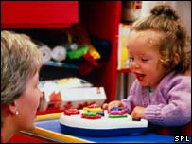
What is Cerebral Palsy?

Cerebral Palsy is a condition in which impairment to the immature brain affects movement, posture and balance. Cerebral Palsy is not progressive - the condition itself does not become more severe as the child gets older, although some of the effects on the body may become more noticeable and function may deteriorate. It’s a complex condition that can be very mild or severe, with no two people being affected in quite the same way.

Therapists can help a child/young person with Cerebral Palsy participate in the important activities within their daily lives. The therapists will work closely with families, schools and other professionals, to help manage the needs of the child in their daily life.

How a Physiotherapist can help?

A Physiotherapist will help to promote and develop more efficient ways of moving through play and a range of treatment options including (please see treatment section);
- Positioning
- Handling
- Exercises
How an Occupational Therapist may help?

Occupational Therapy (OT) can help a child/young person with Cerebral Palsy participate in the activities within their daily lives that they need to do and/or want to do. Working closely with families and schools, an OT may provide any of the following interventions depending on the individual’s needs and goals:
- Adaptation advice – working closely with OTs from Social Services, environmental advice and/or equipment for both home and school/nursery.
- Health and safety advice and management of risk.
- Child/young person specific moving and handling advice.
- Postural management e.g. specialist seating.
- Self-care skills - strategies, equipment and positioning.
- Sensory modulation and integration- to help attention and possible difficulties with sensory sensitivities.
- Specialist equipment – for personal needs such as toileting and bathing.
- Upper limb orthotics/hand splinting.

Coming soon ... relevant Occupational Therapy Home Programmes available for members on this website.

Useful Contacts:

www.scope.org.uk
www.cerebra.org.uk
www.hemihelp.org.uk (includes an interactive forum where you can post specific issues)
www.canchild.ca
http://www.bobathwales.org/

Back to top

Cystic Fibrosis

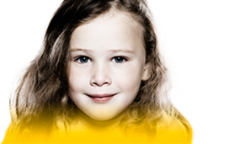
What is cystic fibrosis?

Cystic fibrosis is an inherited disease caused by a faulty gene. This gene controls the movement of salt and water in and out of your cells, so the lungs and digestive system become clogged with mucus, making it hard to breathe and digest food.

More than two million people in the UK carry the faulty gene – around 1 in 25 of the population.

There is currently no cure for CF but many treatments are available to manage it, including physiotherapy, exercise, medication and nutrition. Each week five babies are born with CF, and two people die.

More than half of the CF population in the UK will live past 41, and improved care and treatments mean that a baby born today is expected to live even longer.

Physiotherapy

For people with cystic fibrosis, physiotherapy helps clear the thick, sticky mucus from the lungs.

Parents are taught how to do physiotherapy with their child by the physiotherapist in the CF clinic. Adults with CF can learn to carry out their own physiotherapy.

Why is chest physiotherapy important?
Chest physiotherapy helps prevent thick, sticky mucus in the lungs from blocking the airways, which can reduce infection and prevent lung damage.

What physiotherapy techniques are there?
There are lots of different airway clearance techniques, and a specialist CF physiotherapist will conduct an individual assessment and give advice on the most appropriate technique to use, as well as the length and frequency of treatment sessions.

The technique used may change as you get older, or as the effects of your disease changes. The amount of mucus you clear will also vary, sometimes even from day to day.

Some techniques require no equipment, and focus on specific breathing exercises:
- Active Cycle of Breathing Techniques (ACBT)
- Autogenic Drainage
- Other techniques employ a device to aid the clearance of mucus, using positive pressure to hold open the airways, and some also create vibrations within the airways:
- Positive Expiratory Pressure (PEP)
- Oscillating Positive Expiratory Pressure – e.g. Flutter®, Acapella®

Some techniques involve large pieces of equipment which can be expensive, and may therefore only be available in hospital:
- High frequency chest wall oscillation (HFCWO) – an electric air compressor connects to an inflatable jacket (vest) to vibrate your chest

How much physiotherapy do you need?
The length of treatment sessions varies according to your needs. Daily physiotherapy is usually required, and if you have a chest infection you may need to increase the amount of airway clearance you do.

If there are few or no lung secretions, treatment sessions may only need to last 10-15 minutes, but if there are many then it could take as long as 45-60 minutes.

The number of treatment sessions will also vary. Most people do two a day when all is well, rising to four a day when necessary. If no secretions are present, some people with CF will only need physiotherapy once a day.

Your physiotherapist can advise you how much physiotherapy is needed.

When should physiotherapy start?
Physiotherapy should start from the time of diagnosis.

Who should do physiotherapy?
At first, the adults who care for the child with CF should deliver the physiotherapy. In time relatives or friends should also learn, so that no one person becomes indispensable.

Breathing exercises can be introduced from the age of two or three in the form of a game. From around the age of nine, most children can start doing part of their physiotherapy for themselves.

Most teenagers and adults become completely independent, and only need help if they have increased mucus secretions.

Useful Contacts:

Cystic Fibrosis Trust

Clinics are held in Morriston Hospital Paediatric Outpatients
Contact: Mari Powell (Senior Paediatric Physiotherapist) 01792 530742 or mobile no: 07772098575

Back to top

Developmental Co-ordination Difficulties (DCD)

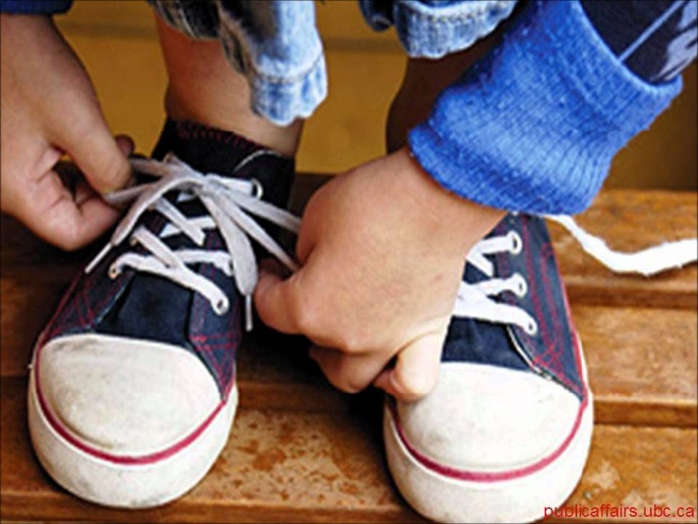
What is DCD?

Developmental Coordination Disorder is a term used to describe co-ordination difficulties that can affect a person’s ability to carry out with ease everyday activities e.g. dressing, handwriting, playing (football), and balance.

More boys than girls have been diagnosed with this condition. In a setting of 100 children, 10 may be affected by this.

How your child may present
- Poorly co-ordinated (Falling and bumping into people/objects)
- Difficulties with recording school work e.g. handwriting
- Avoids activities he/she know are difficult to achieve
- Fidgety
- Low level confidence
- May be socially isolated
- Struggles with sports/PE
- Poor concentration
For more information see the Dyspraxia Foundation website.

How a Physiotherapist can help?

Treatment is based on assessment of your child’s needs and advice may be provided to school and parents on specific activities, exercises and games to improve your child’s motor skills. These could be individualised programmes or group or leisure activities. You may also be advised on compensatory strategies.

Intervention should reflect the underlying functional difficulties and the principal aims of intervention are to promote the child’s development and to optimise their functional performance in daily activities and to reduce secondary difficulties or disabilities.

How an Occupational Therapist can help?

An Occupational Therapist looks at the impact DCD has on all aspects of activities of daily living but with a particular emphasis on how a person processes sensory information and how they manage fine motor skills. Depending on the age of your child this condition may affect your child’s ability to develop and learn, manage activities of daily living [e.g. self-care, writing] or access leisure or play activities [e.g. bike riding skills].

Occupational Therapy advice or intervention aims to help maximize your child’s performance in all aspects of their daily functional skills. An Occupational Therapist may provide individual programmes of advice and strategies, advise on suitable pieces of equipment, or suggest techniques to help your child compensate when carrying out activities they find difficult.

It must be noted that DCD is a lifelong condition and therefore it is essential for your child to learn coping strategies to aid their learning and development. The advice and programmes suggested by an Occupational Therapist will need to be adopted as part of the child's lifestyle to be of benefit.

Useful contacts:

- https://www.canchild.ca/en/diagnoses/developmental-coordination-disorder
- www.cafamily.org.uk
- www.snapcymru.org Swansea: primary schools DCD packs (see school SENCo)
- www.disability-sport-wales.org
- Book developmental Coordination Disorder Advice and Strategies by Marven Ball
Relevant Occupational Therapy Home Programmes available for members on this website:
- Advice for parents of children with Developmental Co-ordination Disorder

Back to top

Down's Syndrome and other syndromes

What is Down’s syndrome?

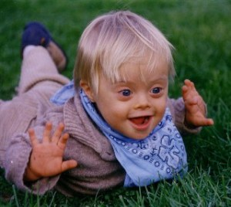
Down's syndrome is caused by the presence of an additional 21st chromosome which causes abnormalities in physical and cognitive development. Around one in every 1000 babies born in the UK will have Down's syndrome. There are 60,000 people in the UK with the condition.

For more information - www.downs-syndrome.org.uk/

How can physiotherapy help?

- A child with Down’s syndrome will often feel floppy. Physiotherapy can help the child improve muscle strength, posture and balance.
- Promoting achievement of gross motor skills such as sitting, crawling and standing.
- Improve independence in functional activities.
- Improve quality of life and confidence
- Reduce the risk of secondary joint problems in later life as a result of lax ligaments and muscle weakness.

Back to top

Juvenile Idiopathic Arthritis

What is Juvenile Idiopathic Arthritis?

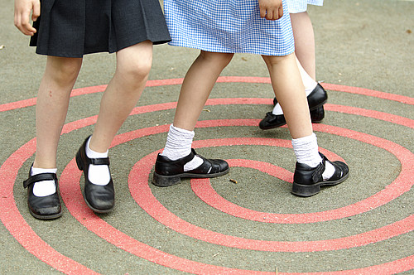
Arthritis in children is called Juvenile Idiopathic Arthritis (JIA). It is a painful condition that affects the joints and the bones. JIA occurs when the immune system, instead of just attacking infections, attacks the tissues of the body as well. The tissue lining of the joints becomes inflamed, making them stiff or swollen. The symptoms may sometimes ‘flare up’, and get worse for a period of time. It can affect any number of joints. The more joints affected the more severe the condition. As JIA is an auto-immune condition it can also affect organs, such as the eyes, liver, heart and lungs as well as the joints.
For more information: www.ccaa.org.uk

Physiotherapy and Occupational Therapy can help arthritis, relieve pain, and improve the child or adolescents ability to get on with life. The therapy aims are to maintain function, minimize any disability, and support children affected by this condition to reach their full potential both socially and educationally.

How can physiotherapy help?

Physiotherapists can provide exercises to stretch soft tissues to improve range of movement in the joints and build up strength and stamina. Advice and strategies for home and school may also be provided.

How can occupational therapy help?

Occupational therapists can help others learn to monitor a child's JIA. They can advise on ways to adapt activities or the physical environment. They do this to help a child participate more fully in work, school, and leisure activities. Working closely with families and schools, an OT may provide any of the following interventions depending on the individual’s needs and goals:
- Special equipment to help with daily routines;
- Splints for the hand to help to improve or maintain range of motion, reduce contractures or reduce pain, swelling, or stress on the wrist or finger joints;
- Balancing school, work, play, and leisure activities.

Coming soon ... relevant Occupational Therapy Home Programmes available for members on this website.

Other useful links:

www.arthritisresearchuk.org

Back to top

Muscular Dystrophy

What is Muscular Dystrophy?
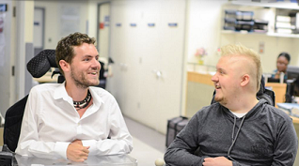
There are a number of different types of conditions under the umbrella of muscular dystrophy. Each type affects different muscles. The severity of the conditions and how the child is affected differs greatly. The conditions are normally progressive causing the muscles to gradually weaken over time. The conditions are either inherited or appear ‘out of the blue’.

There are more than 35 different conditions. Three of the more common are:
- Duchenne muscular dystrophy (DMD). This is a neuromuscular condition caused by a lack of protein and results in progressive muscle weakness of the body. The condition affects mainly boys;
- Charcot Marie Tooth (CMT) also known as Hereditary Motor and Sensory Neuropathy (HMSN). This is a group of conditions which affect the muscles below the knee and often the hands. The condition is hereditary affecting the sensory and motor nerves.
- Spinal Muscular Atrophy (SMA). This is a neuromuscular condition which causes muscle weakness in the body.

For more information:
The Muscular Dystrophy Campaign provides information on the above conditions and on other conditions under the umbrella of Muscular Dystrophy. The campaign will supply leaflets/booklets e.g. guides for families with a child newly diagnosed, other leaflets/related information and advice. The campaign also produce Target MD magazine. Please go to the Muscular Dystrophy website or NHS Choices for further information.

How a Physiotherapist can help?
Physiotherapy is ‘concerned with the physical treatment and management of the condition’ (from Neuromuscular conditions- a guide for families by Muscular Dystrophy Campaign). The child will be referred to a local NHS physiotherapy team. A physiotherapist will initially advise the child to be as active as possible. Activities like walking, swimming and cycling are ideal.

Later on in the condition the muscles can weaken and joints can tighten/stiffen. At this time a programme of regular exercises and stretching will be suggested. The exercises need to be fun and part of a daily routine. Physiotherapy may include hydrotherapy. Physiotherapists help to ensure the children lead as fulfilling a life as possible by advising families, carers and school staff on the condition (from Physiotherapy Management by Muscular Dystrophy Campaign). Most children with neuromuscular conditions benefit from regular physiotherapy reviews.

How an Occupational Therapist can help?
Major aims of the occupational therapist are to encourage activity and promote function. This includes interventions to delay or reduce complications due to the deterioration of muscle strength, and to give guidelines regarding activities, possibilities, adaptations and adjustments enabling the boys/men to live a socially active life together with family and friends. Assistive technologies such as seating and mobility play a primary role in providing postural support, comfort and independence for these clients.

Useful Contacts
www.muscular-dystrophy.org/
www.actionduchenne.org
www.dfsg.org.uk

Back to top

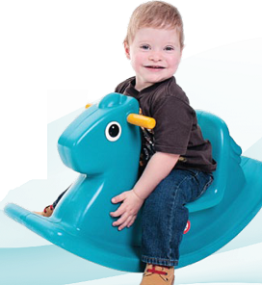
Spina Bifida

What is Spina Bifida?

Spina Bifida is a condition where there has been a problem with the early development of the spine or its coverings before the child was born. The symptoms vary from mild to complex according to the location of the damage in the spine. Most people with spina bifida have problems with their bladder and bowel but there can also be some sensory loss and paralysis below the level of the damage in the spine.

How a Physiotherapist can help?

A Physiotherapist will help the child to develop their physical skills to their best potential through play or a range of treatment options including (please see treatment section);
- Stretches, exercises and activities
- Positioning and postural management
- Liaising with the team who works with the child and their family at home and at school

How an Occupational Therapist can help?

When a child is young Occupational Therapy input is often to provide advice on positions for play and strategies to develop exploratory skills, hand function and eye-hand co-ordination.

We promote postural control where possible and look at alternative ways to provide the best postural support to promote the potential for hand function. This may be by way of specialist seating.

As the child grows, the emphasis changes to providing advice and equipment to promote independence in carrying out everyday activities. This can be by specific strategies and/or pieces of equipment e.g. for bathing and toileting.

Useful Contacts

www.shinecharity.org.uk/
www.spinabifidaassociation.org/

Back to top

