Community Resources

Finding fun in the community for your child!
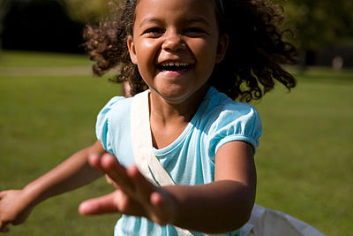
The number-one factor in choosing appropriate community based activities for your child with a disability should be fun! The main reason that children do sports and other activities is fun, and the key reason they quit is a lack of fun. Community-based programs that offer activities for children with disabilities can provide suggestions to help both you and your child select the best activities for your child’s interests and goals.

So, how do you ensure that an activity that your child is interested in will be fun? There are no guarantees, but here are some guidelines that you can follow to help make each experience the best that it can be. To be successful in helping your child create a healthy, balanced lifestyle, activities must be selected that will help your child achieve feelings of:
- belonging/acceptance
- success
- accomplishment
- growth
- competence
Society might usually view physical fitness as exercise in the gym, swimming, running or lifting weights. However, despite your child’s physical condition they can and should participate fully in community based activities. You need to make the time and find the resources. The potential lies within. Attitude is everything!

These days there are clubs and conventions for just about every hobby from dinosaurs to kite flying. Take the time to research local clubs and see if your child can get involved. If the Internet turns up no results, try contacting your area library, museum or disability sports officer.

References:
Brave Kids, Physical Activities for Children with Disabilities, http://www.bravekids.org/families-caregivers/physical-activities-for-children-with-disabilities/ (last accessed 09.09.2015)
National Center on Health, Physical Activity and Disability, Exercise Tips for People with Disabilities, http://blog.ncpad.org/2015/01/05/exercise-tips-for-people-with-disabilities/ (last accessed 09.09.2015)
Brave Kids, Finding Friends for Your Special Needs Child, http://www.bravekids.org/families-caregivers/finding-friends-for-your-special-needs-child/ (last accessed 09.09.2015)
Disability Sports Wales, Get In Touch, http://www.disabilitysportwales.com/contact/
(last accessed 09.09.2015)

Here you will find links to a number of organisations that you may find useful.

Disclaimer: External links are included on this website to provide users with additional information. Swansea Bay University Health Board cannot guarantee that such links will always work, and make no representations as to the quality or accuracy of the sites linked to. SB UHB does not endorse any external sites and is not responsible for their content.

 | Disability Sport Wales - There are hundreds of clubs across Wales offering disability-specific or disability-inclusive sport opportunities. Find the ones that suit you!
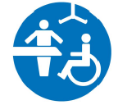 | Changing Places in Swansea - Swansea Parent/Carers Forum, Mencap, SAFE (Swansea Access for everyone) have developed a leaflet to promote the number Changing Places toilets in Swansea so that local families/carers and visitors to Swansea can plan days out without having to worry about accessing suitable facilities.
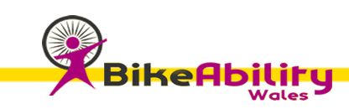 | Bike Ability Wales - providing cycling opportunities to people of all ages and levels of ability from our base in Dunvant in Swansea.
 | Circus Eruption - a place for young people to learn circus skills. Based in Swansea.
 | ELI Project provides love and comfort to families with special needs by hosting events in safe environments where they can come together and connect with others.
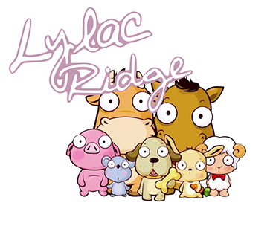 | Lylac Ridge - Lylac Ridge’s main focus is to provide opportunities for children and young people, particularly those experiencing ‘disadvantage’, to grow emotionally and learn through interaction with a range of animals, this is called Animal Assisted Therapies. We are based in Risca, between Newport and Cardiff.
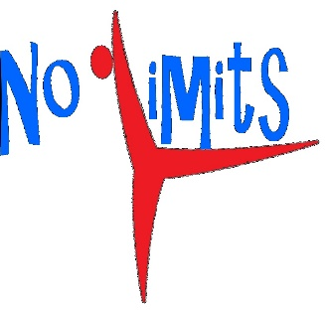 | No Limits Disability Gymnastics. Active gymnastics classes for children of all ages and abilities. Based in Neath.
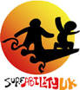 | Surfability UK CIC  Our mission is to make surfing as fun and inclusive as possible for disabled people and to help disabled people experience the many benefits of surfing. We provide indoor and outdoor surfing lessons and can adapt lessons to suit the needs of individuals or groups. As a CIC our profits are reinvested in to making surfing as inclusive as possible. We are based in Swansea.  We provide one-off lessons and experiences as well as regular training sessions for individuals and groups. Participants can use one of our safe soft surfboards or can surf tandem with a member of Surfability Staff.
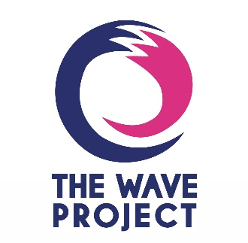 | The Wave Project- Inclusive surfing lessons based in Porthcawl and Aberavon beaches.
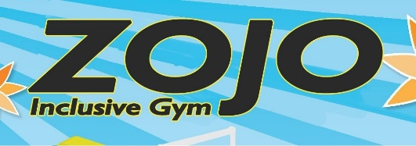 | Zojo Inclusive Gymnastics- Sessions designed for children with disabilities. Based in Pencoed, Bridgend.

Please contact us if you run or have attended a community activity with your child which you think others would enjoy or benefit from! NB. It is essential that the organisation has a website page that can be linked to.

