

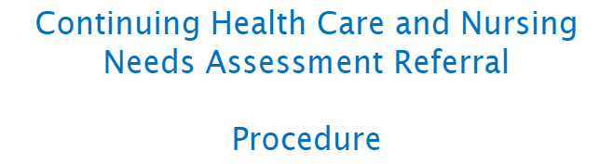

Document written by:
Nina Owen, (District Nurse Assessor) and Rebecca Evans Administration Officer

Contents:

- Introduction

- Purpose of Referral procedure

- Responsibility

- Consent

- Capacity

- Key consequences of refusing CHC

- Consenting to the CHC Assessment

- Criteria for referral

- CHC and FND Care Assessment Flow Chart

- Continuing Healthcare and Funded Nursing Care Assessment Referral Form

- References

Introduction

The role of Nurse Assessor sits within the District Nursing (DN) Team for Swansea Bay. This process covers a range of health specialities including, adults and older people with a range of physical needs. This includes neurological illnesses, muscular diseases, cancer and end of life care, frailty, and transitioning patients from child services to adult continuing healthcare.
The DN Team undertake full assessments and reviews of eligibility using the NHS Framework for Continuing Healthcare (CHC WAG 2022). They are responsible for overseeing case management by the DN Team for those individuals who are in receipt of CHC Funding.
This process involves the following phases;
- Identification and Assessment: Care co-ordinator allocated, and assessment process begins.
- Decisions making: Multi-Disciplinary Team (MDT) will collect evidence needed for CHC assessment and work with the patient, family, and the Local Authority (LA) to achieve the best outcome for the patient.
- Arrangement of Care Package: if eligible for CHC,
- Fast Track option for end of life.
- Review: the review process is three months after eligibility of CHC, then on a yearly basis.
The DN Team work alongside multi-disciplinary teams to ensure individuals needs are reviewed and met. The process involves facilitating meetings following the CHC Framework Guidance in a time specific manner; assessment, planning and commission of care often includes responding to crisis in care provision, problem solving with the support of the CHC team and wider MDT.

Purpose of Referral Procedure:
This document aims to provide an outline of Continuing Healthcare and Funded Nursing Care services available within Swansea Bay University Health board (SBUHB) and the process for appropriate referral.
This guidance applies to all SBUHB staff whose responsibility is for caring for patients with Continued Healthcare needs to ensure the patients' needs are met by following the correct and most time efficient procedure. This can take up to 8 weeks. The fast-track process should always be used for any individual with a rapidly deteriorating condition that may be entering a terminal phase.
Responsibility:
The NHS will be the initial point of contact, and so the referrer has the responsibility of the patient.
MDT members are responsible for working with the individual and/or their representatives to undertake a thorough and objective assessment of their needs, for providing expert advice to the LHB regarding eligibility for CHC and for making recommendations as to the setting and skill set required to deliver the co-produced care plan.
The referrer should contact Single Point of Access (sbu.districtnursesspoa@wales.nhs.uk) 01792 343360 who send out the link for the referral form. The assessment and management of the patient will depend on the needs of the patient but remains the responsibility of the care co-ordinator until the assessment is complete.
The Care Co-ordinator is the named individual responsible for co-ordinating the whole process of assessment for long-term care. They are accountable for ensuring that the assessment process is co-produced, robust, and timely. They must ensure that the individual or their representative is kept informed of the process and fully involved in discussions about their care.

Consent
Where the individual concerned has capacity, their informed consent should be obtained before the start of the process to determine eligibility for CHC. This consent will need to encompass permission to undertake the CHC assessment process, information sharing and processing of data.

Capacity:
If there is a concern that the individual may not have capacity to give their consent or to participate effectively in the decision-making process, this should be determined in accordance with the Mental Capacity Act (2005) and the associated Code of Practice.
For consent to be valid for the purposes it must be:
- Explicit: Consent must be expressly confirmed and recorded in writing, in a very clear and specific statement of consent, which is prominent and kept separate from other information.
- Specific: It should be made clear to the individual to what they are being asked to consent and whether their information will be obtained and shared for a specific aspect of the eligibility consideration process or for the full process. Also, it needs to be explained that, subject to their consent, their personal information will be shared between different organisations involved in their care to complete the assessment of eligibility for CHC.
- Informed: The individual should be informed about what the CHC eligibility assessment process involves, what information will be obtained, and who it will be shared with before the start of the process to determine eligibility for CHC.
- Freely given. This means consent must be given voluntarily by an appropriately informed person who has both the capacity and authority to consent to the intervention in question. It also means giving people genuine ongoing choice and control over how their personal information is used and shared. In the context of CHC this means that the individual must have the capacity to consent freely and voluntarily to the CHC eligibility assessment process as set out in the Framework.
- The individual should have a choice about whether to consent, and consent must not be conditional on the individual agreeing to something that is not related to the CHC eligibility assessment process.
- Can be withdrawn. The individual must be made aware that they can withdraw their consent at any time, and made aware of the process for doing so, and that this includes withdrawing consent to share information. It should be explained that, depending on the information in question, the decision to withdraw or withhold consent to share information might affect whether it is possible to complete the CHC eligibility assessment.

The key consequence of refusing a CHC assessment
Is that the NHS cannot become responsible for arranging and funding the entire care package and therefore providing care services that are free to the individual. The individual’s long-term care requirements may be met by the NHS and LA sharing responsibility and, as a result, the individual maybe charged for a contribution to the local authority arranged services. The individual must be provided with a detailed care plan setting out who will provide which services and what they may be charged.

Consenting to the CHC assessment process
Where there are concerns that an individual may have significant ongoing needs, and that the level of appropriate support could be affected by their decision not to give consent, the appropriate way forward must be considered jointly by the LHB and the LA, considering each organisation’s statutory legal powers and duties. Where necessary, each organisation should seek legal advice.
Although refusal of consent only occurs in a minority of cases, LHBs and LAs should consider developing jointly agreed protocols on the processes to be followed. These should provide clarity regarding approaches such as the use of existing assessments and other information to determine each organisation’s responsibilities and the appropriate way forward.
When the individual does not have a family member or representative a Best Interest decision must be carried out with the authority to make decisions on their behalf, as set out in the Framework.

Criteria for Referral
As of April 2023, all correspondence to the District Nurse Assessors Team regarding advice on referral of an individual in accordance with All Wales Guidance for Data Protection must be emailed to the appropriate service. (See below)
All completed CHC Referrals will be sent to the addresses below when you complete and submit a Microsoft Form. This requires you selecting the correct service location.

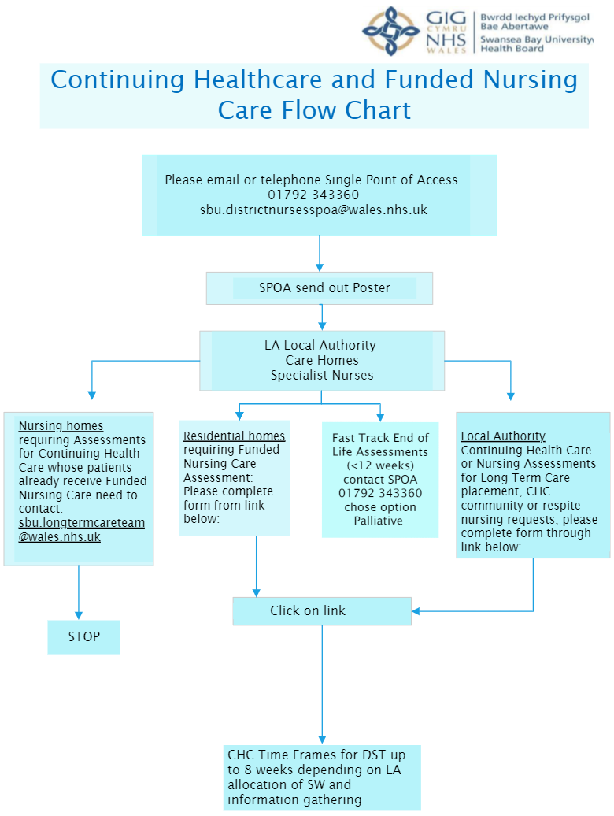

Continuing Healthcare and Funded Nursing Care Assessment Referral Form
 | Patients requiring Continuing Health Care Eligibility Care Assessments in the Community
 | Patients requiring Funded Nursing Care Assessment for Long-term placements or respite.
 | Patients requiring Fast Track End of Life Assessments in the Community or Residential and Nursing placements.
Swansea Bay Community Nurse Assessor Team
- Patients in a Care home who are already receiving Funded Nursing Care and requiring Continuing Health Care eligibility assessment please email to: sbu.longtermcareteam@wales.nhs.uk
- For further information on how to complete the form please go to the 'How to Refer' section flow chart.

Click link or alternatively scan QR code with your device to complete referral form:
Referral Form


The National Framework for Implementation in Wales. (n.d.). https://www.gov.wales/sites/default/files/publications/2022-03/continuing-nhs-healthcare-the-national-framework-for--implementation.pdf

Legislation.gov.uk. (2005). Mental Capacity Act 2005. Legislation.gov.uk. https://www.legislation.gov.uk/ukpga/2005/9/contents

Data Protection Act, 2018

