Transition to Adult Audiology Services (Swansea and Neath Port Talbot)
Survey results 2019-2021

12 of you responded to our survey.
- All of you answered the first question which asked: What did we did well?

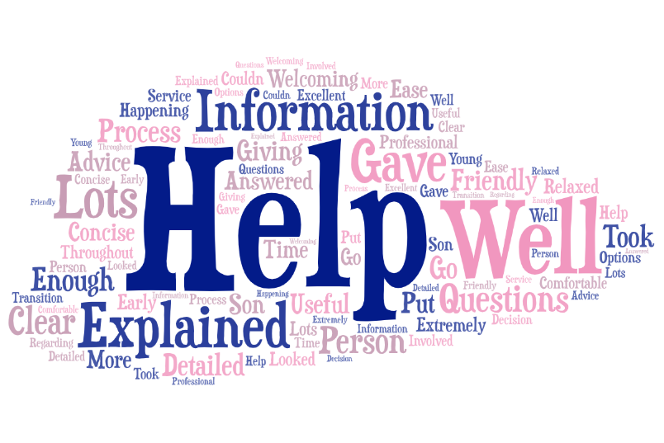
This is a word cloud. The size of the word depends on how often it was used so the most commonly used word was ‘Explained’.

- We also asked: What could we do better?

7 of you gave a written answer for this question. All answered with no further recommendations and responses included 'nothing comes to mind', 'everything was very good. Nothing was bad about my experience' and NA.

- We then asked if we could have provided additional information.

The majority of you responded with None/Nothing or similar. One person commented that ‘I wouldn’t change anything’ and another commented ‘I received all the information that I needed’. One of you did want more information explained on ‘Whether there is any real difference between services in England if that is where university is based’.

- Finally we asked for any other comments and these were your replies:
Service over the years has been exceptional, and made difficult circumstances a lot easier.

Thanks for the help over the years

Both Audiologists brilliant and very helpful.

What we will do now
We will ensure that young people receive the information about the transition to the adult service a number of times prior to transition so that they have this information and have plenty of opportunities to ask any other questions.
We will continue to gather feedback on the transition process and listen to what you say about this service.

