Paediatric Pre-school Audiology Survey results 2019

The Paediatric Pre-School Audiology Survey was provided to families of hearing aid wearers under 2 in the summer of 2019. It was provided to families at MDT meetings and at the NPT playgroup. 7 surveys were returned.

Can you think of any positive experiences that you have had with the Paediatric Audiology service?
For this question there were 7 responses which have been displayed as a wordle below.
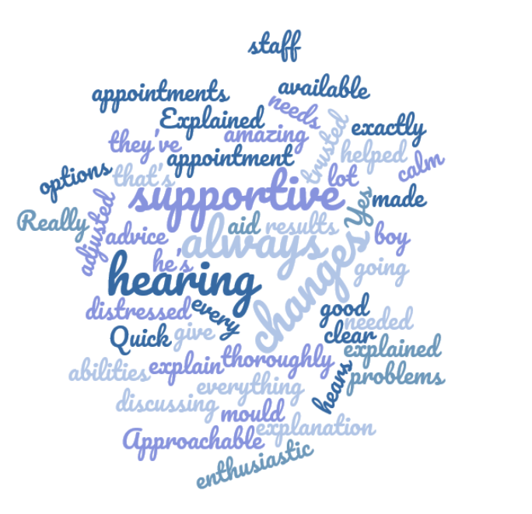

Can you think of any negative experience that you have had with the Paediatric Audiology service?
There were three responses to this question to which we have provided comment and planned or completed actions.
You said We did
Audiologists are not trained medically and so are not able to advise on medical matters safely. We work closely with the Medical Lead for Audiology but for urgent matters it is always safer for Audiologists to refer Patients to their GPs as they are able to put all of the health information about a child together.
They don’t seem to be involved in any health queries which would impact our child hearing. Always told to go to GP

Unfortunately, we have no control over the postal system. We are pleased that email has proved effective and sorry that the same has not been true for the phone. We have spoken to staff about answering telephone queries.
Communication: appointment letters have failed to turn up on time if at all. Some staff seem to confuse information over the phone. Direct email has been effective

Never had a negative experience

Do you have any suggestions of how we could improve the service?
You said We did
No, excellent

No brilliant service

Many children with hearing loss do not have ENT issues and so it would not be prudent to refer all children. However we understand that for those who do the wait is long. We are in discussions with ENT about how access can be improved for those who need it.
Could refer all the kids to ENT doctors as our boy had a lot of problems regarding ENT issues and now still waiting to see them

Staff answering phones – please speak up! I am not hard of hearing but still find it hard to hear you! We have also requested tube are glued into moulds – they haven’t always been
We are sorry if anyone has had difficulty hearing our staff on the telephone. We have ensured that Deaf Awareness training has been scheduled for all staff. The need for Glued in Tubes has been reinforced in training meetings.

None always had positive things happening

Is there anything else that you would like to tell us about our service?
On the whole the team have been supportive, helpful and considerate and we appreciate that

Lovely people if all staff were like you you’d have no complaints

Both Audiology and the Medical Lead provide the GP and HV with all written reports and will liaise with HVs as required for an individual child. We will consult with parents to ask about the other ways in which they would like us to work with GPs.
Closer work with GP not every 6 months in the first year of baby life. As it is the scariest time for parents as they don’t know what is normal for their child

