Please remember to enter the hospital code (if provided) or hospital name during the checkout process.
Hospital code



Danalogic from GN works harder to drive positive outcomes across the whole patient journey, enabling the NHS to deliver better care where it really matters.
Danalogic is part of the GN Group – pioneering great sound from world-leading hearing devices to Jabra office headsets and sports headphones. Founded in 1869 and employing over 5,000 people. GN makes life sound better.
Find out how you can help your patients get the most out of their hearing experience with Danalogic from GN at www.danalogic.co.uk



Purchasing wireless accessories online
website: www.wirelesshearing.co.uk
password: Unite

Patients can buy online in seven quick steps...
Our wireless accessories help hearing aid wearers to access even more sounds, such as telephone calls, music, radio and TV.
Accessories can be purchased by logging onto the website using the password printed on this leaflet

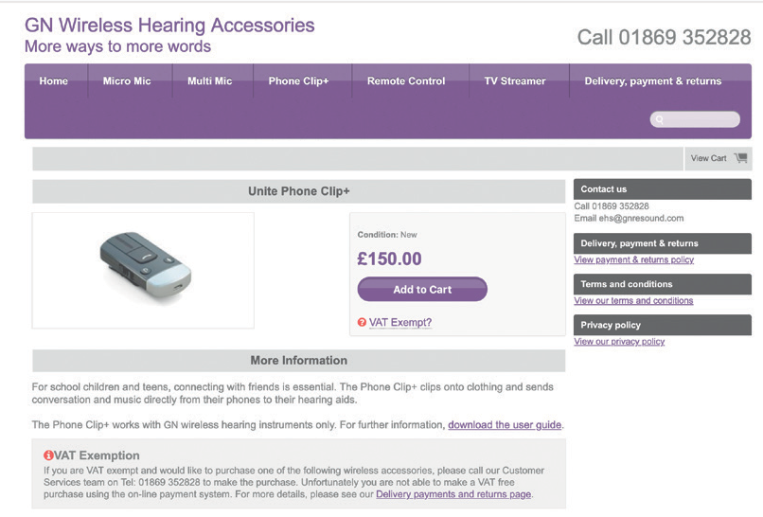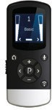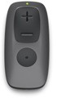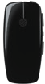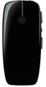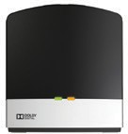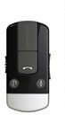

TV STREAMER 2*
MICRO MIC / MULTI MIC | REMOTE CONTROL 2 | PHONE CLIP+ | REMOTE CONTROL

GN Hearing UK Ltd.
Building A,
Kirtlington Business Centre, Portway, Kirtlington,
UK 04.36 E.04.2021
Oxon OX5 3JA
Tel.: +44 1869 352 800
Fax: +44 1869 343 466
Email: danalogicuk@gnhearing.com
www.danalogic.co.uk

www.danalogic.co.uk



Step one:
Step three:
Step five:
Step six:

To buy Danalogic GN wireless accessories, patients need to visit:

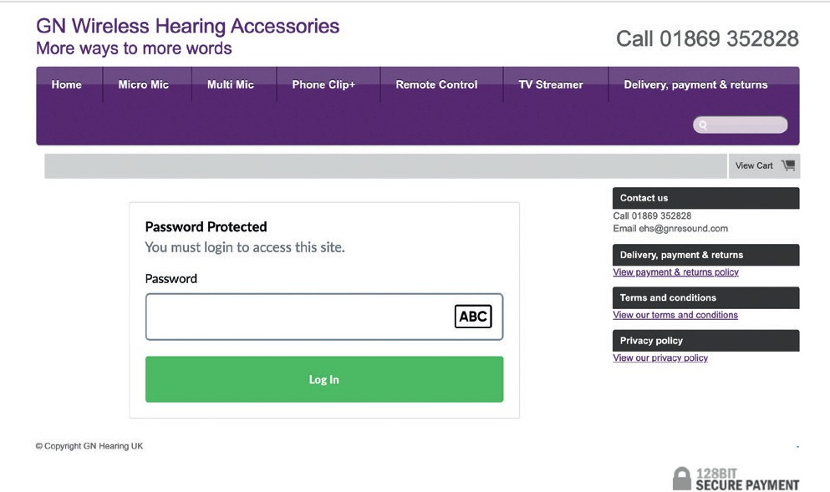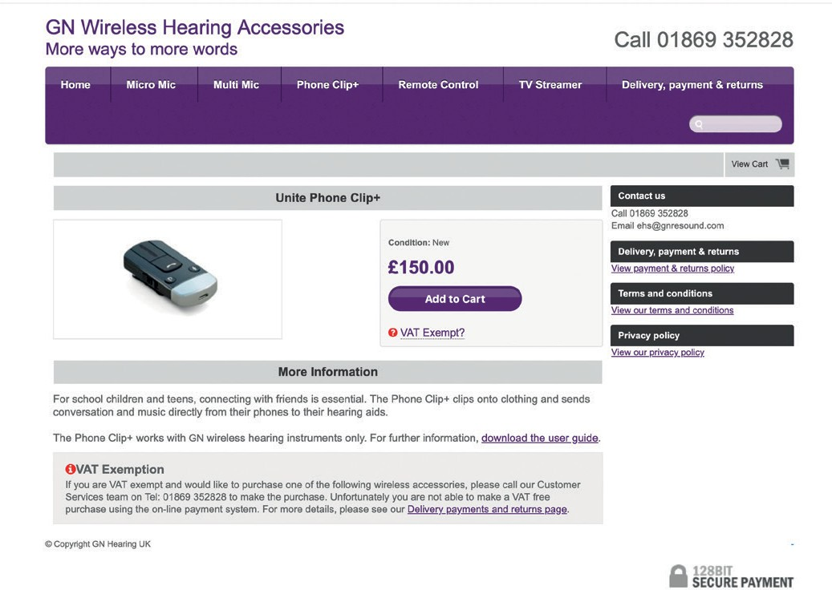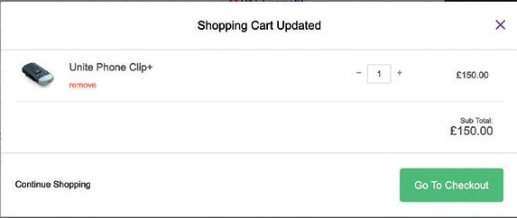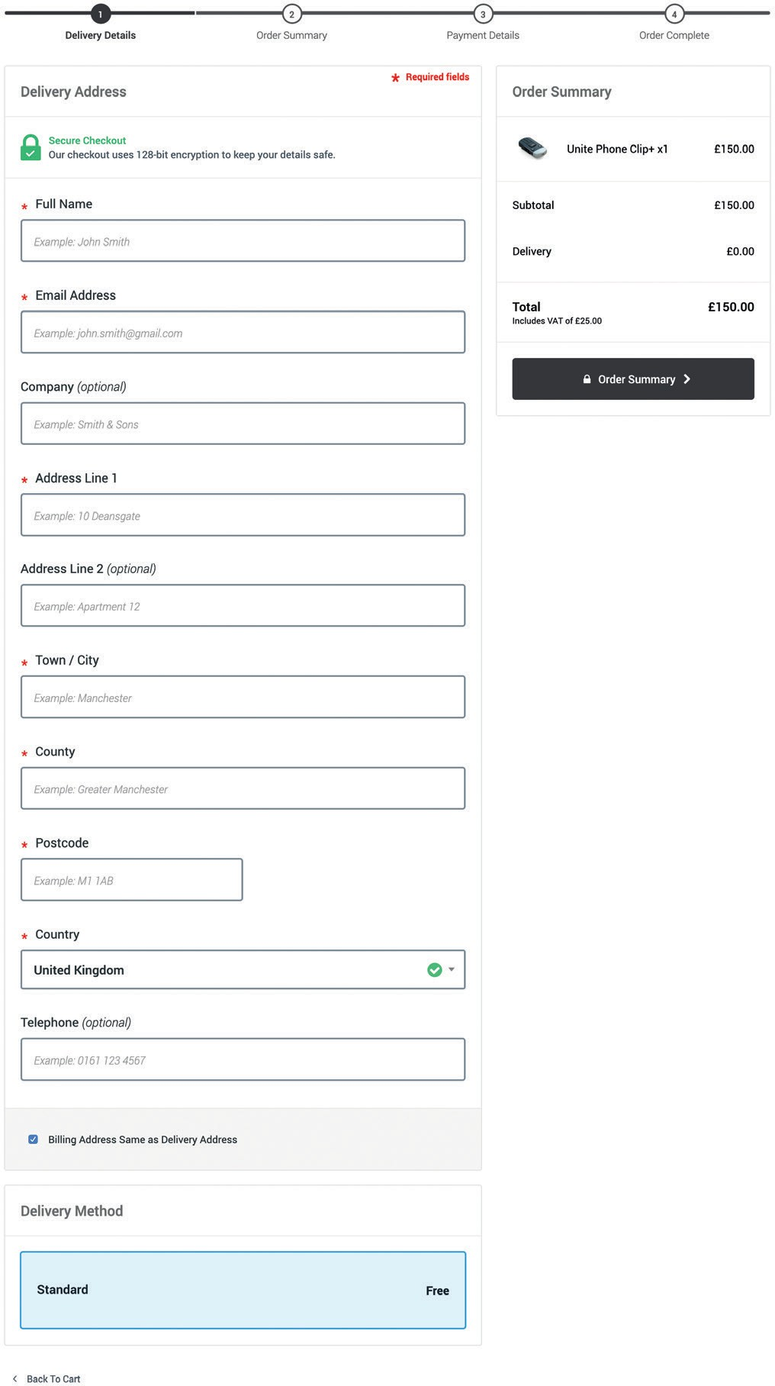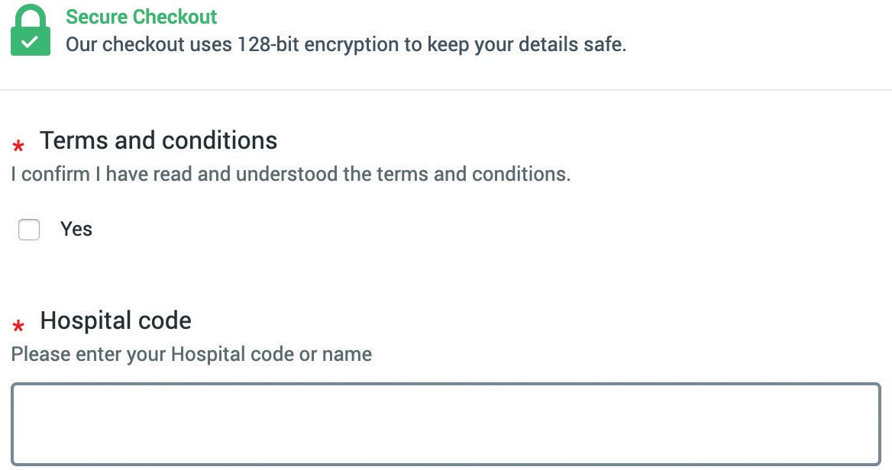www.wirelesshearing.co.uk

1.
Type in the password: Unite and press ‘Login’ button

Add to cart 3a.

3b.

3c. View other accessories... 3d. or go to checkout
If you are VAT exempt, click to find out more details.

5.
Fill in the
required fields

6.
Tick box and
add hospital code or name
Each accessory has its own page with enlarged image and details of how it can enhance the patient’s hearing experience.
The delivery address and details can be added on this page.
Before payment is taken, the patient is asked to confirm they have read the terms and conditions. They are also asked to enter their hospital code or name.

Step two:
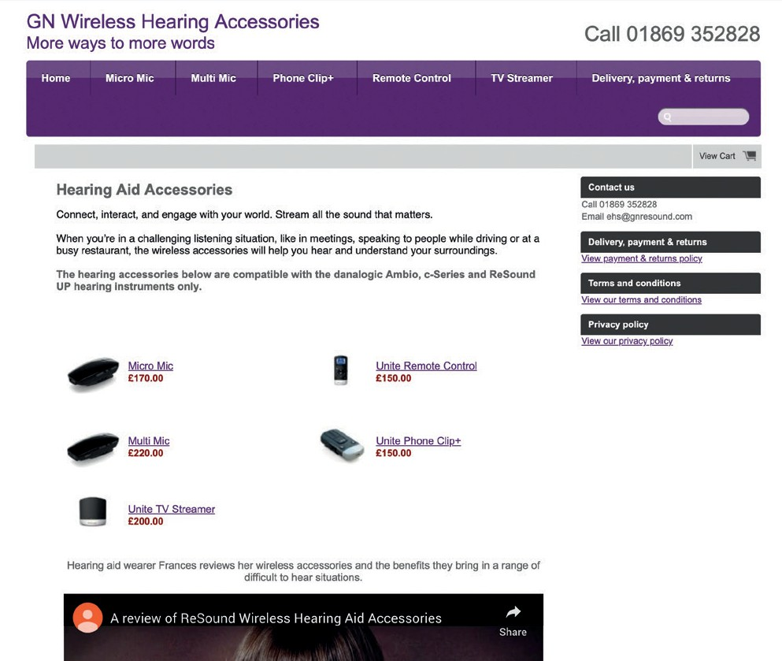The next page shows each wireless accessory available to purchase.
2.
Your patient can click on any image to find out how each accessory can enhance their hearing experience

Step four:
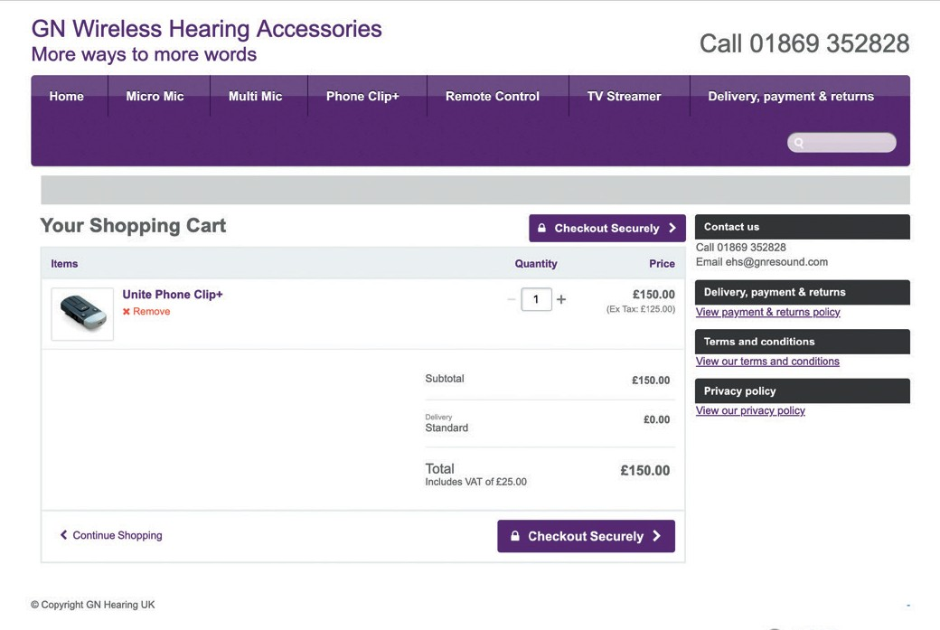The ‘Your Shopping Cart’ page allows the contents of the shopping basket to be checked. Unwanted products can be removed here. When ready, choose ‘Checkout Securely’ to proceed to the payment section.
4a. Remove items
4b.
Check
quantity

Step seven:
The final step is for the patient to enter their payment information through our secure payment provider.

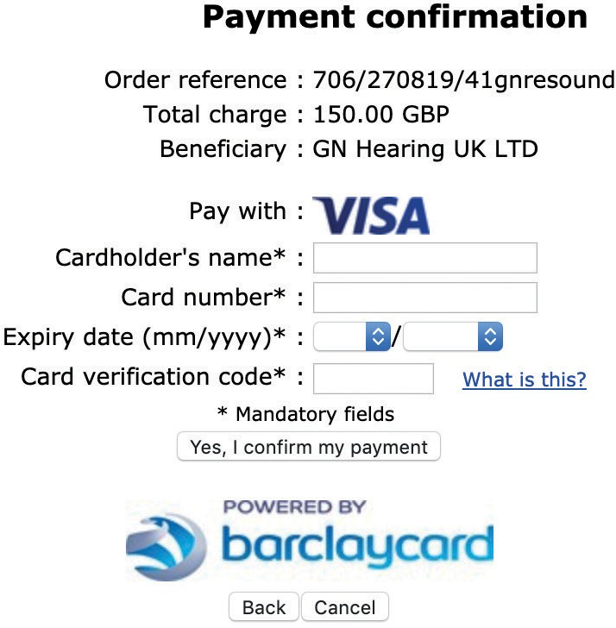

7.
Select payment method and fill in the required fields

