danalogic GN

Wireless Accessories

GN Making Life Sound Better

Introduction
Danalogic GN’s wireless accessories stream sound directly to your hearing devices.
Our unique wireless platform is robust, stable and direct. Unlike other wireless systems, it doesn’t require you to wear a streaming device around the neck. Our range of accessories, combined with the technology in the Danalogic GN portfolio, create a hearing system that addresses many of the problems experienced by hearing device wearers.
Our 2.4GHz accessories can be added at anytime without the need for software programming.

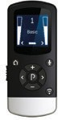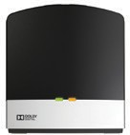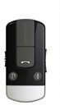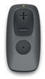

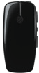
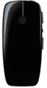
TV STREAMER 2*
MICRO MIC / MULTI MIC
REMOTE CONTROL 2
PHONE CLIP+
REMOTE CONTROL



*Requires AC power & cable connection to TV
  - GHz wireless connection
Bluetooth® connection

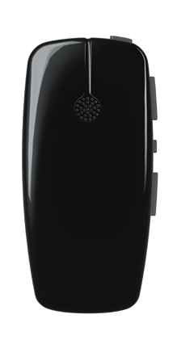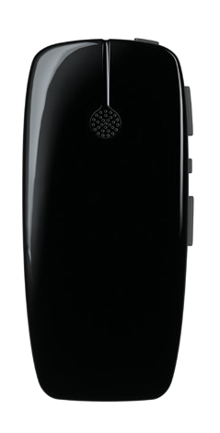

Micro Mic & Multi Mic
Danalogic GN’s Micro Mic and Multi Mic enable you to hear more of everything. The voice of a loved one, a teacher, a colleague – whether they are in a noisy place or several metres away, you’ll hear them with crystal- clear sound.

Micro Mic Benefits:
    - Sound can be streamed from up to 25 metres away with clear line of sight
    - Up to 10 hours of talk time per battery charge
    - 3-hour charge
    - Discreet design
    - Easy to pair
    - Our 2.4GHz accessories can be added at any time without the need for software programming
    - Rechargeable

Multi Mic offers you all of the above plus:
    - Up to 11 hours of talk time per battery charge
    - Can also be used as a table mic, you can hear everyone around it
    - Connects to FM and Loop systems
    - Has a mini-jack input for streaming audio from virtually any device with a headphone output

www.danalogic.co.uk 3

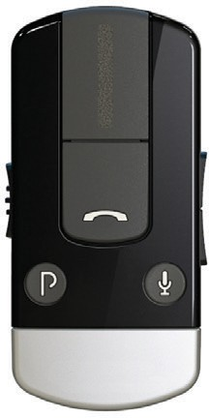

Phone Clip+
Even when you’re in a busy, crowded place, talking on the phone becomes effortless with Danalogic GN’s Phone Clip+. Just push the answer button and the Phone Clip+ will stream the call directly to both hearing devices.
If it’s too noisy, you can even reduce surrounding noise to better hear your phone call. When you aren’t
on the phone, you can use the Phone Clip+ as an audio streamer and remote control.

Benefits:
    - Up to 6 hours of talk time and 80 hours of standby time
    - A mute button to reduce all other surrounding sounds so you can concentrate on your call
    - Simultaneous connection to two Bluetooth devices (such as phone and tablet)
    - Easy-to-use remote control functionality for your hearing devices
    - Quality stereo sound when streaming music
    - Private and secure connection
    - Call reject and transfer, last number dial and voice dial functions
    - Rechargeable
    - Charge time - 3hrs

4

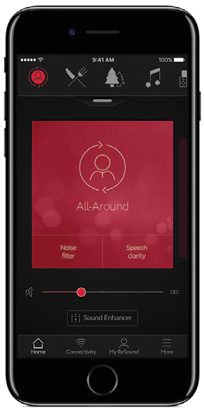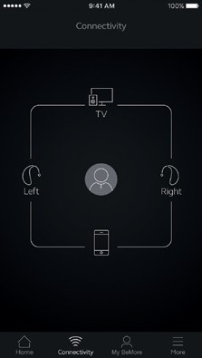BeMore App
Access the BeMore App to discreetly control and personalise your hearing devices.

Benefits:
    - Adjust volume, background noise and change programs with one simple tap
    - Remote Assistance feature - send and receive fine-tuning adjustments via the app (check with your local Audiology service
for availability)
    - Geo-tag favourites for automatic programme change based on location
    - Track misplaced hearing devices via the app

Works with AndroidTM

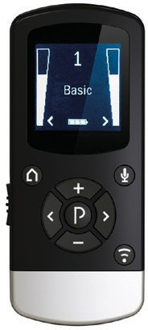
Remote Control 2
Danalogic GN’s Remote Control 2 allows you to easily control your hearing devices and wireless accessories. Its visual interface gives you a clear indication of the current volume and program settings of your hearing devices. Overview, control and discretion – all in one.

Benefits:
    - Adjust volume of hearing devices together or individually
    - Change hearing device programs
    - Start streaming programs and control balance of the hearing device volume and streamer volume
    - Reduce surrounding sounds with the mute button
    - Rechargeable

www.danalogic.co.uk 5

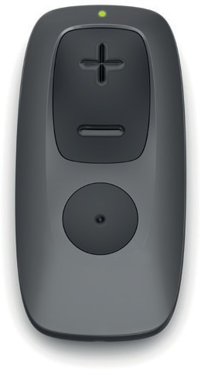
Remote Control
The GN hearing simple Remote Control is easy to set-up and use. It will quickly become a valued part of your daily life.

Benefits:
    - The large tactile buttons on the Remote Control make switching
settings and adjusting the volume simpler than ever
    - Easy to use
    - Adjust volume of hearing devices together or individually
    - Change hearing device programs

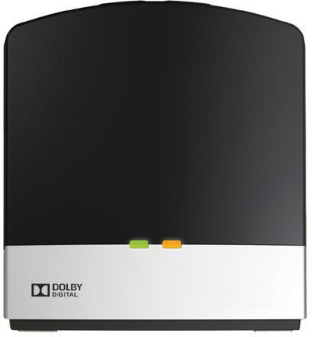
TV Streamer 2
With Danalogic GN’s TV Streamer 2, you can enjoy clear sound from the TV and still participate in conversations around you.

Benefits:
    - Connects directly to virtually any
audio device – TVs, stereos or computers
    - Delivers stereo sound directly to hearing devices without the need for any additional device around the neck
    - Easy to use
    - Very discreet
    - More than one user at a time can connect to the same TV Streamer 2

6

Compatible hearing devices
Danalogic GN Wireless Accessories are compatible with the following hearing devices:

danalogic Ambio Smart
    - RIE rechargeable
    - Mini RIE
    - RIE
    - MINI BTE
    - BTE
    - POWER BTE
    - SUPER POWER BTE
    - ITE, ITC, CIC (CUSTOM DEVICES)

danalogic Ambio
    - Mini RIE
    - RIE
    - MINI BTE
    - BTE
    - POWER BTE
    - SUPER POWER BTE

danalogic CSW-Series
    - RIE
    - MINI BTE
    - THIN TUBE BTE
    - STANDARD/POWER BTE
    - SUPER POWER BTE

ReSound UP
    - MINI BTE
    - BTE
    - POWER BTE

www.danalogic.co.uk 7

How to purchase?
To purchase wireless accessories for your hearing devices visit:
www.wirelesshearing.co.uk Password: Unite
Please remember to enter the hospital code (if provided) or hospital name during the checkout process.
Hospital code

Danalogic is part of the GN group, one of the world’s leading manufacturers of
advanced hearing care solutions. Founded in 1869 and employing over 5,000 people. People are at the heart of everything we do. GN makes life sound better.


Order information
For information on our
Danalogic GN products:

GN Hearing UK Ltd.
Building A,
Kirtlington Business Centre, Portway, Kirtlington,
UK 04.36 E 04.2021
Oxon OX5 3JA
Tel.: +44 1869 352 800
Fax: +44 1869 343 466
Email: danalogicuk@gnhearing.com www.danalogic.co.uk

