Swansea teenager takes to the sky for palliative care unit
Friday, 7 September 2018
A teenager has taken to the sky for a sponsored tandem skydive from 12,000 feet.

Nineteen-year-old Jack Roberts took part in the experience of a lifetime to raise money for Ty Olwen Trust, which involved freefalling at 120mph for about 45 seconds, before a parachute deployed at 5,000 feet.
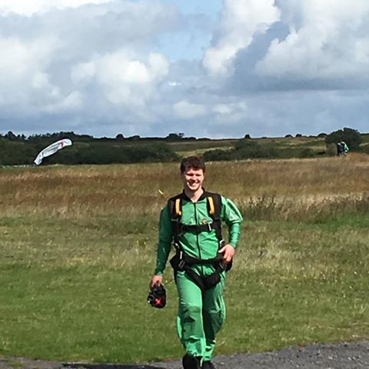
Jack, from Swansea, was inspired by his mother who is a nurse at Ty Olwen Hospice at Morriston Hospital in Swansea.

“I have grown up and around the place, where I have learnt of all the wonderful things that are done there” he said.

“I have always wanted to have a go at skydiving, so I decided that if I was going to do such a big life experience then it should be for a good cause”.

“The initial jump and build up to it was very intense but once I was in the air I felt amazing. I would definitely do it again!”

Jack has raised £948 for Ty Olwen Trust through the tandem skydive at Swansea Airport, which will go directly into patient care.

Grant Nockles, Ward Manager at Ty Olwen Hospice said: “We are incredibly grateful that Jack chose to do such a daring activity for Ty Olwen Trust. He is an inspiration to all young people. His bravery and courage has helped raised money that will benefit patient care at Ty Olwen.

“It’s been fantastic to see that the work of his mum, has inspired Jack to follow her footsteps into helping others and we can’t thank him enough for this fantastic achievement”.

Source: Abertawe Bro Morgannwg University Health Board

