Pioneering Morriston team hosts visit by leading young US researcher
Friday, 21 September 2018
A pioneering team at Morriston Hospital has hosted a visit by one of the world’s leading young researchers as part of a Transatlantic collaboration.

Dr Valerie Tutwiler was the guest of Morriston’s internationally-renowned Haemostasis Biomedical Research Unit.
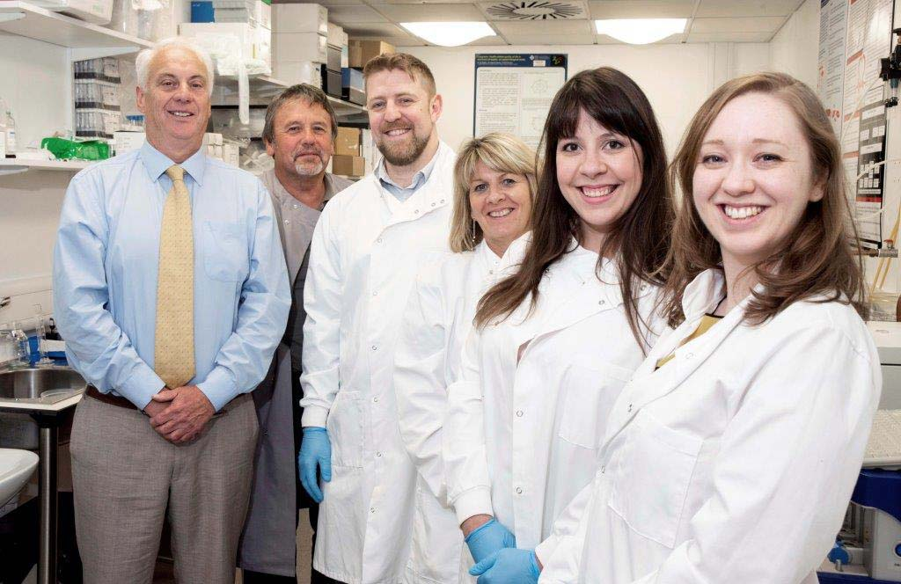
Pictured left: Professor Adrian Evans, Professor Keith Morris, Dr Matthew Lawrence, Jan Whitley, Dr Valerie Tutwiler and Vanessa Evans

The HBRU is one of the leading centres in the UK and Europe on clotting research in the field of emergency medicine.

Dr Tutwiler, from the Perelman School of Medicine, Pennsylvania University, visited as part of an established ongoing research collaboration headed by Professor Adrian Evans in Morriston and Professor John Weisel in Pennsylvania.

She updated and trained Morriston researchers on new techniques to detect abnormal clotting in blood in patients arriving in the Emergency Department with a variety of illnesses such as stroke, heart and respiratory diseases and sepsis.

Professor Evans said: “Val is an outstanding young scientist and we were pleased to have her visit our centre and train our staff.

“This visit will give us new and innovative techniques in our understanding of how disease and its treatment alters clot structure and affects patient outcomes.

“We will now use these new techniques to begin several studies over the next several years.”

The Pennsylvania centre, led by Professor John Weisel, is a world leader in researching how disease leads to the development of abnormal clot microstructure.

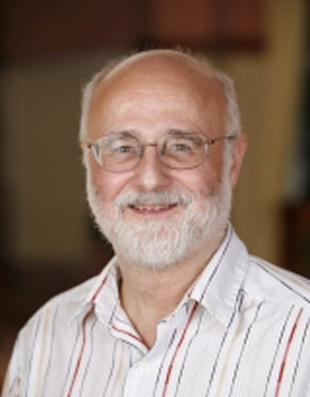
Professor Weisel (pictured right) said: “We have had a very productive collaboration with Professor Evans’ group for several years, with many different projects underway, all relating to thrombosis and haemostasis in different patient groups.

“This an especially good collaboration because we have complementary expertise and as part of our collaboration there has been an ongoing exchange of scientists from the two groups.”

Source: Abertawe Bro Morgannwg University Health Board

