Maternity teaching team commended with top award
Friday, 28 September 2018
A Swansea obstetrics and gynaecology teaching team has been commended for their excellent work with a Maternity and Midwifery Festival Team Award.

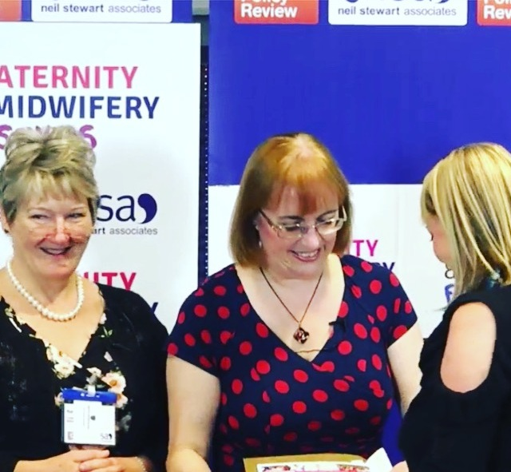
Their method of working, which was honoured at the South West and Wales Maternity and Midwifery Festival Awards - encourages all allied health professional students to work together to help prepare a health workforce that is best prepared to respond to local health needs.
Left: The team picking up their Team award Thursday 20th September at Cardiff City Stadium – one of four annual regional awards that recognise outstanding achievement and commitment by midwifery and maternity staff across the UK.
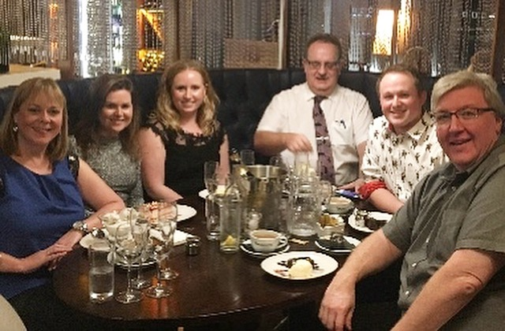
Formed of two consultants - Mr Euan Kevelighan and Mr Jeremy Gasson, teaching registrars Dr Ceiros Jones and Dr Khadija and midwife clinical lecturer Suzy Rees – the Singleton Hospital-based team successfully worked together to introduce inter-professional sessions.
Right: The team together
Known as inter-professional student obstetric emergencies simulation sessions, they were an opportunity for medical students to work alongside midwifery students, student physician associates and paramedics in a supportive learning environment.
Speaking about this new way of working, Suzy Rees said: “We encourage medical students to work closely with midwifery students to consider the MDT (multi-disciplinary team) as a whole when working in the maternity department, which is helping tremendously in eroding boundaries between medical and midwifery staff.
“The importance of inter-professional learning in fostering excellence in team working is essential in the modern NHS.
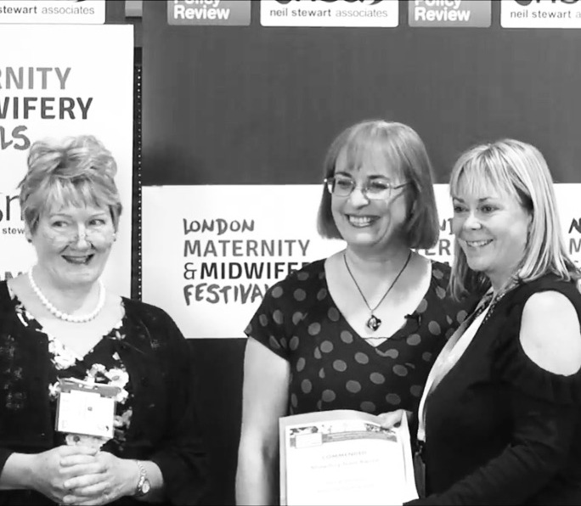
Feedback from students was overwhelmingly positive following the introduction of the sessions, resulting in a dramatic improvement in awareness of obstetric emergencies and a deeper understanding and insight into the roles and responsibilities within the multi-disciplinary team.
Students also saw an increase in their confidence when working within their chosen professional teams in the future and really enjoyed the opportunity to learn together.
Commenting on the award win, Suzy added: “We are thrilled and immensely proud that our hard work and passion for teaching has been recognised in this way.

“It is a true reflection of the high level of clinical teaching, not only from our teaching team – but all the maternity and women’s health clinical staff in ABMU as a whole.

“We are a highly motivated, dedicated and passionate teaching team and we will endeavour to continue to deliver the highest possible standards of clinical teaching at all times.”
Source: Abertawe Bro Morgannwg University Health Board

