Vaughan Gething visits POWH cardiac facility after £1.6 million refit
Monday, 18 September 2017
Health Secretary Vaughan Gething has been checking out a cardiac facility at Princess of Wales Hospital following its £1.6 million refit.

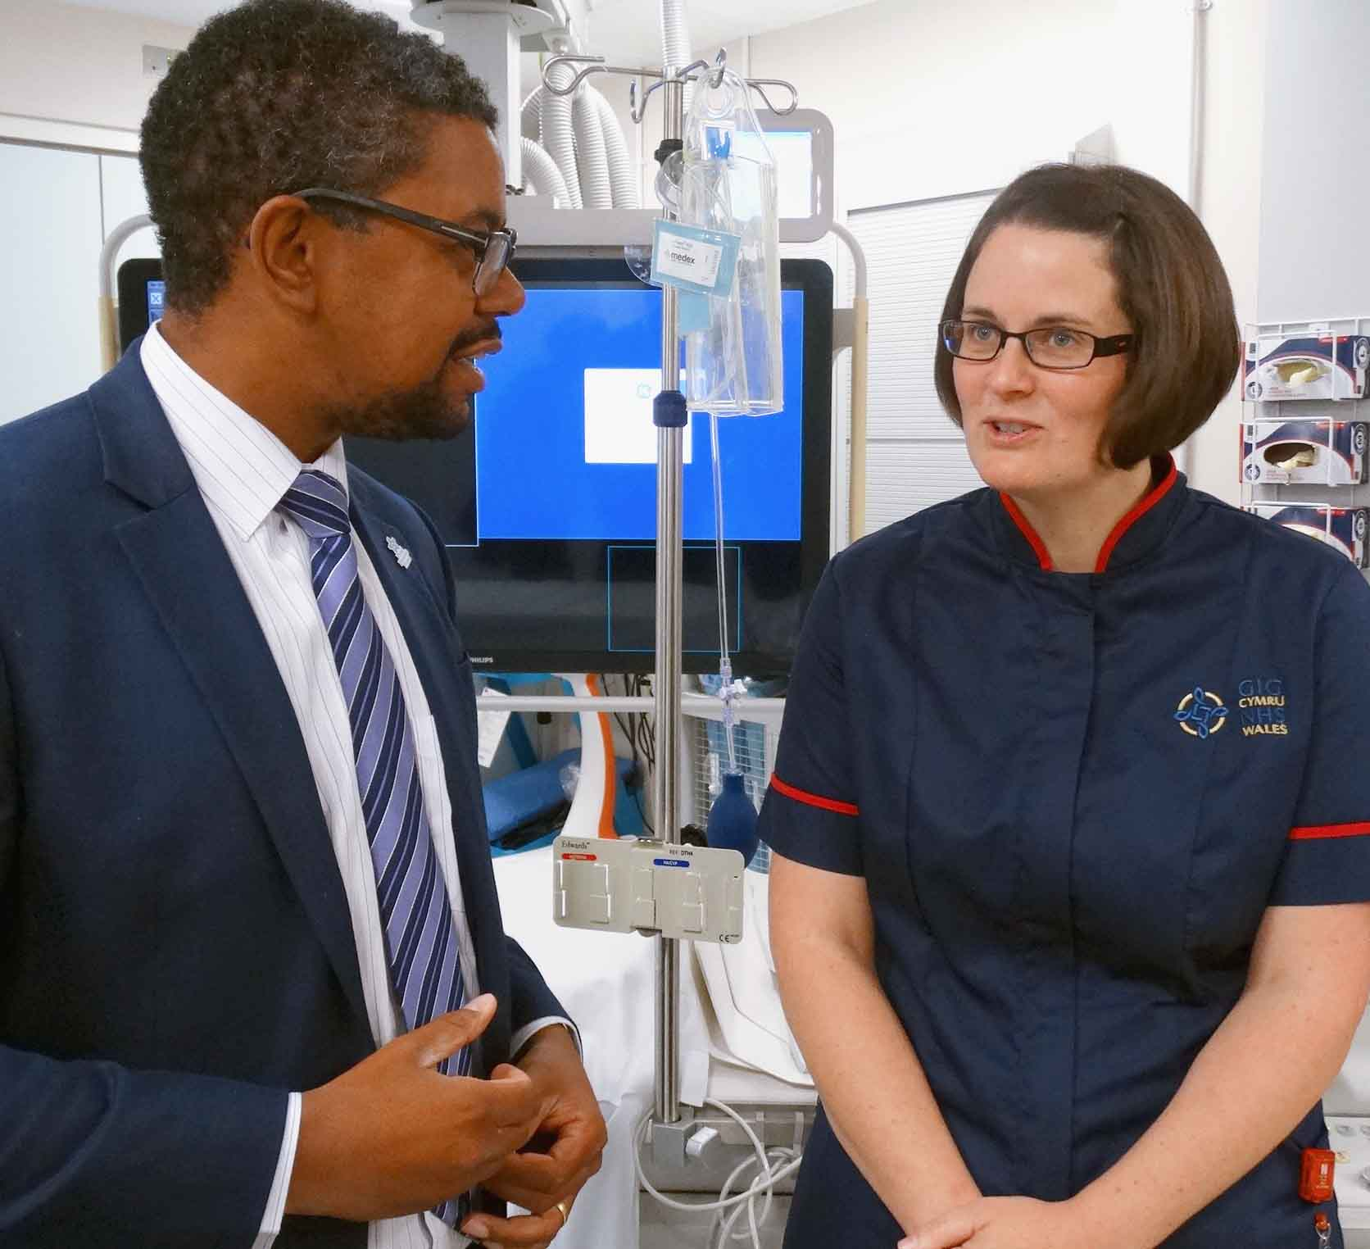
Last November the Welsh Government announced investment of more than £10 million to allow seven hospitals with cardiac catheter laboratories across South Wales to replace key equipment.

Left: Health Secretary Vaughan Gething with Princess of Wales Hospital cardiac matron Catherine Theron

Cardiac catheter labs are where key procedures such as coronary angiography and pacemaker and defibrillator implants are carried out – usually under local anaesthetic.

Princess of Wales Hospital was allocated £1.66 million and Morriston Hospital, which also deals with emergency cases such as heart attacks as well as a range of other specialist procedures, received £2.43 million.

POWH’s cardiology clinical lead, consultant cardiologist Martyn Richards, said the investment had paid for a complete refit, including a new X-ray camera, a large imaging screen and other equipment and software.

Mr Richards said: “The most common procedure we carry out here is coronary angiography.

“This is looking at the arteries that supply the heart with blood, sometimes augmented by measurements of the pressure and oxygen saturations within the heart chambers.

“We also implant cardiac devices, including standard pacemakers to treat slow heart rates, and small devices to monitor the heart rhythm.

“We also implant more complex devices such as biventricular pacemakers which help the heart beat more efficiently, and defibrillators, which can treat life-threatening fast heart rhythms.

“Occasionally we also carry out tests to evaluate the heart’s electrical properties.”

POWH cardiac matron Catherine Theron added: “The catheter lab is part of a bigger facility which starts with the cardiology day unit that pre-assesses patients before they come in.

“That’s where they arrive and recover.

“We do about 1,000 angiograms a year. We fit about 150 pacemakers, and about 20 complex pacemakers and defibrillators so the improvements here benefit a great many patients.”

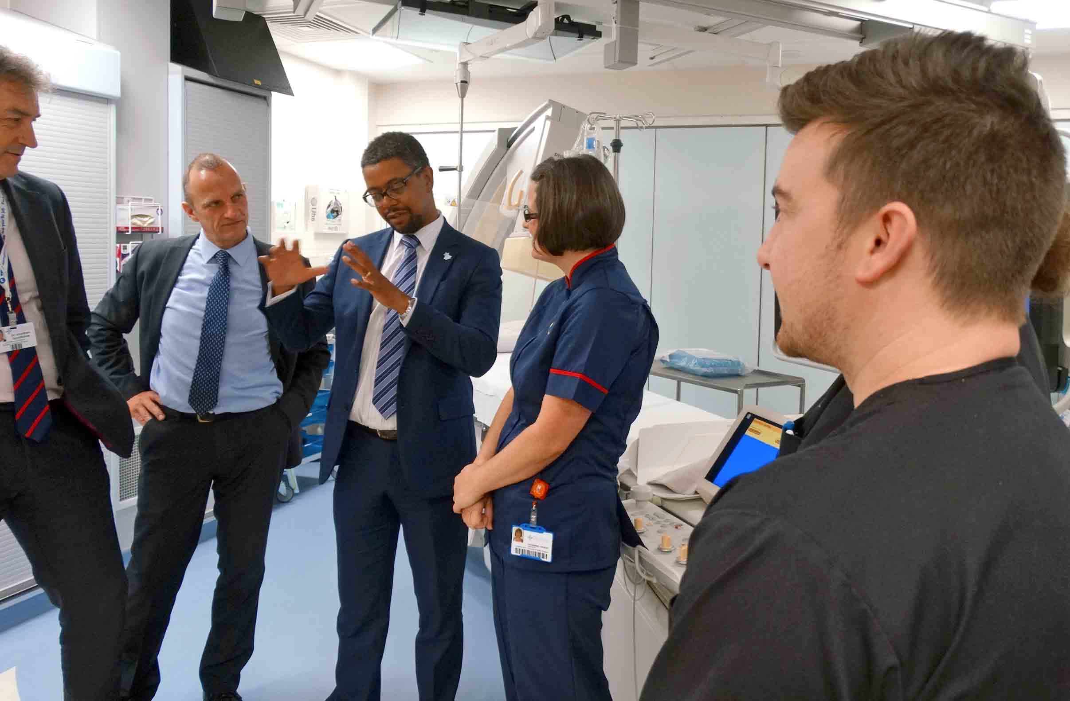
Pictured right: Vaughan Gething with (l-r) POWH Medical Director Jonathan Goodfellow, cardiology clinical lead Martyn Richards, cardiac matron Catherine Theron and specialist cardiac physiologist Dai Williams

The POWH facility is not just for Bridgend patients as it also carries out routine diagnostic procedures on people from Swansea and further west.

This frees up the Morriston catheter labs to provide an emergency cardiac service for patients from a wide area, including Bridgend.

Mr Gething visited the POWH lab to see the improvements made as a result of the investment – and to meet the staff. “Because it’s not just about the equipment,” he said.

“What is really important to understand is that it’s a whole team effort – not just consultants, not just nurses but a range of staff making it work.”

Source: Abertawe Bro Morgannwg University Health Board

