Teenager goes coast to coast to help young eye patients
Thursday, 7 September 2017
When it comes to fundraising for the medical team who have treated him since he was a baby, teenager Steffan Williams has certainly proved he is up for a challenge.

He saddled up and spent five days cycling 650km from Llandudno down the west coast of Wales and on to Singleton Hospital in Swansea, raising more than £2,000 on the way.
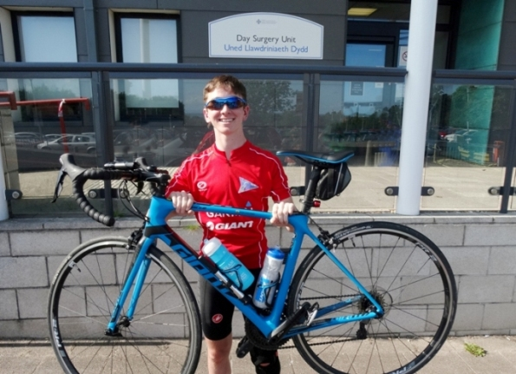
Sixteen-year-old Steffan, from Pontarddulais, said the solo bike ride was not only a great way to say thanks for the care he’s received but also the perfect distraction as he waited for his GCSE results.

A delighted Steffan Williams arrives at Singleton Hospital after completing his mammoth solo bike ride.

Born with a cataract, Steffan had his first eye operation at just two weeks olds and since then he has been seen regularly at consultant ophthalmologist David Laws’ clinics.

He said: “I have been a patient of Mr Laws for the majority of my life. I am very grateful for everything he and the department have done for me over the years.

“Initially I thought I would walk around Wales to raise money but that would take too long so I decided to cycle it instead.”

Steffan headed off from his grandparents’ home in Llandudno and followed a route which took him through Gwynedd and Ceredigion before heading into Pembrokeshire.

Although he cycled on his own, Steffan’s mum and dad Danny and Rhian were able to follow his progress, thanks to Steffan’s sat nav. They met him for meal breaks and at the end of each day’s journey after he had clocked up around 130km or 80 miles.

Mum Rhian said: “It has been nerve-racking – particularly when the weather was bad - and we are glad it is all over now but we are very proud of Steffan and how much he has managed to raise.”

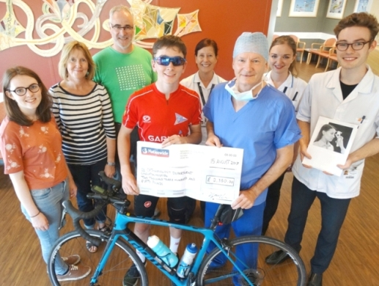
One of the toughest days was his penultimate stretch from St Davids in Pembrokeshire to St Clears when heavy rain saw Steffan forced to make a detour inland along the busy Llanddowror bypass instead of the flooded coastal route.

Steffan is pictured with (from left) Lydia Howard, mum and dad Rhian and Danny, deputy head orthoptist Suzanne Martin, consultant ophthalmologist David Laws and orthoptists Phoebe Tilley and Rhys Dumont Jones.

“That bit wasn’t nice as the weather was awful but apart from falling off on my first day and getting a bit lost now and then, I didn’t have too many problems,” said Steffan who only took up cycling six months ago.

Appropriately enough Steffan completed his ride by cycling to Singleton Hospital’s Day Surgery Unit where he was reunited with his parents and girlfriend Lydia Howard and also had the chance to give the proceeds of the ride to Mr Laws.

Ysgol y Strade pupil Steffan handed over a bumper cheque for £2,350 but since he’s completed the ride his final total has been pushed up to £2,400.

The money will go towards buying equipment to help make diagnosis and treatment of young eye patients easier.

Mr Laws and his team are planning to use it for an Icare Tonometer which measures pressure in eyeballs without using uncomfortable eye drops. The high-tech device can provide results if child is lying down or being held in a parent’s arms.

Mr Laws said: “We already have one tonometer and we didn’t realise how much we needed this device until we actually had one.

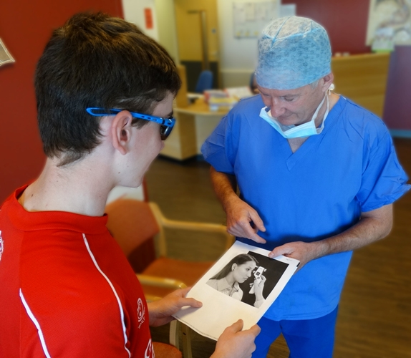
Consultant ophthalmologist David Laws tells Steffan more about the tonometer which his donation will be used to buy.

“This completely changes our practice. Without this tonometer we need to put drops in the eye to measure the pressure. These drops sting and upset the children so much that in some cases they need a general anaesthetic to get a reading.

“This tonometer means less children will go on to be admitted for this investigation.

“We are very grateful to Steffan, this is a tremendous effort and the money really will make a difference to young patients.”

Now Steffan has received his exam results – 9A*s, 3As and the Welsh Baccalaureate – he is a step closer to his aim of becoming a doctor, a career choice he says was inspired his experiences as a patient at Singleton.

“Because I have had to come to hospital so often over the years I’ve had a chance to see the difference doctors can make,” he added.

Source: Abertawe Bro Morgannwg University Health Board

