Take a look inside as Maes-y-Gwernen Hall opens its doors
Thursday, 14 September 2017
There will be a final chance to see inside Morriston Hospital’s Maes-y-Gwernen Hall when it opens up its doors to the public.

The building has had a variety of uses since it was acquired in 1944 - it has hosted clinics, training and most recently been used by clerical staff and for storage.

Although the hall is a much-loved part of the Morriston site, it is too costly to bring up to current building regulations and make fit for modern healthcare purposes.

As it is not a listed building it was approved for demolition by Swansea Council in 2014 and is scheduled to come down early next month as part of ongoing improvements at Morriston to remove out-of-date facilities and replace them with modern state-of-the-art buildings.

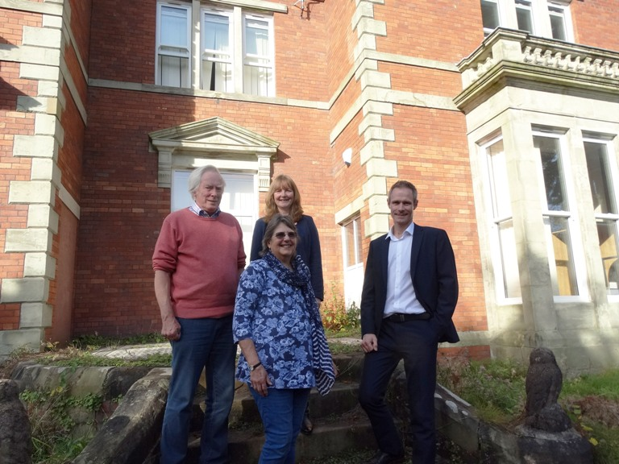
Heritage Group lead Martin Thomas (far right) with David and Sue Thomas whose ancestors lived at the hall and ABMU’s property manager Fiona Edwards

It is currently empty and ABMU’s Heritage Group wants to give staff and members of the public an opportunity to look around before contractors begin work.

The building will be open from 9.30am to 4pm on Monday, 25th September and from noon to 4pm on Tuesday, 26th September.

The Heritage Group’s Martin Thomas and Rebecca Kelly will be on hand to offer tours and answer questions about the building (left) which was originally a farmhouse before being bought by tinplate tycoon and Swansea MP William Williams in 1885.

He extended and transformed it into a gentleman’s residence with sweeping views down the valley towards his tinplate works. It remained in the Williams family’s possession until it was acquired by the hospital through compulsory purchase.

The Heritage Group, which is dedicated to documenting and celebrating the history of healthcare across all of our sites, has been collecting photographs and documents about the hall’s heyday, some of which will be on shown on the open days.

Martin Thomas said: “The health board has explored every avenue to see if would be possible to save Maes-y-Gwernen Hall.

“Unfortunately in today’s financial climate the costs of not only renovating but also the ongoing maintenance that it would require would just be too great.

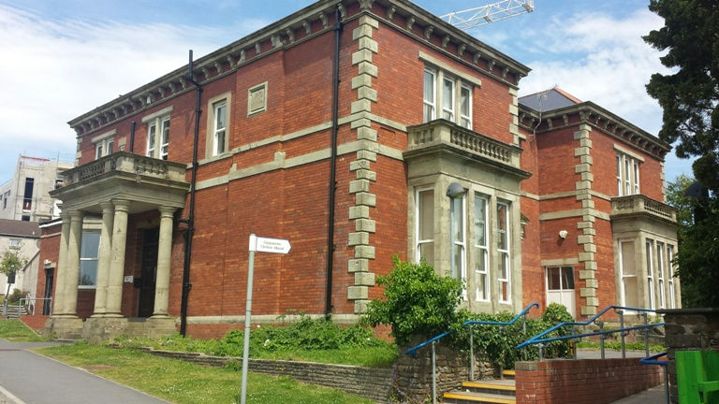
“However, we are committed to preserving the hall’s memory and the contribution it has made to Morriston over the years.”

For example, he said, a distinctive stained glass from a window above the hall’s main staircase (right) will be expertly removed and stored, ready to be included as part of a new building on the hospital site in the future.

Other items set to be recovered include a brass servants’ call bell, ornate beehive design door knobs and a safe dating back to around 1914.

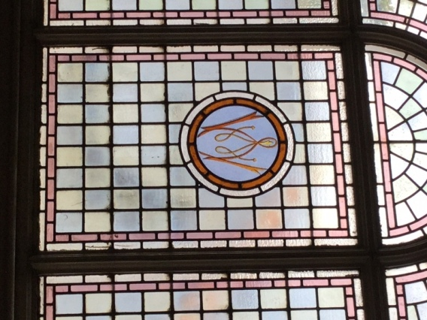
Martin explained that AMBU has been working closely with the Royal Commission on the Ancient & Historical Monuments of Wales to ensure that as much of the hall’s history as possible was preserved and recorded.

The heritage group has also liaised with descendants of the Williams family, local interest groups such as Morriston History Group and the Montana Park History Group and Swansea East AM Mike Hedges as well as members of the public.

Stained glass from the inner entrance doors of the
hall will also be preserved

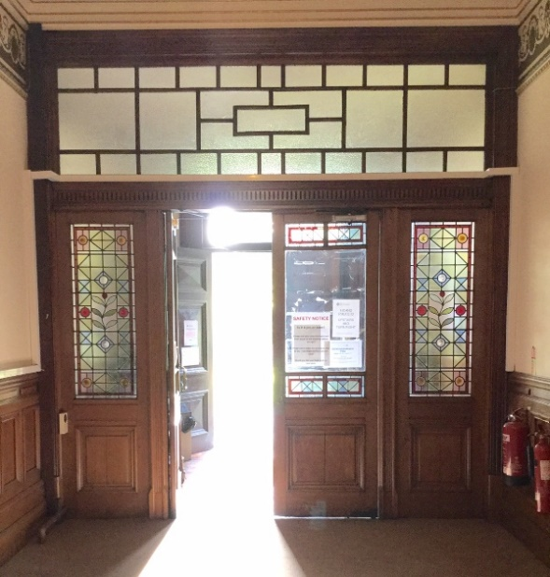
Before the bulldozers move in, Martin has also arranged for 360 degree photography of the building which will be used to create a virtual tour of the hall.

Anyone interested in the history of the hall is welcome to attend a public talk about the Williams family being given by Morriston History Group at 2pm on Tuesday, 19th September. The event, at Morriston Library, will feature pictures from ABMU’s collection.

Source: Abertawe Bro Morgannwg University Health Board

