State-of-the-art new service launches at Singleton Hospital
Tuesday, 12 September 2017
A state-of-the-art new service has been launched at Singleton Hospital to diagnose and treat pleural diseases and cancers such as lung cancer.

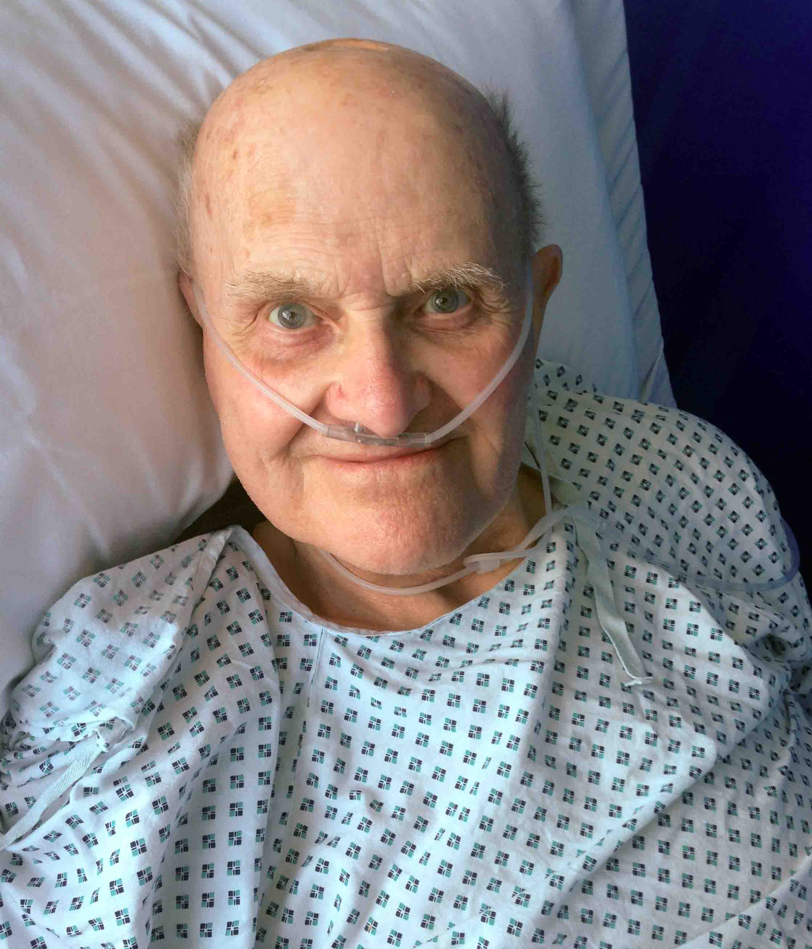
It will significantly reduce diagnostic waiting times for patients.

And as it is far less invasive than the previously-available surgical procedure at Morriston, it means a much shorter stay in hospital.

Pictured is John Voaden from Swansea: the first patient to benefit from the new service

The new medical thoracoscopy service at Singleton has been introduced by consultant chest physicians Narendra Babu Chinnappa and Rhian Finn.

It follows on from the highly successful outpatient pleural service at Singleton Hospital, which Dr Chinnappa started two years ago.

This is known as the Ambulatory Pleural Procedure Service (APPS).

One of its main aims is to help avoid unnecessary hospital admissions, especially for cancer patients suffering with pleural effusions (a build-up of fluid next to the lungs).

However some patients still need to come into hospital for diagnosis and treatment of pleural diseases including lung cancer.

For them, the medical thoracoscopy service will lead to a significant reduction in waiting times and fewer days spent in hospital. It will also free up thoracic surgeons to do other work.

Patients with pleural effusions needing further diagnosis previously had surgical thoracoscopy by Morriston Hospital thoracic surgeons.

This procedure, known as VATS (Video Assisted Thoracoscopic Surgery), uses an endoscope under general anaesthesia.

But, Dr Chinnappa said, the waiting time for this could be around four to six weeks.

“As surgical thoracoscopy requires patients to have a general anaesthetic, they would need a surgical bed at Morriston Hospital for a few days before and after the procedure.

“However medical thoracoscopy is minimally invasive. It uses a keyhole incision and is done as a short stay procedure under local anaesthesia.

“The patient only requires a hospital bed for 24-48 hours after it has been carried out. With experience, day case procedures may be possible without any hospital admission for suitable patients.

“The waiting time is also shorter – usually one to two weeks.

“So medical thoracoscopy results in faster diagnosis and prevents unnecessary prolonged admission.

“This is better for the patient as surgical intervention is not required, and it reduces the cost to the hospital.

“It also reduces the burden on thoracic surgeons who can concentrate more on therapeutic lung surgery for cancer patients.”
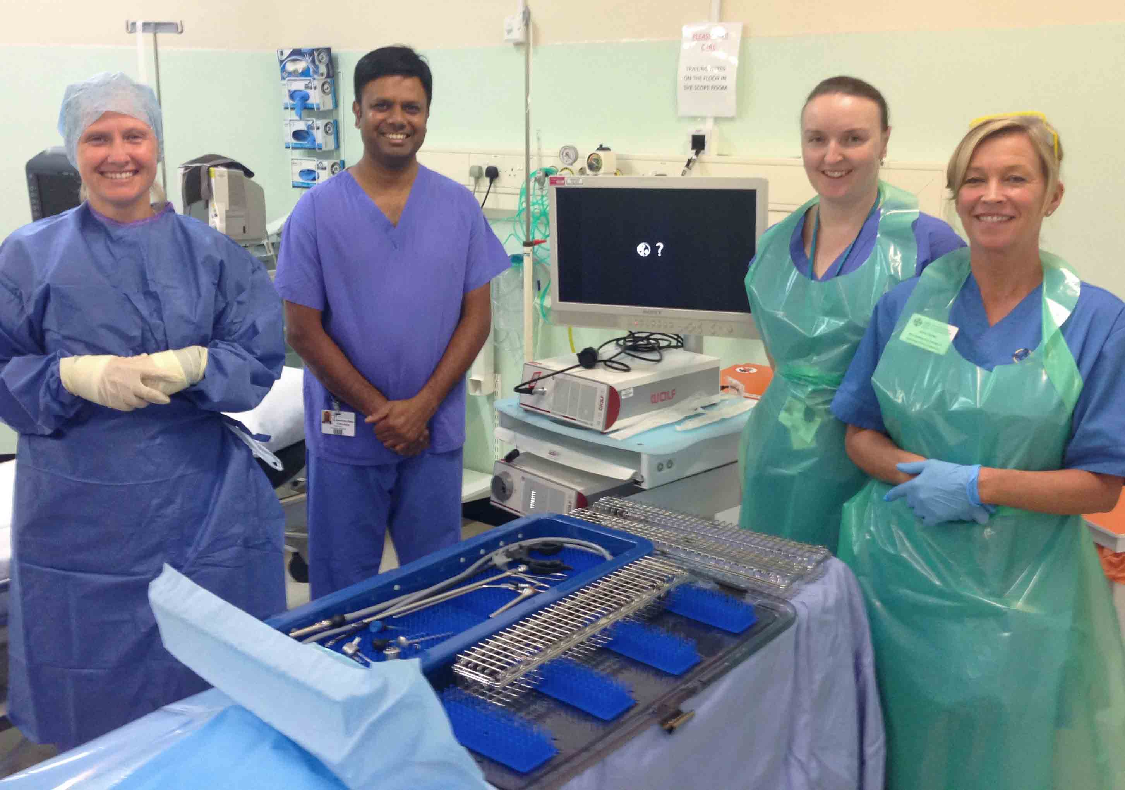
Meet the team (l-r): Endoscopy staff nurse Rhian Wheatley, consultant chest physicians Narendra Chinnappa and Rhian Finn, and endoscopy staff nurse Anna Davies

Dr Chinnappa and Dr Finn will carry out the procedure every week for patients from the Swansea and Neath Port Talbot areas.

The first patient to undergo a medical thoracoscopy at Singleton Hospital was 84-year-old John Voaden from the Mount Pleasant area of Swansea.

Mr Voaden said: “I am glad I did not need to have the surgical procedure at Morriston.

“I’m also glad to be first patient so that it gives confidence to the clinicians who can offer this to others like me from now on.”

Medical thoracoscopy is also used for therapeutic pleurodesis. This is a treatment to prevent re-accumulation of fluid around the lung, the main cause of symptoms in patients with advanced lung and other cancers.

Dr Chinnappa thanked everyone who had supported the new service, including the endoscopy team; Ward 8; Singleton's main theatres and Hospital Sterilization and Disinfection Unit; and staff at Glangwili Hospital, Carmarthen, who provided training.

Dr Chinnappa said: “The service is a further expansion of already well-established successful outpatient pleural service at Singleton, which has been well received and appreciated by many patients.”

Source: Abertawe Bro Morgannwg University Health Board

