ABMU Support Worker shortlisted for national #OurHealthHeroes award
Monday, 29 October 2018
Her boundless energy and enthusiasm have seen her crowned a Welsh health hero.
Now the public are being urged to vote for Lindsey Gill to help her win the overall UK title too.

Health care support worker Lindsey, who spends time at both Neath Port Talbot and Singleton hospitals, won the Our Health Heroes Regional Clinical Support Worker Award for Wales.

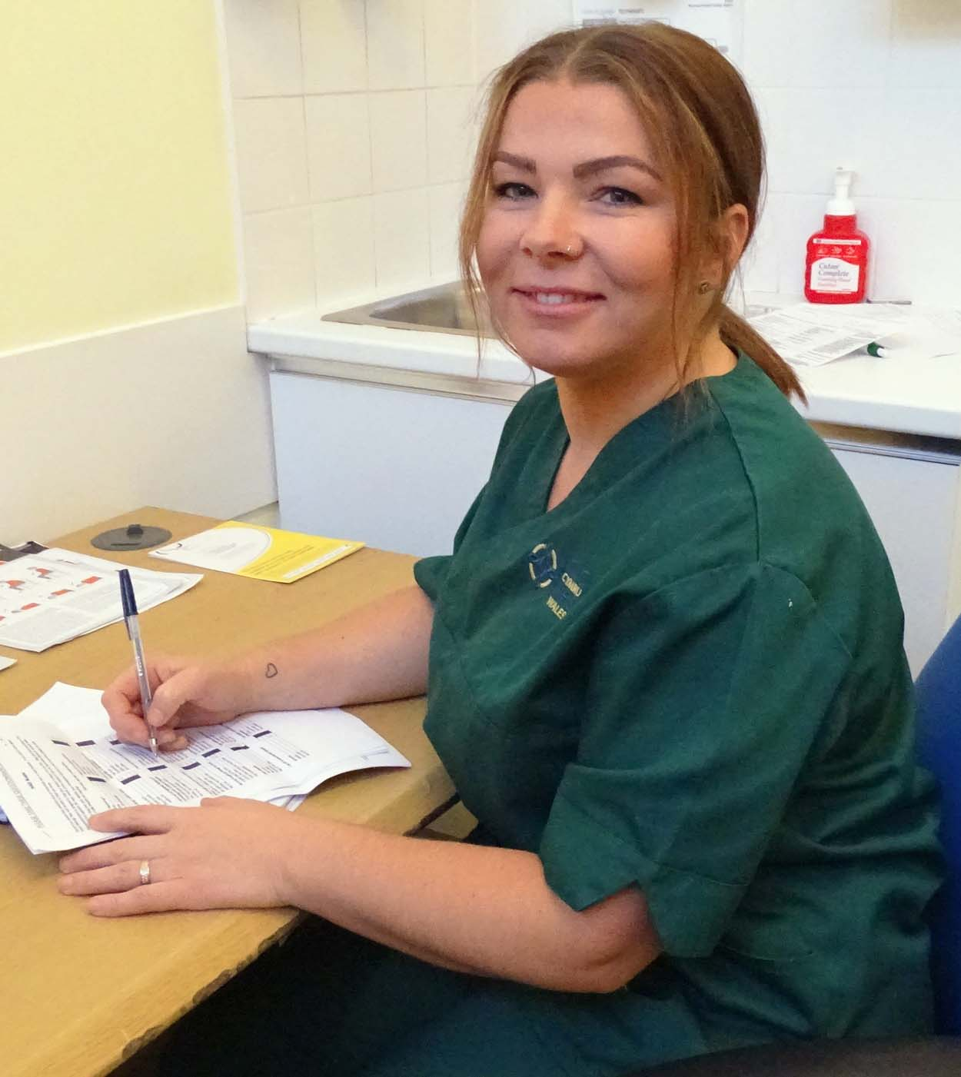
The awards are run by not-for-profit workforce development body Skills for Health.

They showcase the work done by the huge numbers of healthcare workers who are not doctors and nurses, but whose work is still vital to patients.

The 36-year-old is in the running for the national Clinical Support Worker trophy thanks to the dedication she has shown in her role across hospitals within the ABMU area.

Lindsey has worked in health care since she left school and was a nurse for twenty years before her current role.

Lindsey said: “I’m feeling so overwhelmed that my colleagues thought I was worthy enough to be nominated – I couldn’t believe it when I read the email.

“I absolutely love everything about my job, from my colleagues who are more like my friends, and getting to know the patients in and day out.”

Chronic Pain Lead Christian Egeler said Lindsey had worked with boundless energy and enthusiasm since the launch of the ABMU specialist pain service.

“She has been part of all aspects of the service from clinics to self-management approaches, injections and pain management programme.

“She works closely with pain physicians during intervention clinics and keeps everyone happy with her cheerful attitude and outstanding work ethics.

“She has also taken on extended roles with telephone follow ups, and is a vital link for patients contacting the service.”

If Lindsey can scoop the UK title it would be the second time it has gone to a member of NPTH staff.

Paediatric physiotherapy technical instructor John Clifford won the 2017 award and so impressed the organisers that they chose NPTH to launch the 2018 awards.

The winners will receive their awards at a glittering ceremony at the OXO Tower in London next month.

Lindsey added: “Having this recognition is just amazing and I want to say a big thank you to everyone for their support.”

To vote for Lindsey go to http://www.skillsforhealth.org.uk/ohh-2018/clinical-support-worker
Voting closes on November 8

Source: Abertawe Bro Morgannwg University Health Board

