Young patients go in front of the camera to help other children
Tuesday, 3 October 2017
When it comes to picking up new skills nothing beats watching someone else having a go. That’s why a new video aimed at helping young respiratory patients should be a big hit – because it features some of them in a starring role.

The short film has been produced by the paediatric respiratory team at Morriston Hospital who wanted to come up with a way of teaching children being treated for asthma and wheezy episodes the correct way of using their inhalers.

It shows three patients – five-year-old twins Bethan and Steffan and 18-month-old Elijah along with their mums – being given a demonstration in using inhalers, peak flow meters and volumatic spacers by paediatric respiratory nurse Joy Williams.

Respiratory nurse specialist Joy Williams explains how to use a volumatic spacer to Bethan and her mum in the video.

This equipment is vital in helping patients – whatever their age – to manage their condition by getting the correct amount of medicine into the lungs where it can work to reduce symptoms.

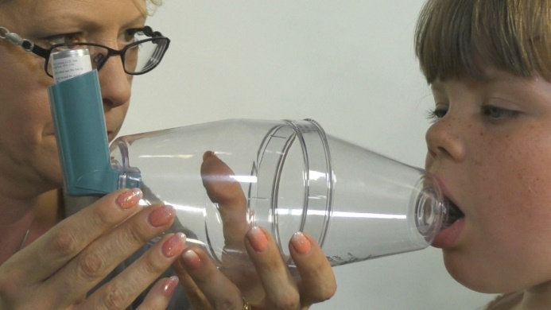
The video was made by Joy and consultant paediatrician Dr Pramodh Vallabhaneni with expert input from consultant paediatrician Dr Rachel Evans, who is respiratory lead for Morriston paediatrics.

The aim of film is to reinforce exactly how and when children should be using the inhalers.

Joy explained this should mean children becoming more confident about taking their medication, resulting in improved outcomes as they will feel better more quickly without getting as distressed.

A survey for charity Asthma UK revealed that up to a third of people with asthma do not use their inhaler the right way.

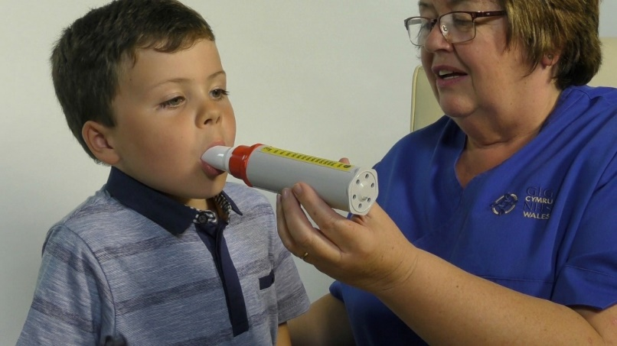
“If they don’t use them correctly patients aren’t going to get the full dose of their medicine in their airways where they need it,” said Joy.

Steffan tries the peak flow meter under the guidance of Joy Williams.

“We wanted to show young children using them because that is just the age group the film is aimed at and the three of them were absolute stars, they really enjoyed their moment in the spotlight.

“The video shows how to use inhalers and volumatic spacers properly but it wasn’t too serious and we were able to shoot it all in an afternoon – they were hilarious.”

Joy said children like the ones in the video who suffer with respiratory conditions often need to attend specialist clinics regularly for help managing their treatment.

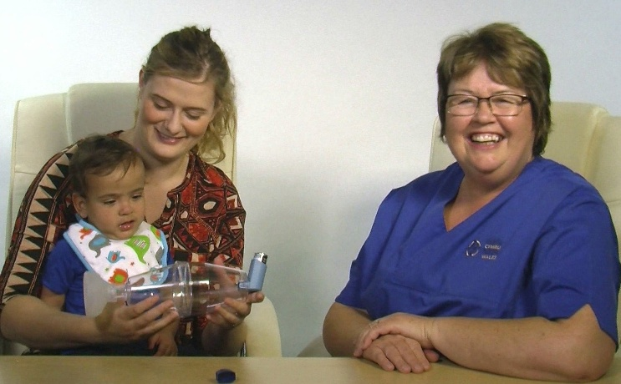
The video will help act as a reminder to young patients and their parents in between their clinic appointments, she said.

Elijah and his mum with Joy Williams in a scene from the video.

Dr Vallabhaneni added: “Our sincere thanks go to Belinda Colton, of ABMU’s medical Illustration department, who produced such a fantastic video and to the parents and children who volunteered to take part.

“Hopefully this video will be a real benefit to other families and without their help we couldn’t have done this.”

ABMU’s head of nursing for women and child health Eirlys Thomas (right) said: “We always try to do as much as we can to engage with our young patients so we can reassure them and make any treatment they need a little less daunting or frightening.

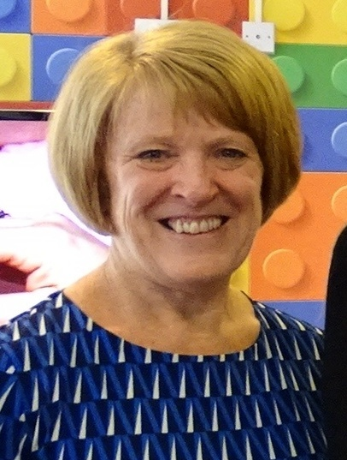
“This video is a great example of that and hopefully will be a handy guide families can access whenever they need it.

“I am delighted and very grateful the families involved were so eager to get involved with this project.”

She added that as part of an ongoing drive to improve services for children the health board now has its own advisory panel, ABMyouth, made up of young people aged from 13 to 22 who share their views about health services and how they can be improved.

ABMU also became the first health board in the UK to launch its own Children’s Rights Charter last year.

https://www.youtube.com/watch?v=LzbNfogoq-w

Source: Abertawe Bro Morgannwg University Health Board

