Welsh healthcare support worker of year now in running for national award
Wednesday, 18 October 2017
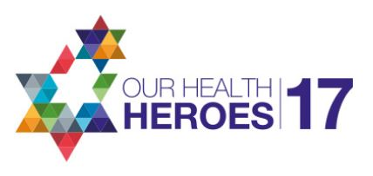
An ABMU healthcare support worker who swapped coal mining for caring for children has been named the best in Wales.

Paediatric physiotherapy technician John Clifford, who works at Neath Port Talbot Hospital Children’s Centre, has just won the Clinical Support Worker of the Year title for Wales in the Our Health Heroes Awards.

After impressing the judges with his hard work and dedication to children with disabilities, John is now in the running to pick up the overall national award.

Clinical lead paediatric physiotherapist Rebecca Kennedy said: “We are so proud of John’s success but not at all surprised.

“He is 100 per cent reliable and the first person you call on in a crisis. He is calm and innovative in his problem-solving approach. John is hugely valued by his colleagues and the best team worker I have ever known.”

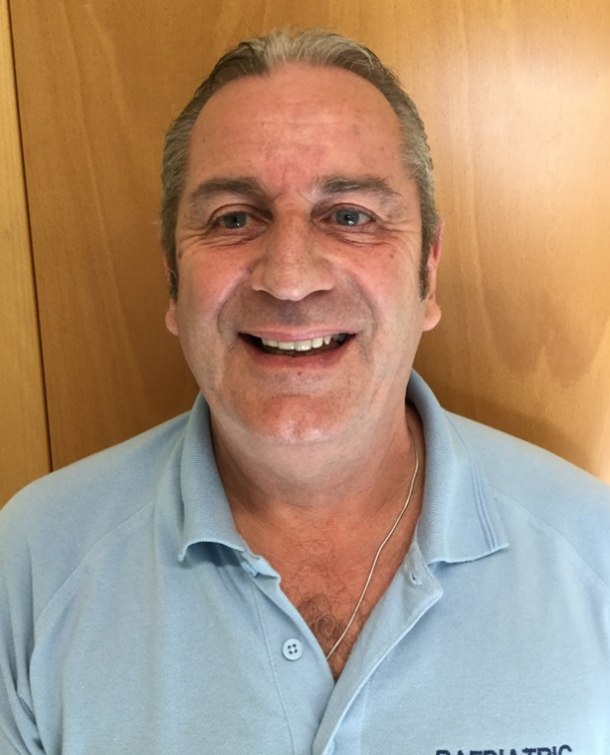
John, who is from Neath, has been working for the health board since 1994 when the closure of coal mines sparked a change of career.

He decided to pursue his interest in working with children with disabilities and underwent training in developmental care, mobility and movement.

Among the many different projects he is involved with, including qualifying as a lifeguard for hydrotherapy sessions, training school staff and accompanying skiing trips, John (left) runs bike skills groups for children with disabilities

Rebecca added: “These children are often terrified at the start but John wins their trust, runs around holding the back of their bike for hours and achieves the most amazing outcomes.”

A delighted John said: “I am very honoured to have been nominated for this award. I really enjoy my job and I am very lucky to be working in such a fantastic team, this makes my job easy. We support each other every day, in and out of work.”

He added: “I think everyone in the Children’s Centre should be getting this award, they are all Health Heroes.”

John is one of 12 regional winners who have now gone forward to a public vote via the Skills for Health website. The overall winner, to be announced at an awards ceremony on 21st November, will be the one who tops the poll.

Rebecca is now urging John’s colleagues, patients and their families to show their support for him.

“As a team we are extremely lucky to have John onboard and would love the opportunity to tell people outside of our hospital how great he really is. It would be amazing if we could rally some support for such a deserving person,” she said.

The public vote for national winner of Clinical Support Worker of the Year will be open until Monday, 6th November. To vote for John go to http://www.skillsforhealth.org.uk/ohh-2017

Source: Abertawe Bro Morgannwg University Health Board

