Welsh award a career highlight for long-serving cardiac physiologist Jennifer
Tuesday, 31 October 2017
A long-serving member of Princess of Wales Hospital’s cardiology team has paid tribute to her colleagues after winning an all-Wales award.

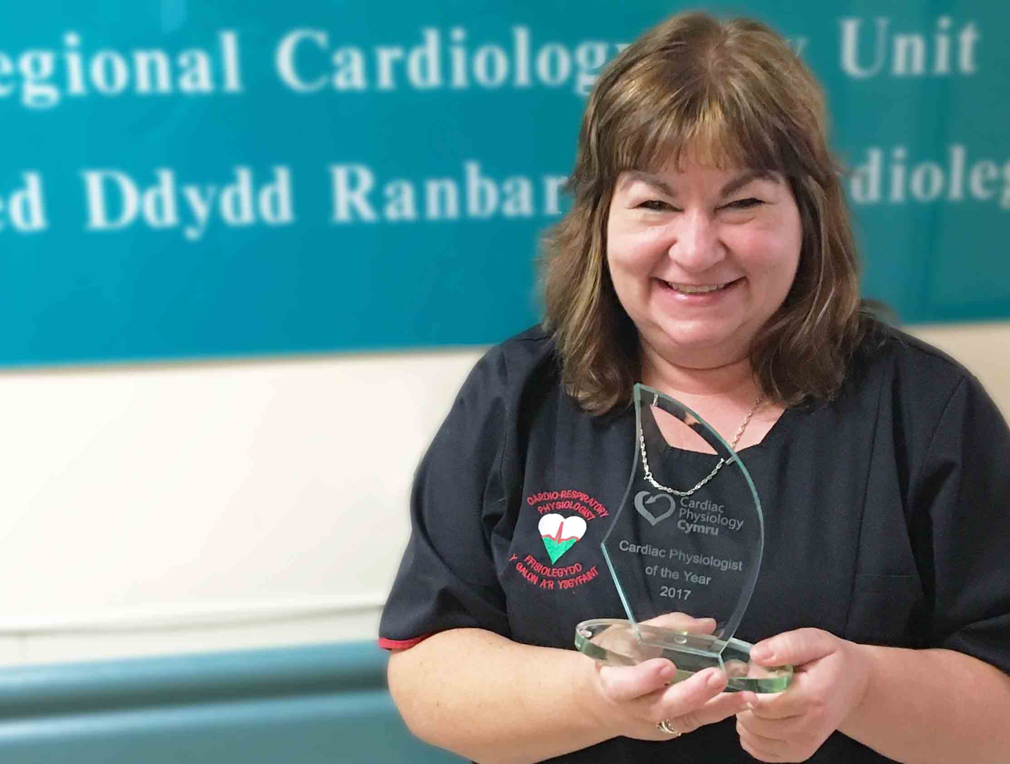
Jennifer Torkington has worked as a cardiac physiologist for 34 years and has already received an ABMU long service award.

Now she has been presented with the Lynda McGurk Award for Welsh Cardiac Physiologist of the Year – which came completely out of the blue.

“I didn’t even know I’d been nominated,” said Jennifer, who received the award at the Cardiac Physiology Cymru annual conference, held this year in the Vale Resort, Hensol.

“I try to go to the conference every year and the first I knew about the award was when my name was read out as the winner.

“I was shocked but I was also extremely honoured that my colleagues felt I was worth nominating.”

Cardiac physiology involves the diagnosis and assessment of heart disease – though Jennifer’s role now extends beyond that.

She started her career in 1983 in the University Hospital of Wales, moving to Princess of Wales Hospital in 1990.

When she started in the Bridgend hospital there were four cardiology members of staff and no echocardiogram machines, pacemaker service or cardiac catheterization investigations.

“I am delighted to say we now have 20 members of staff and six echocardiogram machines and other services – so we have come a long way in my 34 years of service.”

POWH specialist cardiac physiologist Dai Williams, who proposed Jennifer for the award, said she was integral to the cardiorespiratory department, and to cardiology services at the hospital.

Mr Williams said: “While Jen’s time is solely based in echocardiography, she takes a keen interest in all aspects of cardiac physiology, ensuring high standards are set.

“She promotes a good work ethic and strives to ensure staff morale is high. She is well respected by all disciplines throughout the hospital.”

In 2012, Jennifer and colleague Hugh Pascoe set up a physiologist-led valve clinic so patients did not have to be seen in a general cardiology clinic.

More recently they also set up a solely physiology-led stress echocardiography service – the only one of its kind in South Wales.

Both initiatives improved patient care and reduced waiting times.

Jennifer said she wanted to express her appreciation for the support she had received from everyone in the department.

“I could not have been the cardiac physiologist I am today without my colleagues.

“We all support each other through everything, work-related or personal, and in doing so we have created an amazing department.

“It’s an absolute honour and probably the highlight of my career receiving this award.

“I feel it is not only a reflection on my career but on the department and how far we have come.”

Source: Abertawe Bro Morgannwg University Health Board

