Pupils get hands-on lesson in healthcare at hospital
Thursday, 19 October 2017
When it comes to seeing a doctor, one group of primary pupils will have nothing to fear after being given hands-on experiences of medical procedures.

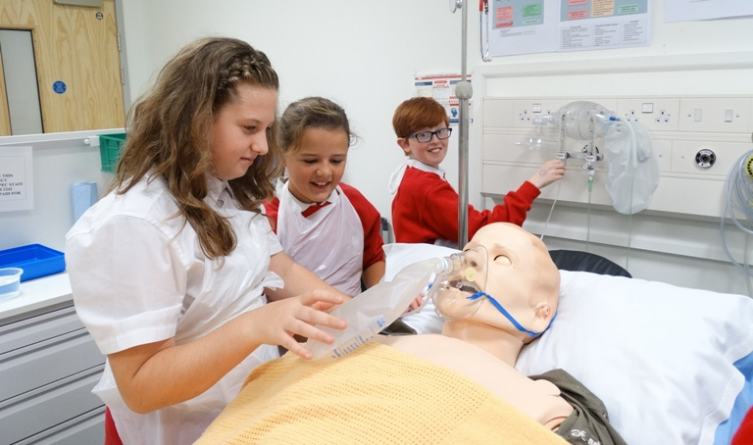
The Year 6 children were special guests at Princess of Wales Hospital’s education centre where they had a go at everything from injections to CPR, pulses to putting on plaster casts.

Some of the youngsters try their hand at procedures in the hospital’s simulation suite.

Under the guidance of fifth year medical students, the pupils from St David’s Church in Wales Primary in Colwinston had the chance to find out more about how the body works and what can be done to treat it in interactive sessions using medical teaching aids designed for training doctors.

Overseeing the visit to the hospital’s education centre were clinical teaching fellows Dr James Hotham and Dr Fran Teasdale.

They came up with a timetable which included a session in the simulation suite with clinical skills tutor Karl Thorne, a quiz on X-rays with Dr Adam Aboalkaz and learning how to put on plaster casts with clinical nurse specialist Lee Casey.

Dr Teasdale said: “This is the first time we have done something quite like this but there is an academic element.

“We’ve asked the children to fill in forms letting us know what they think about doctors and medical treatment before and after taking part in the sessions.

“We want to know how their impressions changed and this feedback will then be used for a poster presentation at surgical conference being held in Port Talbot later this month.”
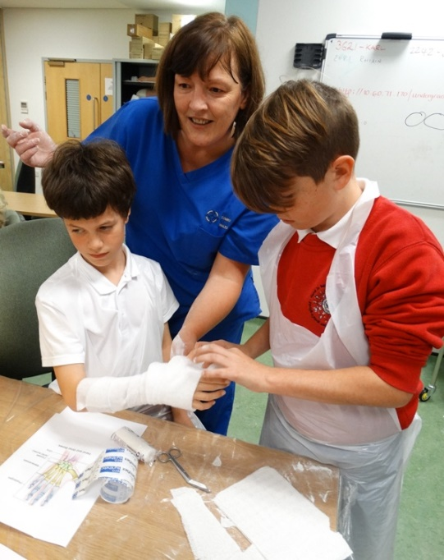
Clinical nurse specialist Lee Casey
passes on plaster cast skills.

One youngster who definitely enjoyed the trip was Grace Cole, aged 10. She said: “It has been very good, really interesting. My mum is a doctor and now I know a little bit more about what she has to do. I really enjoyed taking blood and given injections.”

Teacher Louise Rosser said: “The topic we are working on this term is Bones, Blood and Gory Bits so we asked the hospital if we could visit.

“We were absolutely delighted when they agreed to let us come in but we never expected anything like this – we have been blown away by all they have done for the children, it has been a trip they definitely won’t forget.”
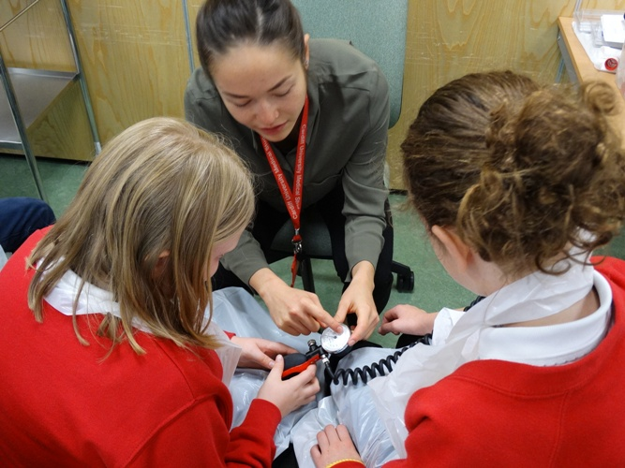
Dr Hotham added: “It has been a great experience for all of us. Our students got the chance to interact with children which is valuable for their training and we really enjoyed showing the pupils how we look after patients.

“They came up with some really good questions so hopefully we may have a few future doctors with us today.”

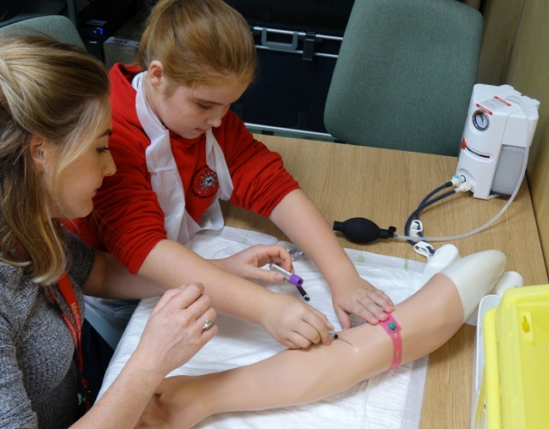
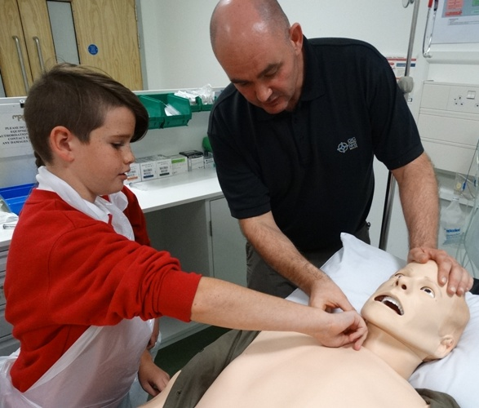
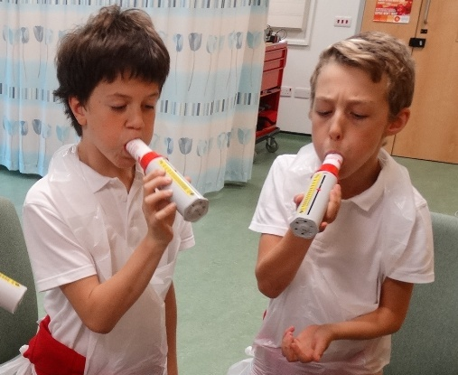

Source: Abertawe Bro Morgannwg University Health Board

