Play team’s space age adventure for young patients
Friday, 27 October 2017
Dedicated ABMU staff made sure celebrations to mark this year’s Play in Hospital Week really were out of this world.
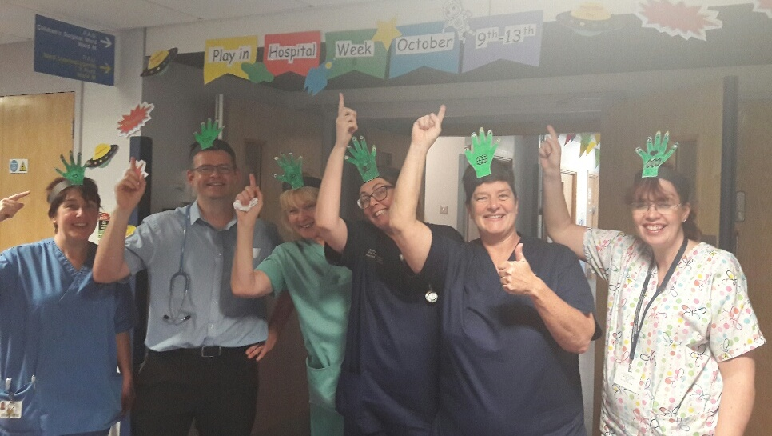
The annual event celebrates the importance of play during a child’s time in hospital and saw ABMU’s Play Team come up with an action-packed week of activities at Morriston and the Princess of Wales hospitals, all with a space age theme.

Children’s wards at Morriston and Princess of Wales hospitals were decorated with space age designs and featured an eye-catching display board all about the Planet Play.

The team’s efforts secured it third place in a national competition sponsored by Starlight, the charity which supports seriously ill children.

It is the third year in a row it has been placed in the keenly-contested competition, open to every UK children’s ward, and it has won a voucher for therapeutic toys for young patients.
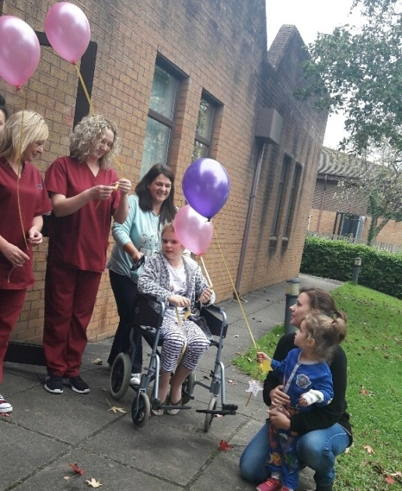
Play co-ordinator Lisa Morgan said: “We believe that the power of play is essential to a child’s hospital admission.

“We strive to deliver the highest quality of play practice and we encourage all children to shine like the stars they are.

“We’re so pleased to have been so successful in the competition again this year.”

During the week children were invited to join puppet friends as the playroom was transformed into a space station for a host of different activities.

Patients were invited to design their own rocket, create an own alien and name a memory star.

They also enjoyed visits from a storyteller and balloon modeller and had the chance to transform into astronauts for selfies. Their space journey ended with an out of orbit themed party.

Lisa added: “We will always continue to make it our mission to create the best atmosphere for all children and their families when they are admitted to hospital.”
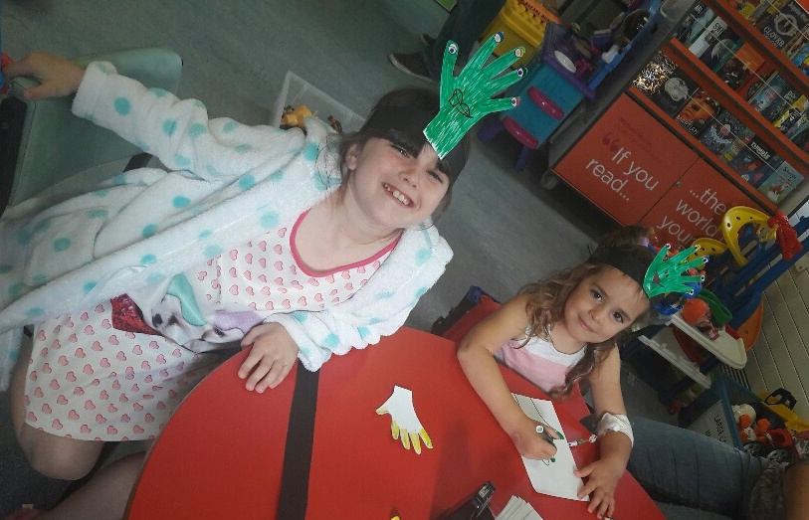
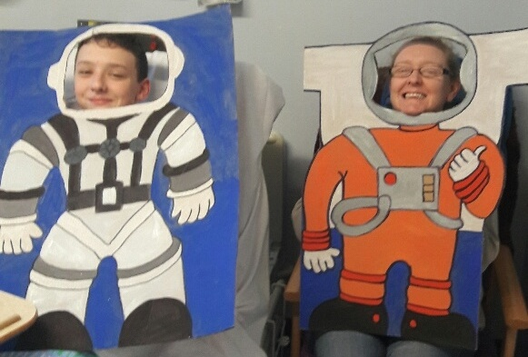

Source: Abertawe Bro Morgannwg University Health Board

