Pioneering conference sharing advice about life after secondary cancer diagnosis
Tuesday, 10 October 2017
Health professionals and cancer patients will be uniting in Swansea at a special conference to raise awareness of secondary breast cancer.

The event is being held on the same day as national Secondary Breast Cancer Awareness Day on Friday.
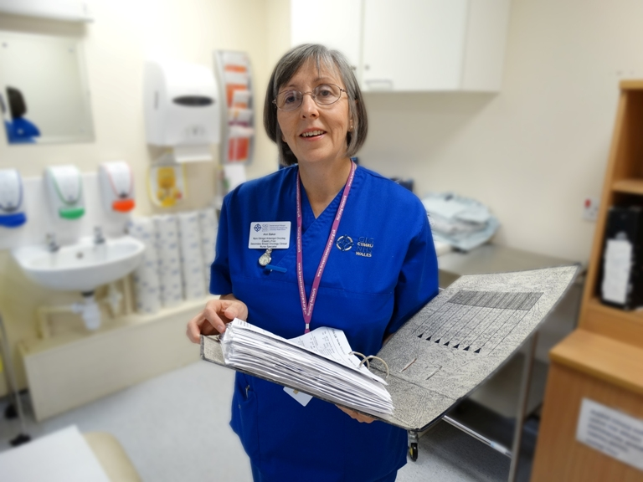
It is the first event of its kind to be held in Wales and features a packed agenda of expert speakers who will be sharing information about living with a secondary cancer diagnosis.

The conference, at the Village Hotel, has been organised by ABMU’s Ann Baker (right) who has been supporting women with primary breast cancer for 26 years in her role as breast care specialist nurse.

However, she has since changed duties to take up her current post as Wales’s first secondary breast oncology specialist nurse.

“The aim of the event is to increase awareness regarding secondary breast cancer, to educate and inform practice,” said Ann, who is based at the South West Wales Cancer Centre, Singleton Hospital.

It was while researching for a Masters degree and analysing the feelings of patients that Ann discovered the real need for support after a secondary diagnosis – support from other women in the same situation and from nursing and breast/oncology staff.

She went on to make a case for a dedicated nurse and secured funding from ABMU for the new post which she took up in March 2016

“It was definitely something that our patients needed. It didn’t have to be me but they needed someone in this role. Fortunately I was successful at interview.

“Women who have secondary breast cancer often feel they have let themselves or people down by being diagnosed, either at the time of their primary diagnosis or many years later. They can feel forgotten and isolated,” she added.

“This conference is a first for Wales and it is taking part on Friday because that is the national awareness day.

“Although October is Breast Cancer Awareness Month and we are familiar with seeing pink everywhere, women with secondary breast cancer just have this one day and we wanted to make sure we did something positive to mark it.”

More than 90 delegates have signed up to attend the conference and among the speakers will be patient Carolyn Gammon, of Cwmavon, who will be sharing her own story.

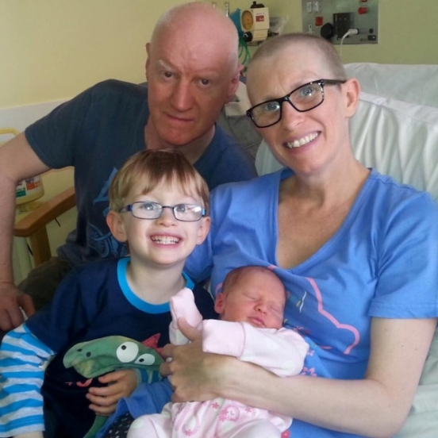
Carolyn was diagnosed with primary breast cancer when she was pregnant with her second child and gave birth to a healthy daughter after receiving chemotherapy during the pregnancy. However, a CT scan later revealed secondary cancer in her liver and lung which she is now receiving treatment for.

Carolyn Gammon with her partner Gos and their son Rudy just after baby Mira was born.

Carolyn said: “I'm so honoured to have been asked to speak at this conference. I feel it's important that the patient voice is heard so that clinicians can learn from both the positives and negatives of their experiences."

She is a member of Breast of Friends secondary breast cancer support group which meets on the first Tuesday of every month at Sketty Hall.

It was set up by Ann following the focus group research to promote awareness, to inform patients as well as giving them a chance to meet and discuss their experiences.

Ann says the group is going from strength to strength and she has received very positive feedback from members about how valuable it has been.

One patient said: “The group makes me feel normal, we can share or just listen, and there is no pressure” while another added: “I don’t know where I would be without this group”.

It is hoped Friday’s conference will give those attending a chance to share ideas – subjects on the agenda include body image, the physical and emotional impact of diagnosis and lymphoedema care.

Ann said: “We very much consider at our patients’ needs and their feedback when we are looking at how we can develop and improve the services we offer them in the future.”

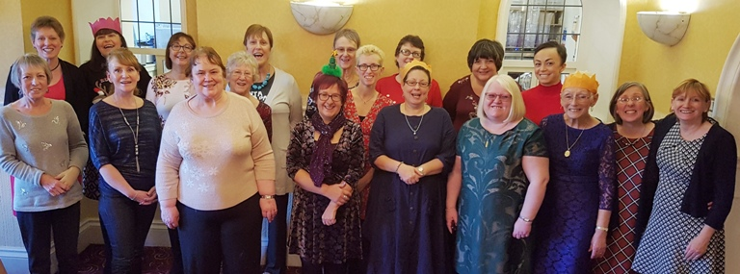
Ann Baker (second from right) with members of the Breast of Friends support group at last year’s Christmas celebration.

Conference speakers include AMBU specialists as well as experts from Maggie’s Centre, the University of Wales Trinity St David and Velindre Hospital.

They include Linda McCarthy, head of Breast Cancer Care Wales, who will be talking about the charity’s new report Secondary – Not Second Rate, which is being launched at a House of Commons reception on Wednesday. It sets out the changes needed to improve the care and support for the estimated 36,000 people living with incurable secondary breast cancer in the UK today.

Ann added: “We want to remind people although secondary cancer is not curable, it is treatable. This conference is about having a quality of life and living with secondary cancer – the message is life goes on.”

The conference is now fully subscribed and is not open to the public, however anyone who would like to find out more about secondary breast cancer or would be interested in joining the support group can contact Ann on 01792 285376 ext 35567 or email her on Ann.baker@wales.nhs.uk

Source: Abertawe Bro Morgannwg University Health Board

