Patients' families happy to share their experience of hospital care
Friday, 13 October 2017
More patients and families than ever have revealed just how happy they are with the care provided at ABMU hospitals.

Latest feedback has shown a satisfaction score of 96 per cent - the highest level recorded.

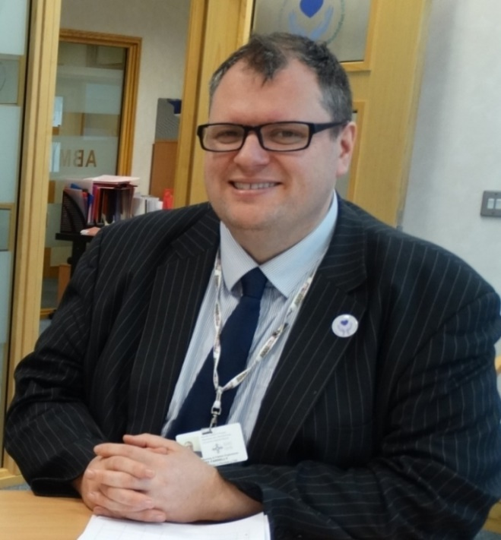
Since 2014 all sites have been using the Friends and Family Test, a patient feedback system which gives patients, their friends and family the opportunity to complete a survey telling us what has worked well and which areas need improving.

During September a total of 6,215 Friends and Family forms were competed with the health board recording an overall satisfaction score of 96 per cent.

ABMU’s Director of Nursing and Patient Experience Rory Farrelly (left) said: “This feedback provides the health board with insight into what matters most to patients, what we do well and how we can improve.

“We are listening to what people are saying and acting on recommended improvements. All of which are vital in helping to improve the quality of care provided across our hospitals.

“It’s an excellent satisfaction score, and we are continually looking at new ways of improving the service we provide.”

The health board has just hit another milestone with 1,518 surveys being completed in a week, the highest returns since the system started.

The weekly survey results are sent to managers and directors across the hospital sites with copies put on ward information boards for everybody to see.

ABMU staff say the feedback has been invaluable for dealing with issues as they arise, often allowing them to chat to the patients while they are still in our care.

Source: Abertawe Bro Morgannwg University Health Board

