New NHS repeat medication ordering service for east Bridgend
Monday, 16 October 2017
Ordering a repeat prescription is about to get quicker and easier for patients in 6 east Bridgend GP surgeries thanks to a new telephone ordering service.

A confidential NHS repeat prescription ordering service, run by ABMU health board on behalf of 6 GP surgeries, is being trialled in east Bridgend. It will provide patients with one dedicated number to call when they need to order repeat medication.
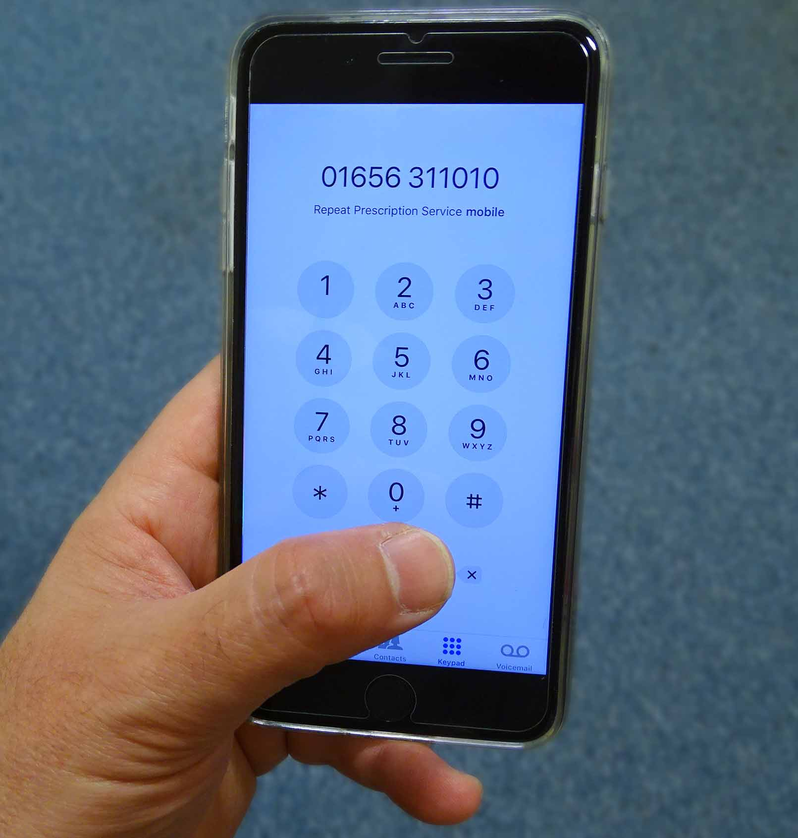
The call is answered by fully trained NHS staff based in Bridgend, who have secure access to a patient’s repeat prescription record. The call handler is able to take the repeat order, check details and process the prescription on behalf of the patient and GP surgery.

A pharmacist is also on hand to help with any concerns or queries a patient may have about their medication.

Once the call handler has processed the prescription it is taken to the relevant GP surgery for signing and then on to the patient’s chosen pharmacy for dispensing, completing the process in 3 working days.

Leading the project is ABMU head of prescribing Alex Gibbons, she said: “This is a first for Wales and we’re running it for a trial period of six months in partnership with local GPs to see how it goes. We’re hoping that if it’s as successful as it has been in England we’ll be introducing it permanently and rolling it out across the whole ABMU area.

“We want to make it as easy as possible for patients to order the medication they need when they need it. Sometimes patients order medication when they don’t need it thinking they have to, or if they don’t they won’t get it when they do.

“This service will be able to reassure patients about their medication, answer medication queries, and help us to save millions of pounds a year by reducing the amount of unused medication being prescribed.”

An estimated £4 million worth of prescription medicines are destroyed each year in Swansea, Neath Port Talbot and Bridgend because they aren’t needed.
In many cases, these were drugs ordered on monthly repeat prescriptions, stockpiled unused in people’s homes or returned to local pharmacies for disposal.

The service, which will be available 10am – 3pm, Monday to Friday (excluding Bank Holidays), will begin operating on Monday 23rd October for patients in the Medical Centre, Pencoed and rolled out on a phased week by week basis to the following surgeries also taking part in the trial, Ashfield, Oaktree, Riversdale, Newcastle and New Surgery, Pencoed.

Talking about this new service, GP Dr Matthew Peach of Riversdale Surgery said: “This is an exciting new service which will make it easier for patients to request their repeat medications whilst at the same time reducing wastage. Unused medications cost ABMU alone millions of pounds a year so there is the potential to make very significant savings which can then be used to improve other areas of patient care.”

Once up and running patients can order their medication up to 7 days before their supply is due to run out on 01656 311010. However, if patients would prefer to continue ordering their repeat prescription directly with their GP surgery or via a pharmacy ordering service and / or a pharmacy delivery service they can do so.

Any patients who call from surgeries not yet covered by the service will be advised to continue using their normal repeat ordering method.

Source: Abertawe Bro Morgannwg University Health Board

