Maureen’s dedication to students earns her special recognition award
Tuesday, 17 October 2017
Singleton Hospital’s Maureen Noonan has been honoured for her years of dedication to helping healthcare professionals of the future.
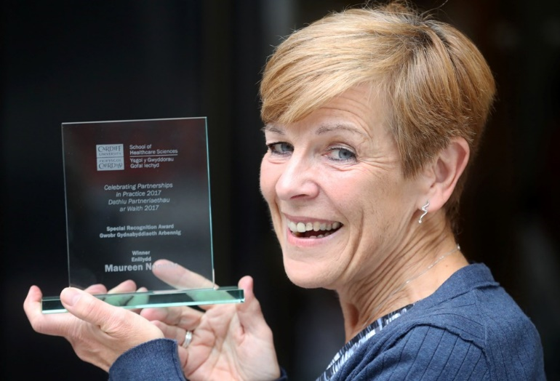
Radiotherapy services manager Maureen received the first ever Special Recognition Award at ceremony held by Cardiff University’s School of Healthcare Sciences to recognise its partnerships with practice.

The event, now in its second year, aims to celebrate the opportunities offered to the university’s students throughout Wales and reward the achievements of mentors, educators, teams and students who have made an impact and ultimately influenced care of patients.

Organisers said Maureen personified the kind of encouragement that was fundamental to students’ experience and education.

Her special award was presented to demonstrate the School’s gratitude and appreciation for her years of support.

Maureen said: “I am humbled and very, very proud to have been recognised. This really is a reflection on the effort all my colleagues here put in with our placement students.

“I have always had an interest in training. I feel it is so important to educate students about a career that I love and am passionate about – they are the future of our profession.”

She wasn’t the only ABMU success at the event with Singleton Hospital’s musculoskeletal out-patient physiotherapy team picking up the Physiotherapy Best Placement Team Award.

It won the title after students at the end of their third year degree programme nominated and voted for the best clinical placement team in Wales throughout their training.

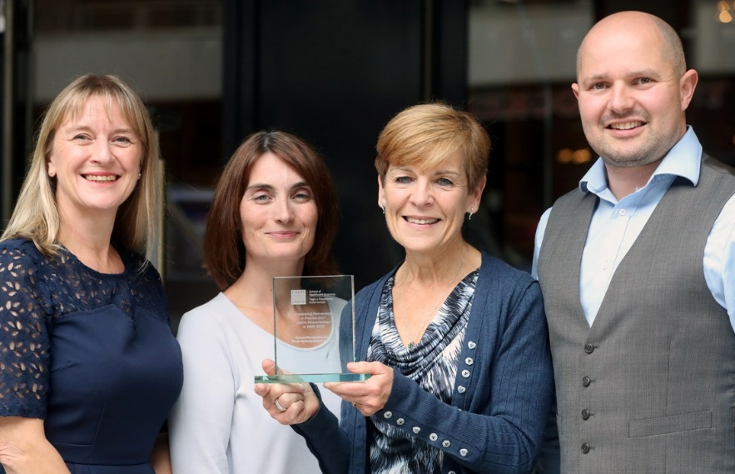
Maureen Noonan with (from left) ABMU’s Assistant Director of Therapies and Health Sciences Alison Clarke, radiographer Catherine Davies and physiotherapist John Morgan at the awards event.

Physiotherapy clinical manager Ruth Emanuel said: “I am so proud of the whole MSK team here at Singleton. They work so hard, and take great pride in providing good student clinical education. Having that learning culture benefits everyone in the team.”

The hospital’s radiology department narrowly missed out on the team award in its category, being voted second best placement for radiography students out of 12 major hospitals throughout South Wales.

Superintendent radiographer Ian Worthing explained how clinical practice educator radiographer Kelsey Bryant supports Jason Elliot, clinical lecturer for the School of Radiography but said the whole team deserved credit for the time it invests in developing students during their placements.

He said: “I feel very proud to be a part of a department that values students’ input and their role within Singleton radiology department. It’s an excellent achievement. “
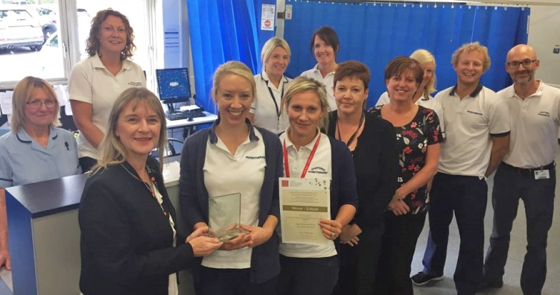
Alison Clarke presents the award to physiotherapy team members Susan Thomas, Zoe Gunn, Naomi Wood, MSK team leader Jordanna McCarley-Roberts, Tanya Francis, Jess Hedden, Kath Tracey, Liz Summers, Philippa Evans, Luke Jones, Damian Wilkinson. Not pictured are John Morgan, Christine Harrison, Rhian James, Hayley Barclay.

Also named runner-up was Singleton radiotherapy radiographer Catherine Davies who was shortlisted as Best Placement Educator/Mentor for radiotherapy and oncology.

In their citation one grateful student said Catherine made them feel “like a member of the team, not just a student”.

Maureen Noonan added: “I am delighted that Catherine’s hard work has been recognised. Last year our CT simulation team won the Clinical Team Placement Award and I feel we have really continued to build on that success and show our commitment to supporting students.”

ABMU’s Assistant Director of Therapies and Health Sciences Alison Clarke said: “Maureen’s long-standing enthusiasm for supporting students is a real example to other mentors and she richly deserves this honour.

“Also congratulations to the physio team - a true exemplar for the physiotherapy profession in the health board. To not only be nominated by your students but also to win the category shows what an outstanding team they are.

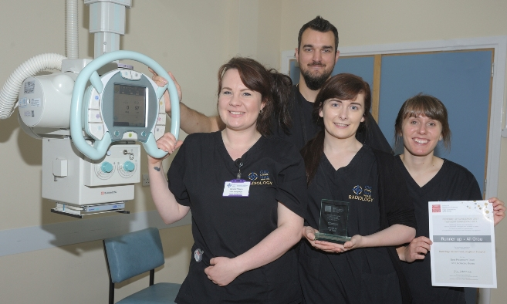
“We are very proud of all our staff who were recognised at the awards. They are certainly supporting the strategy Train, Work, Live in Wales as a good student experience on clinical placement can lead to successful recruitment and retention of staff.”

Pictured with lecturer Jason Elliott are representatives of the radiology team Danielle Williams, Kelsey Bryan and Sara Widlake.

Source: Abertawe Bro Morgannwg University Health Board

