Liz Baker Award has special significance for first winner
Monday, 16 October 2017
An award honouring the memory of an inspirational Morriston Hospital nurse has a very special significance for its first winner.

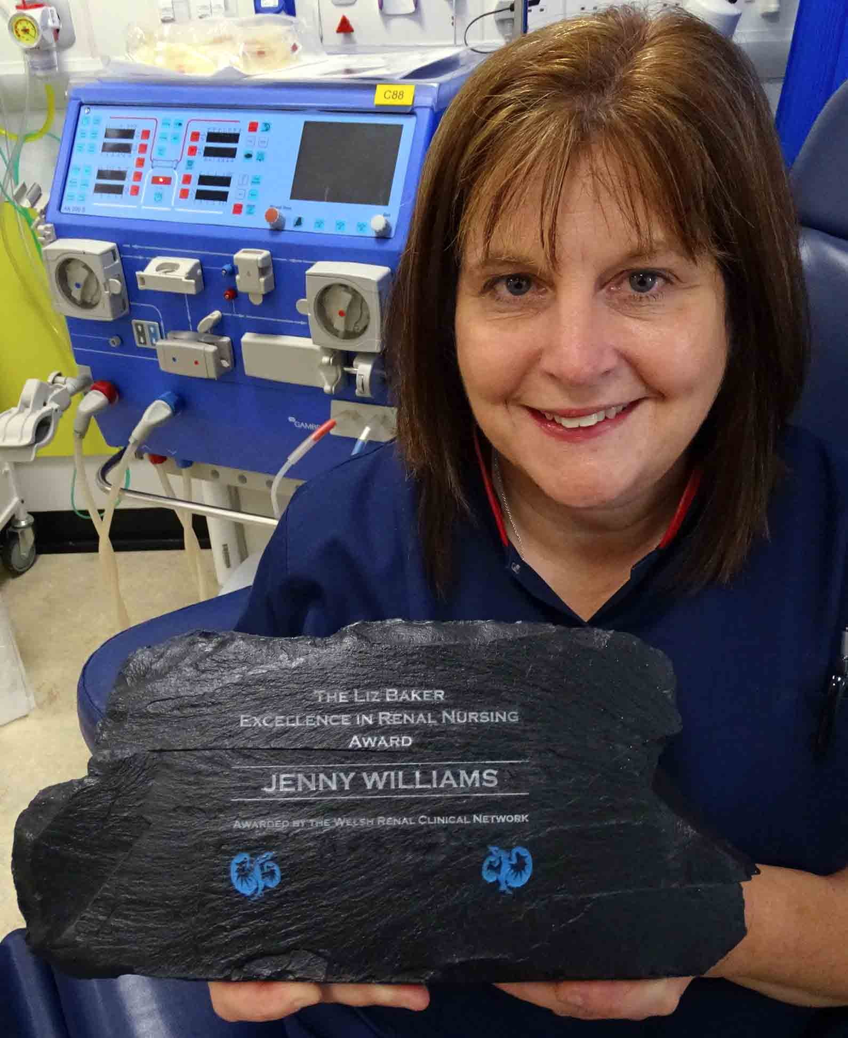
Renal services lead nurse Liz Baker passed away in February this year following a short illness.

Her family set up the Liz Baker Excellence in Renal Nursing Award in collaboration with the Welsh Renal Clinical Network to honour the contribution she made at Morriston Hospital and further afield.

The distinctive award, sculpted from Welsh coal, will be presented annually to recognise outstanding achievement in renal nursing care.

The inaugural winner was ABMU renal anaemia lead nurse Jenny Williams (left), who was not only a long-term colleague but also a close friend of Liz’s.

Coincidentally, it was presented to her 20 years after she won the RCN’s Renal Nurse of the Year Award – for which Liz nominated her.

Jenny started in nursing in 1986 and has worked in renal since qualifying – specialising in renal anaemia for the last 20 years.

Morriston is a regional renal centre so although Jenny is based there she runs clinics across the ABMU and Hywel Dda health board areas.

She said: “Liz was the person who interviewed me for my first job in renal all those years ago.

“I got to know her very well from having the privilege of working with her. Liz became a big part of my life. I built up a close rapport with her.

“She was so popular and what she did for this unit was incredible. She was completely dedicated and supported the staff too.”

Jenny’s role involves monitoring and prescribing medication for patients with renal anaemia – red blood cell deficiency caused by kidney failure.

She was one of the first nurses to become an independent prescriber and one of the first to become a blood prescriber.

The award citation also recognises her as being at the forefront of many treatment advances and providing leadership, innovation and professional support – inspiring many nurses to aim for great achievements.
Poignantly, the award also recognises how Jenny stepped up following Liz’s death – not only taking on the temporary role of renal matron but also providing pastoral support for staff during a very difficult time.

Jenny said: “Everybody here was in shock because of what happened with Liz. You have to have someone to take the lead but I wasn’t really aware I was doing it.

“I just went from week to week, absorbing Liz’s work into my own job as best I could. Your whole world is shattering inside you but you have to find a way of carrying on.”

Barry-born Liz was a nurse for 38 years, 32 of them spent at Morriston Hospital.

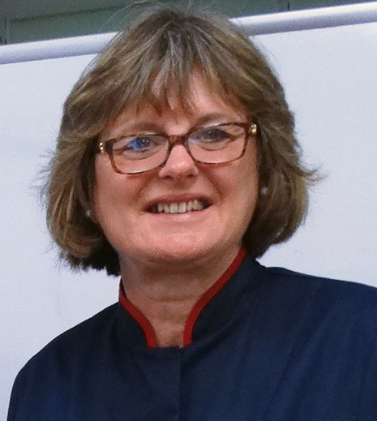
During this time she established and built up the network of renal services across South West Wales.

Latterly, she led on the modernisation of facilities for patients in Morriston Hospital, and helped develop an MSc syllabus at Cardiff University.

Right: Liz Baker

Earlier this year a book of poems co-written by renal patients, called The Poetics of Renal Dialysis, was published and dedicated to Liz’s memory.

The award was founded after a generous donation by her brother David, who said: “We all felt we would like to keep the memory of this remarkable woman alive.

“The setting up of the Liz Baker Excellence in Renal Nursing Award will be a way to keep her inspirational legacy continuing into the future.”

Jenny said she had felt flattered and honoured on discovering she was one of the 18 nurses across Wales nominated for the award – something that came out of the blue.

She was announced as winner during a Welsh renal conference in Llandrindod Wells.

Jenny said: “You don’t do things for awards. You do them because it’s your job. But this award is particularly important for me.

“It’s lovely and something I will treasure always. It was a high point in the year after so much sadness.”

Source: Abertawe Bro Morgannwg University Health Board

