Hospital bereavement service expanding to help more grieving families
Tuesday, 24 October 2017
A pilot project offering support to bereaved families at Morriston Hospital has been such a success it is being extended to help more people.

Originally the service was only offered on six wards but after positive feedback during a six-month trial run it is now set to resume for a further five months on all of the hospital’s 28 wards.

The project was originally set up to look at ways of developing and enhancing existing bereavement services.

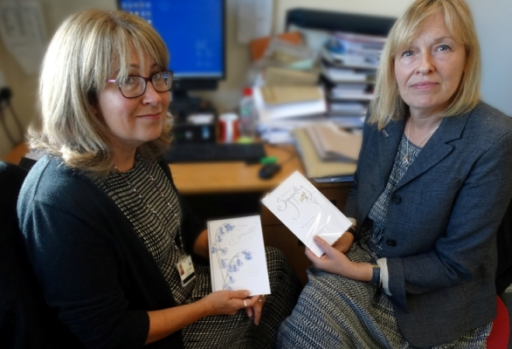
Now psychologists Alison Gorman and Liz Brimacombe-Jones, senior Emergency Department sister Karen Evans and psychology assistant Nina Humphreys have been awarded further funding to continue their work.

Alison Gorman and Liz Brimacombe-Jones with some of the cards that they send out to bereaved families.

As part of the service the team sends out condolence cards to bereaved families within a week of a death at the hospital, passing on sympathies and letting them know about the service.

This is followed up six weeks later with an invitation for the family to meet the bereavement team to discuss any questions they might have as well as an offer of emotional support.

Alison said the team has been building on work originally pioneered within Morriston A&E. Though some areas already have their own provision, it is hoped the service will provide a point of contact for anyone who needs support after a bereavement, whether family member or staff.

She said: “Generally in our society death is a subject we tend not to talk about. But we want people to know there is somewhere they can turn if they do have questions, if there was something about their loved ones’ death they didn’t understand.”

Liz said the service also supports ward staff by holding regular reflective workshops to discuss grief.

“These have provided a better understanding of how grief works and given staff confidence when they deal with grieving families,” she said.

During the pilot period the team sent out cards to the families of 148 patients. The feedback received was overwhelmingly positive and led to 16 family meetings.

Liz added: “Although many families didn’t feel they needed to take up the offer of meeting, they appreciated the invitation and were very pleased we had contacted them.”

One letter the service received from a grateful daughter following her mum’s death said: “My father and I were shown the utmost compassion, which we both needed and appreciated.

“What I did not expect, however, was the bereavement service which followed my mum's demise. This service, in my humble opinion, is of paramount importance in coming to terms with the death of a loved one.”
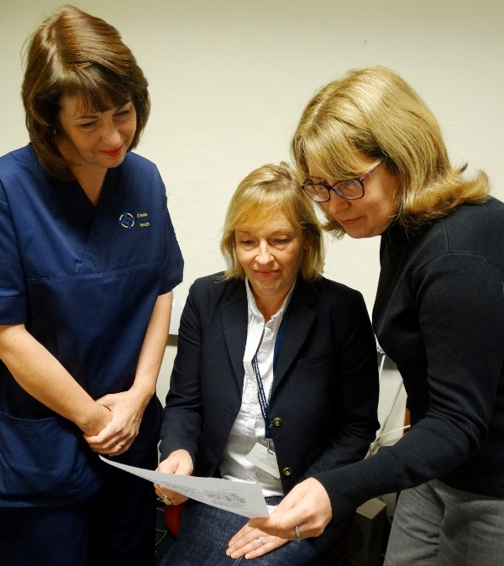
By having the service available to deal with a family’s questions, it is hoped to address any concerns arising after a death. It is also now a crucial part of developing a recognised bereavement pathway at the hospital.

Liz Brimacombe-Jones and Alison Gorman with senior Emergency Department sister Karen Evans at the start of the bereavement pilot scheme last year.

The service has been instrumental in establishing better links between wards and the mortuary service, even arranging visits for staff so they have a better understanding of how a loved one needs to be prepared ahead of viewing by their families.

“Because of this the hospital is now in the process of standardising the way last offices – the care given to a patient after death – are carried out which will crucially improve the experience for grieving families,” said Alison.

She added: “The ultimate aim is for this to be a core service, so there is somewhere for families and staff in each hospital in the health board to go to receive support through the grieving process.”
The funding for the project’s additional period is being provided by Morriston Hospital General Purpose Fund and ABMU’s Charitable Funds Committee as well as from the proceeds of additional external teaching work carried out by Liz and Alison.

Morriston Hospital’s Nursing Director Nicola Williams said: “I am delighted we are now able to extend this service across the hospital. It is important to us that families of our patients - as well as our staff - feel supported during difficult times and that they have somewhere to turn when they need it.

“The service has already made a considerable positive impact and I look forward to it building on that success. “

Alison added: “A loved one’s bereavement is often the last memory of hospital some people will have, we want that last contact to be as positive as possible.”

Source: Abertawe Bro Morgannwg University Health Board

