Help available for people struggling with mental health problems at work
Thursday, 5 October 2017
People who are struggling with mental health issues in work can turn to a specialist ABMU service for help.

World Mental Health Day takes place on October 10th every year.

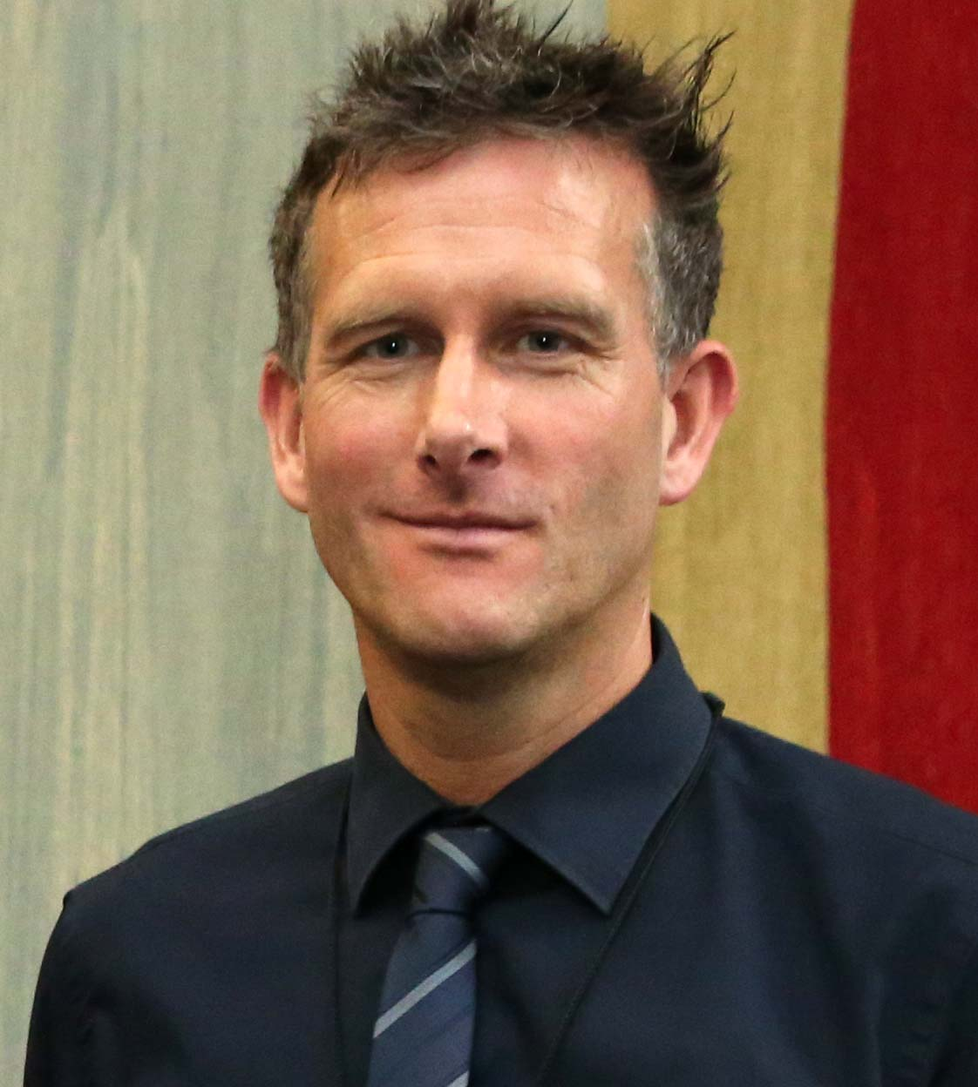
To mark the occasion this year, a special event supported by ABMU will take place in Swansea next Tuesday, 10th October.

It will be held in the Grand Theatre Arts Wing from 10am until 3.30pm and will feature local consultants presenting talks on various aspects of mental health including depression in older adults, and dementia.

It is open to the public and admission is free of charge.

Left: ABMU Head of Staff Health and Wellbeing Paul Dunning: “People who experience mental illness often face stigma and discrimination in the workplace, socially and within families.”

The Swansea event has been organised annually for more than 10 years by Lily Bidmead of the Patients’ Council, based at Cefn Coed Hospital.

Lily said: “Every year there is a different theme to Mental Health Day and this year’s is Mental Health in the Workplace.

“As well as talks by clinical staff, there will be information on almost 60 projects involving the health service, local authority, universities, the Third Sector, and service user and carer groups.”

Although the Swansea event takes place once a year, ABMU has a number of ongoing projects and campaigns to improve the health and wellbeing of its own workforce.

However, it also runs the Wellbeing through Work In-Work Support Service, which is open to anyone struggling in work or on sickness absence due to mild to moderate mental health issues – such as stress, anxiety or low mood.

The initiative, which can also help with muscle or joint problems like back or hip pain, provides rapid access to a team of locally-based NHS occupational therapists, who specialise in emotional health issues, and physiotherapists.

They provide tailored support to help people manage their health condition in work, or to successfully return to work.

It’s confidential and, as the service is funded through the Welsh European Funding Office, free to employers or individual employees.

The service is open to people who are employed or self-employed, and live or work in the Bridgend, Neath Port Talbot or Swansea areas.

ABMU Head of Staff Health and Wellbeing Paul Dunning said: “People who experience mental illness often face stigma and discrimination in the workplace, socially and within families.

“Yet there is growing awareness that the best way to improve knowledge and understanding is to get people talking about mental health.

“Opening up about mental health issues can be very difficult, particularly in the workplace, but it is reassuring to know that there is local support out there.”

UK-wide research shows the number of people experiencing mental health issues while in employment has risen from a quarter to a third over the last five years.

Despite this, the majority of employees still don’t feel that those affected are supported well enough at work.

In-Work Support encourages employers to take a proactive approach to workplace wellbeing, and can deliver targeted health programmes for small to medium-sized business of up to 250 staff members.

Mr Dunning said: “The programmes are designed to meet the specific needs of the business.

“They can include staff health and wellbeing advice, health promotion activities or the development of workplace policies or practices that help support employee wellbeing.

“A range of awareness sessions that promote mental health can be delivered in the workplace.

“They focus on coping with pressure in or outside work, recognising the signs and symptoms of stress and effectively managing change.”

To find out more or to access support call Freephone 0845 601 7556 or email wtw@wales.nhs.uk

Source: Abertawe Bro Morgannwg University Health Board

