Grateful family says Andrea is their Autism Hero
Thursday, 26 October 2017
The life-changing difference ABMU’s Andrea James has made to a grateful family has led to her being shortlisted for a major UK honour.
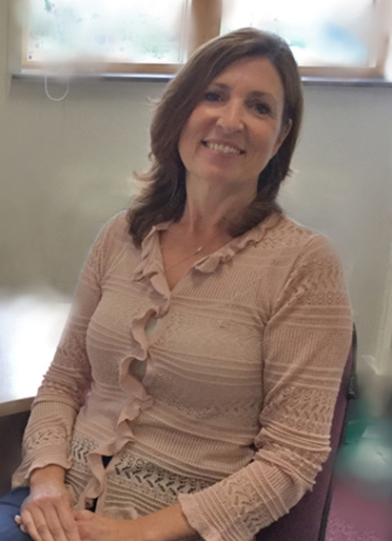
Andrea, a psychologist practitioner (right), is in the running for the Healthcare Professional title at next month’s Autism Hero Awards.

She was nominated by Julie Morgan and her 21-year-old daughter Gemma who say Andrea has gone above and beyond her role to help them cope with autism and the difficulties it has caused.

Julie, of Maesteg, said: “If it wasn’t for her I don’t know what we would have done, Andrea’s help has made a massive difference.”

Andrea first started helping Gemma, who has autism and learning disabilities, three years ago when she was old enough to come under ABMU’s adult learning disability service.

She said: “My priority was to get to know Gemma and to build up her trust. I recognised there were ways I could help her and her mother and they realised this was an opportunity for them.”

Since then Andrea has worked regularly with Gemma and her mum and also introduced her to a group of trusted carers who also see her for weekly activity sessions.

Julie said: “Gemma’s behaviour can be very challenging but Andrea has worked out what triggers Gemma’s anxieties and has given us coping strategies to help.

“She meets up with my daughter every week for activities which help with communication. Gemma communicates much more now and her behaviour has become much more manageable, thanks to the work with Andrea. She has made a big difference to our lives.”

Musically gifted, Gemma is now an enthusiastic member of Gwaun-cae-Gurwen Band.

“She is now able to attend rehearsals once a week and I am very proud of musical ability, added Julie.

Andrea said: “Gemma is now in a much happier place, she is not so isolated and I am just pleased that I have been able to help her and her mum.”

She said she was delighted and very proud to have been nominated for the awards, organised by national charity AnnaKennedyOnline, which take place in London on Saturday, 11th November.

Andrea, who is one of two psychologist practitioners working in ABMU, “That’s a lovely thing to do for someone, I was surprised when I found out I had been shortlisted.

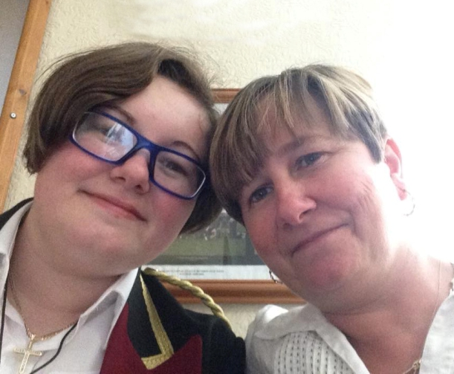
“I always take the lead from Gemma and I have learned so much from her. I might work with some people for 10 to 15 years and not achieve a much as we have been able to with Gemma.”

Gemma with her mother Julie Morgan.

Hazel Powell, Nurse Director for Mental Health and Learning Disability, said: “‘Getting to know the person and working in a person and family-centred way really is key to successfully supporting people and their families.

“This is a great example of working together to get the best outcomes. To be nominated by the family has to be one of the nicest forms of feedback and I will be keeping my fingers crossed for Andrea.”

Source: Abertawe Bro Morgannwg University Health Board

