Get your teeth into healthier ways to celebrate Halloween
Monday, 30 October 2017
Halloween is here and once again it will see children dressed in their scariest costumes, ready for trick or treating.

But for many little ones the sweets they collect won’t be a treat as they’re already used to nibbling on chocolates and sticky snacks regularly.
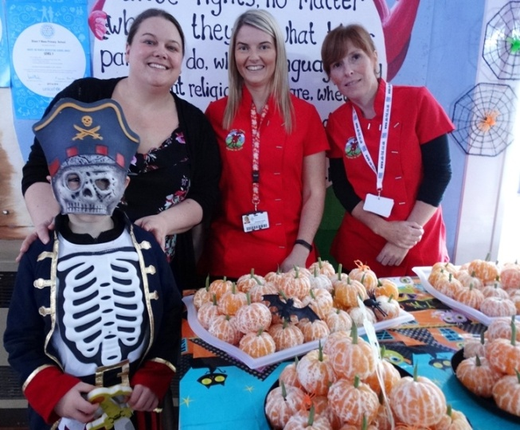
Now health staff are urging families to make some simple changes to help their children avoid the real-life horror story of tooth decay, fillings and extractions.

Teacher Emma Amirat, and pupil Marley-Jay Bradnum, aged six, with Samantha Tarling and Claire Hayes-Davies, of the Designed to Smile team

ABMU’s Designed to Smile team dental health manager Mandy Silva said: “We are not trying to be spoilsports, we know that children enjoy sweets and chocolates especially at times like Halloween, Christmas and Easter.

“What we are really concerned about is youngsters having them day in, day out, all year round.

“We want to encourage parents to keep sweets for special occasions and also to introduce healthier options instead which will make a real difference to their dental health.”

One school leading the way when it comes to healthy eating is Blaenymaes Primary where teacher Emma Amirat and her colleagues are committed to sugar-free fun.

She said: “We have recently received our Healthy Schools Phase 6 Award and we always give out the right messages about food, fitness and oral hygiene but when it came to seasonal events like fetes and discos it used to be a green light to give out sweets.

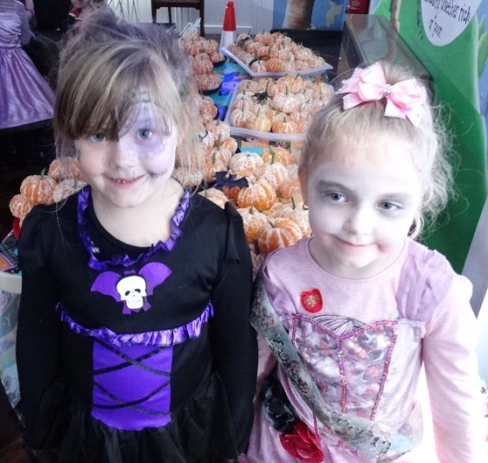
“You get stuck in that trap of thinking ‘oh, it’s Halloween’ or ‘it’s Christmas’ forgetting the fact the children will be having sweets at home at those times of year so they don’t need to have them in school too.

“It was contradictory for us to be giving out sweets so we stopped doing it last year and have been building on that decision since.”

Right: Blaenymaes Primary School pupils Mia Long, and Bonnie Crocker, both aged five

She said to change attitudes the school’s family inclusion officer Helen Spencer worked closely with the Parent Teacher Association which is right behind the staff’s efforts.

“At the school fete instead of doing the usual hot dogs and crisps, we do things like a fruit pick & mix and pulled chicken wraps with vegetables.

“As time goes on it is almost like a challenge for us – at every event we try to present something exciting that doesn’t have to be sweets.”

The pupils’ sugar-free disco last week saw a school hall full of little witches, monsters, vampires, and ghouls dancing around and having fun with a special treat of pumpkins – satsumas decorated with green beans – as they left.

“We haven’t had any of the children moaning. They love the disco for the lights, the music and the games, not for the pop and the sweets. They all have fun, that’s all they need,” added Emma.

Community dietitian Anna Parton agrees it doesn’t have to be difficult to serve up healthy snacks and has plenty of eye-catching alternatives that are just perfect for Halloween.

She said: “We all know children are eating and drinking too much sugar which is making them unhealthy and more prone to illness, not just now but more worryingly as they get older.

“With a little imagination children can help to prepare these easy to make options which are healthy, fun and spooky to serve as alternatives at Halloween.

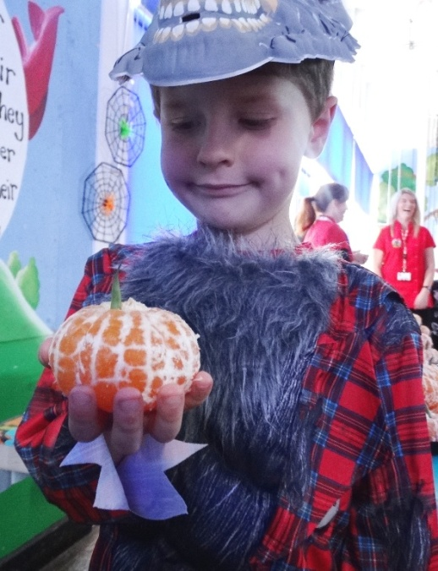
“It's not a case of ‘never’ but unhealthy food, drinks and snacks have become things our children are consuming frequently, not occasionally.”

Left: Caine Jones, aged six, with one of the special Halloween pumpkins at the disco.

Work to highlight children’s oral health by Designed to Smile, health visitors, dietitians, schools and community dental services has helped to drive down levels of tooth decay.

Latest figures from Public Health Wales show a consistent fall in the number of children in ABMU with missing or decayed teeth – now in a class of 30 five-year-olds, 10 children will have an average of 3.6 teeth affected. Ten years ago the figure would have been 14 pupils with an average of 4.2 affected teeth.

“However, we know there is more work to do so we want to build on this and continue to spread the word about how to protect our children’s teeth for the future,” added Mandy.
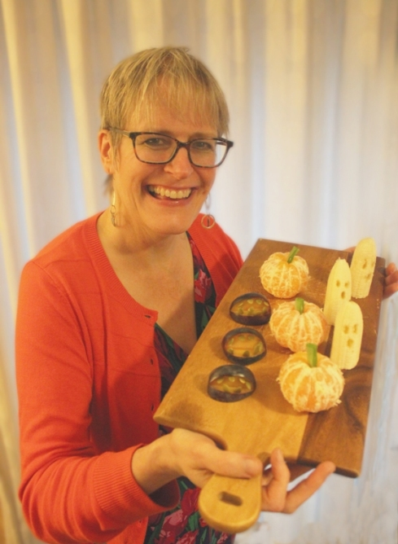
Right: Anna Parton with nasty gnashers made with plums and pumpkins seeds, petrifying pumpkins created with satumas and beans and banana ghosts.

Parents should always:

• Clean their child’s teeth last thing before they go to bed and one other time during the day with fluoride toothpaste;
• Help clean their children’s teeth until they are seven;
• Try to wean babies off dummies by 10 to 12 months, avoid dipping dummies in sweet food or cleaning a dummy by putting it in their own mouths – this can pass on bacteria which wouldn’t normally be in a child’s mouth;
• Choose sugar-free non-acidic snacks and drinks;
• For pre-school children remember milk and water are the only drinks they need; and,
• Take them to visit the dentist regularly.

Lead health visitor for public health Jane O’Kane, who is also chair of ABMU’s Healthy Teeth Steering Group, said: “Dental decay is completely avoidable and we cannot over-emphasise the importance of good oral health in our children. Limiting how many sugary snacks and drinks they have is a crucial part that parents can play in protecting their children.”

Source: Abertawe Bro Morgannwg University Health Board

