Diabetes programme for children and young people celebrates award win
Friday, 27 October 2017
A Wales-wide diabetes programme for children and young people which ABMU experts helped develop is celebrating after winning an award.

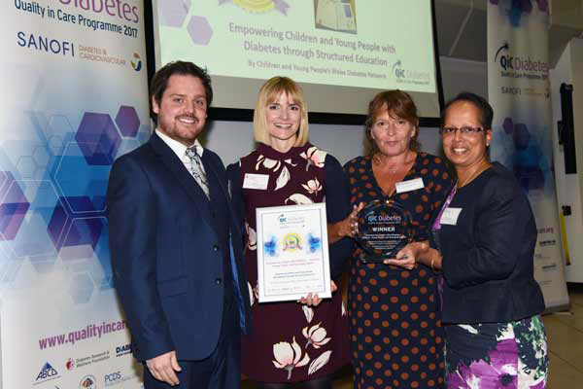
The Children and Young People’s Wales Diabetes Network, which supports paediatric diabetes teams across Wales, has won a Quality in Care (QiC) Diabetes Award for SEREN, the all-Wales structured education programme.

Dr Nirupa D’Souza (far right) is pictured receiving the award alongside colleagues from the SEREN project group.

QiC Diabetes Awards recognise, reward and share innovative practice demonstrating quality in diabetes management, education and services for people with diabetes and/or their families.

The SEREN structured education programme won the Empowering People with Diabetes - Children, Young People and Emerging Adults prize.

SEREN is a national diabetes education programme for children and young people (CYP) developed by healthcare professionals and parent representatives from across Wales.

Members of ABMU's paediatric team have played a key role in developing SEREN over the past three years.

Dr Nirupa D'Souza, consultant paediatrician and clinical lead for acute paediatrics at Princess of Wales Hospital, has been integral to the project, leading the team that developed the programme.

The first SEREN education modules are delivered over the six to eight weeks following diagnosis and aim to improve CYP’s knowledge and understanding of diabetes, empowering them to manage their diabetes from day one.

The programme includes a full curriculum with lesson plans for staff, a workbook for the young person, educator records to track progress and an array of supporting teaching resources.

In awarding the prize to the Children and Young People’s wales Diabetes Network, the judges said: “SEREN is completely child-centred and the judges loved this.

"It’s broad, clearly impactful and it revolves around child’s ability to understand rather than the age. It’s very well put together for the short time period and the workbooks make it easy for parents and healthcare professionals to track progress.”

SEREN is now used by ABMU's paediatric diabetes teams, ensuring children and young people diagnosed with diabetes receive all the information they need to successfully manage the condition.

More information about SEREN is available here

More information about the QiC Awards 2017 is available here

Source: Abertawe Bro Morgannwg University Health Board

