Campaign helps rally support for organ donation
Thursday, 5 October 2017
Staff and visitors at Morriston Hospital have shown their support for organ donation during a special awareness campaign.

To mark National Donation Week the hospital hosted a stand in the foyer which provided information about why it is so vital as many people as possible agree to donate their organs after their death.

Wales has long led the way in organ donation - it was the first UK region to introduce the kidney donor card in 1971 and two years ago it became the first UK country to introduce deemed consent. This means if a person hasn’t recorded any decision on the NHS Organ Donation Register it will be assumed they have no objection to donating any of their organs after their death.

Other areas are now considering following Wales’ lead but there is still more we can do to improve donation figures, according to consultant intensivist and clinical lead for organ donation Dr Peter Matthews.

By positively opting into the donation scheme and registering your decision to become a donor online you can choose to donate all or only certain organs. This makes it easier for everyone to know your wishes after death.
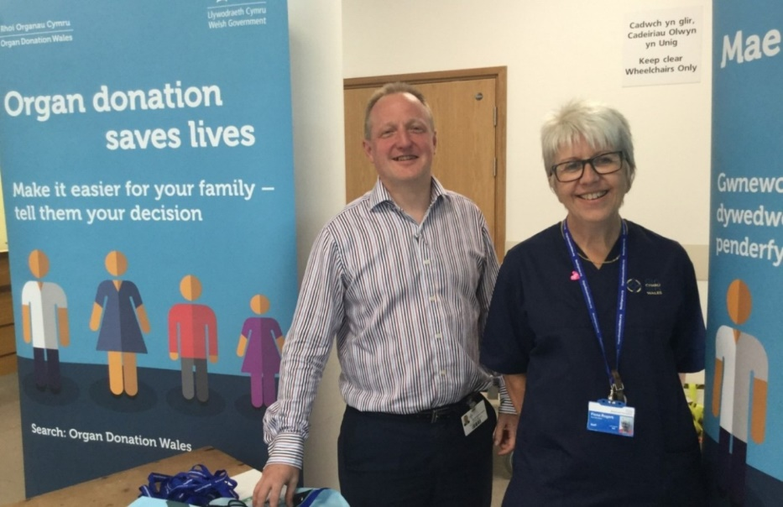
Clinical lead for organ donation Dr Peter Matthews with specialist nurse for organ donation Fiona Rogers at the stand at Morriston Hospital

Dr Matthews said: “Many individuals who sign up to the organ donation register, or are willing to be a donor by deemed consent, assume that their wishes will be carried out if they die in the circumstances where donation is possible.

“Unfortunately this isn’t always the case. Donation can’t proceed without the support of their families, and some families do override their loved one’s wishes to be a donor.

“We would encourage everyone to speak to their family and friends and make their donation wishes clear.

“Not only will it mean that your decision is more likely to be honoured but it will also help your family and friends at what will be a very difficult time for them.

“Every time a family overrides a decision it means that many other individuals who may desperately need a transplant don’t get one. So go on, do it, have the talk!”

Those waiting for transplants depend on people being willing to donate their organs and sadly many more could have their lives dramatically improved on receiving a transplant.

On average in the UK three patients die every day due to a shortage of donated organs.

Fiona Rogers, specialist nurse for organ donation at Morriston, said “We had a really positive response from staff and visitors during the week. Many signed up to the organ donation register online, and there was a lot of interest from a huge number of people who visited the stand.

“Although many people have opted-in or are willing to be donors by deemed consent the actual number of people who die in the circumstances where donation is possible is very small and therefore any individual who is willing to be a donor can make a massive difference.
“People often wrongly believe that their organs won’t be wanted because of their age or some health issues but frequently that isn’t true.”

Go to www.organdonationwales.org for information options, advice about discussions with family and friends and the opportunity to register your donation.

Source: Abertawe Bro Morgannwg University Health Board

