Burns staff share messages to help highlight dangers in our homes
Tuesday, 17 October 2017
Last year 470 children were seen by burns experts at Morriston Hospital – 340 of them were aged under five.
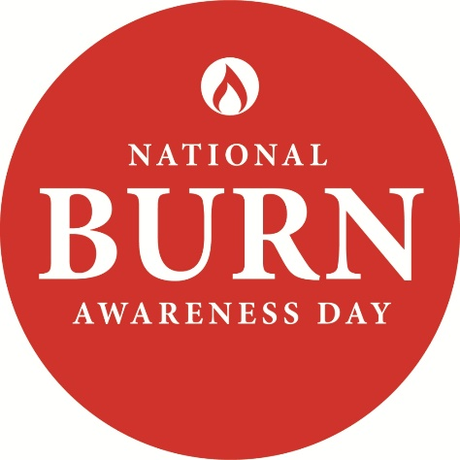
Now to help families protect their little ones from the risk of burns and scalds staff from the hospital’s Welsh Centre for Burns and Plastic Surgery have been in the community sharing safety messages and first aid skills.

Ahead of National Burn Awareness Day on Wednesday, 18th October advanced practitioner occupational therapist Janine Evans joined a mother and baby group to explain how to minimise the dangers.

She told the group: “Children from the age of 6 months to five years old are the group most at risk of sustaining burn injuries.

“I want to try to raise awareness of potential hazards and make you think if you need to change the way you do things in your home.”

Everyday household appliances like ovens, irons or hair straighteners were to blame for 182 contact burns dealt with by Janine and her colleagues last year.

“Straighteners in particular can be really dangerous because they are still very hot after they have been switched off.
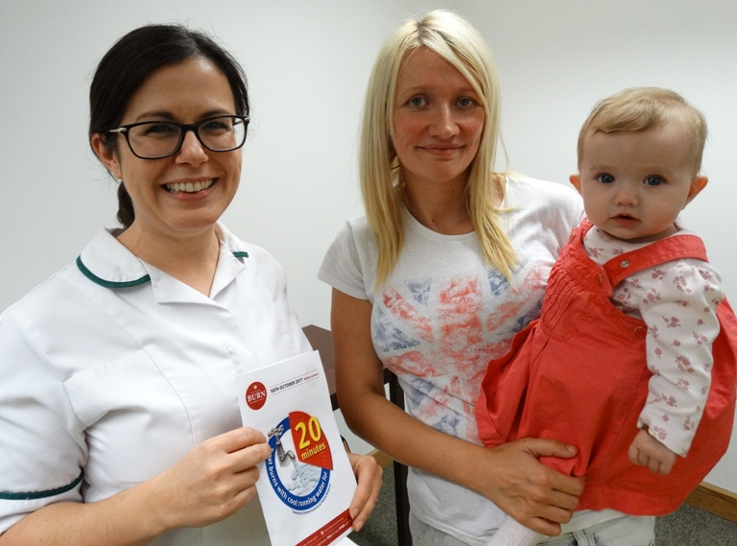
“If they have been heated up to 220 degrees it will take 40 minutes for them to cool down and it is easy for toddlers to grab the leads and pull them down on to themselves.

“Always make sure you put them at the back of a high surface while they cool down.”

Advanced practitioner occupational therapist Janine Evans with Donna Strangward, of Pontardawe, and five-month-old Isla.

She also said scalds from hot drinks were also too common.

“Just think how long a cup of coffee takes before it cools down enough for you to drink it. A cuppa that is 70 degrees will only take 1 second to cause skin injury to a baby and when liquids spill they can really spread.”

She urged the mums at the group, which meet every week at Clydach Health Centre, to share the safety information and tips.

“This is all about being mindful and getting used to safe practices at home. Don’t be afraid to tell people when you see something that could be risky.”

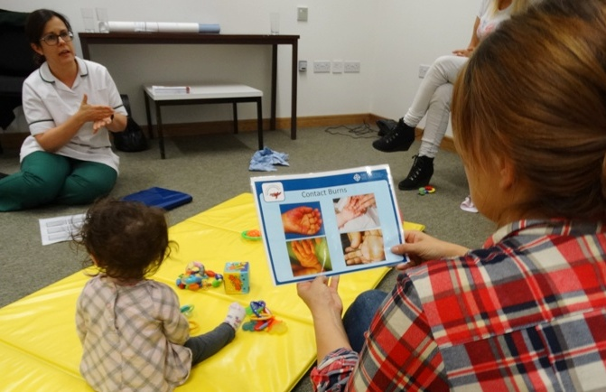
As Wales has the highest incidence of skin cancer in the UK, Janine was also keen to remind parents about the dangers of sunburn.

Mum Sam Brennan looks at injury pictures during Janine Evans’s talk

She said: “More people die from skin cancer in the UK than Australia, with Wales having the highest incidence of skin cancer in the UK.

“This year alone 19 children – 11 aged under five - were admitted to the centre to receive specialist treatment for sunburn and as we only see the most severe cases there will have many more dealt with at A&E and GPs surgeries.

“These aren’t burns caused by people deliberately leaving a child in the sun, these are children whose parents have often been caught out because our weather in Wales is so changeable.

“They’ve left the house when it’s cloudy but then the sun has come out.

“Remember the skin of a child under five is 15 times thinner than an adult’s so always keep suncream in your changing bag, in the car, at grandparents’ houses, so you won’t get caught unawares.”

During the talk Janine handed out leaflets produced by the Children’s Burns Trust and the British Burn, the charities behind National Burn Awareness Day with advice and information.

They include details of what you should do if you are with someone who is burned or scalded – remember Cool, Call, Cover:

Cool the burn under running cold water for at least 20 minutes to take the heat out of the injury;
Call for help – this could be 999, 111 or your local GP
Cover with cling film, never cotton wool which could get stuck in the wound.

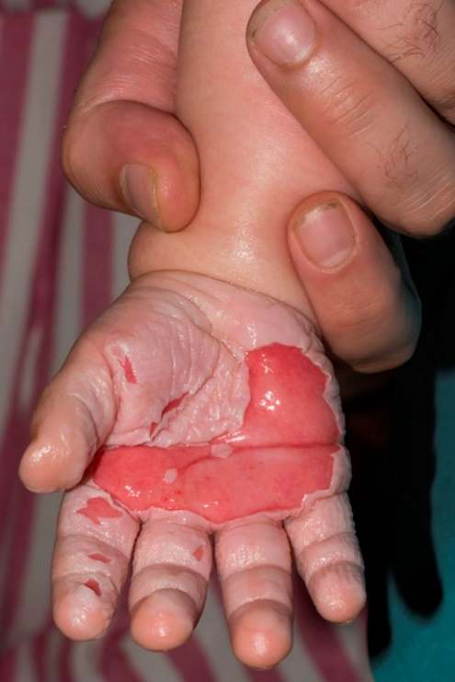
“Good first aid is essential. If you do it right it can have a massive effect on the burn,” said Janine.

This toddler needed treatment at Morriston after burning their hand on an oven door.

Among those attending the session was Carla Nightingale, of Treboeth, who brought along her four-month-old son. She had first-hand experience of how quickly a child can be hurt.

Her elder son had needed treatment after pulling a bowl of hot water over himself.

She said: “He wasn’t even supposed to be in the kitchen at the time, we thought he was still upstairs. But before we knew it he saw the bowl and reached up to grab it and tipped the water.

“There were no long-term injuries but it was very frightening at the time and it made us realise just how careful you have to be.”

Mum Sam Brennan, of Birchgrove, was at the session with seven-month-old Betsan, said she found the information very useful.

“I have already made changes in the way I do things but this has given me more to think about. I found it very helpful,” she said.

Janine added: “Fortunately most injuries we see are superficial, they don’t often result in long-term scarring, but most burns are preventable and because of this parents can be left feeling very guilty.”

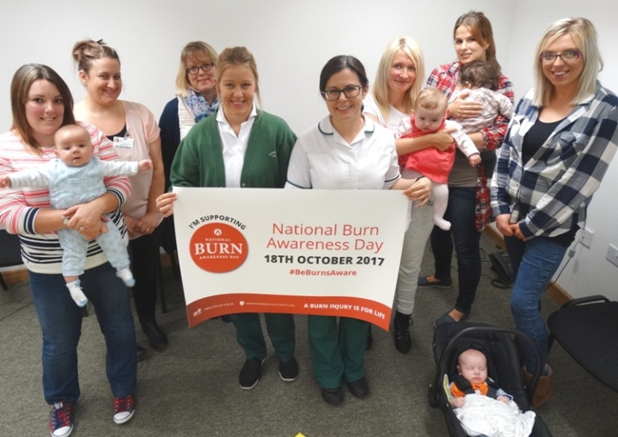
For more details go to www.britishburnassociation.org www.cbtrust.org.uk or www.hotwaterburns.org.uk

Watch out for Burns Awareness Day on Twitter using #BeBurnsAware #CoolCallCover and #WelshCentreForBurns

Carla Nightingale, with Josh, aged four months, nursery nurses Sarah Trower and Isabel Baker, student OT Sam Mizen, advanced practitioner occupational therapist Janine Evans, Donna Strangward, with Isla, Sam Brennan, with Betsan and Laura Glenister with nine-week-old Leo.

Source: Abertawe Bro Morgannwg University Health Board

