A hearty happy birthday as Morriston Cardiac Centre celebrates 20 years
Tuesday, 24 October 2017
Morriston Hospital’s Cardiac Centre is celebrating its 20th birthday this month – and what a difference those two decades have made.
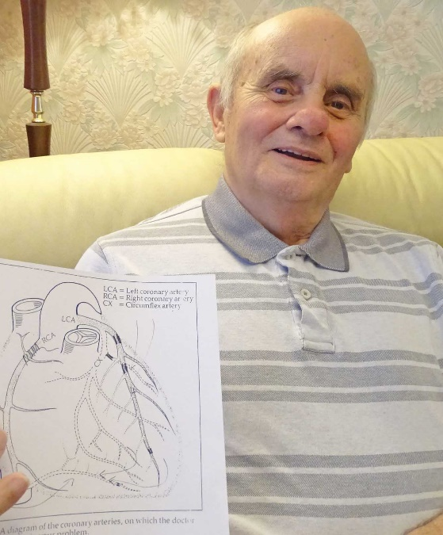
Life-saving procedures now used routinely when people have heart attacks were unheard of back when Morriston became Wales’s second cardiac centre in 1997.

Derek Morgan with the diagram of his cardiac surgery from 20 years ago

In fact anyone needing any kind of cardiac intervention would have needed to go to Cardiff.

Former DVLA worker Derek Morgan, who lives near Morriston, had several heart attacks before the centre opened and was among those taken to Cardiff for treatment.

Eventually he needed bypass surgery and was told he would have to go to London for it. Then Mr Morgan was contacted and told a surgeon was coming to Morriston so he could have his operation there.

“I thought it was great,” said Mr Morgan, who became one of the very first patients to have cardiac surgery – in November 1997 – in the newly-established centre.
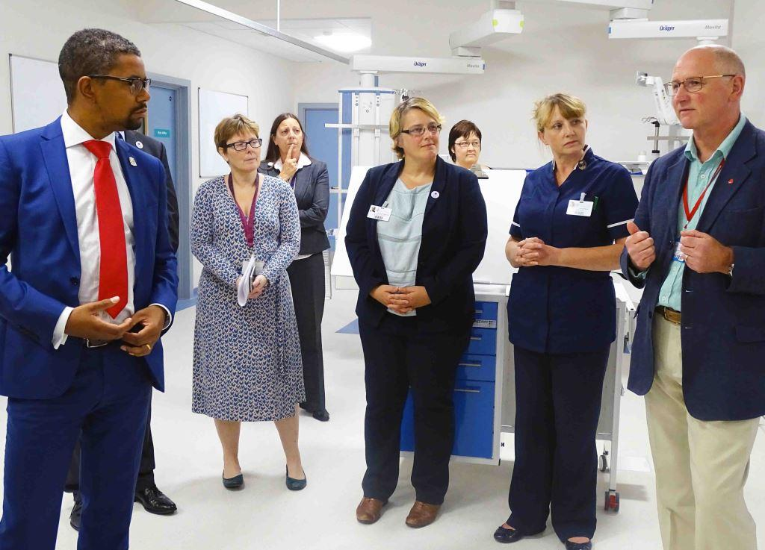
“The surgeon, Aprim Youhana, came to see me before the operation and drew me a diagram of what he would be doing – I’ve still got that diagram.”

Mr Morgan, now aged 79, needed an angioplasty last December but otherwise has been doing very well since his operation 20 years ago.

Health Secretary Vaughan Gething visited cardiac ITU at Morriston Hospital in August 2016 after its £6.6 million expansion (also see picture below)

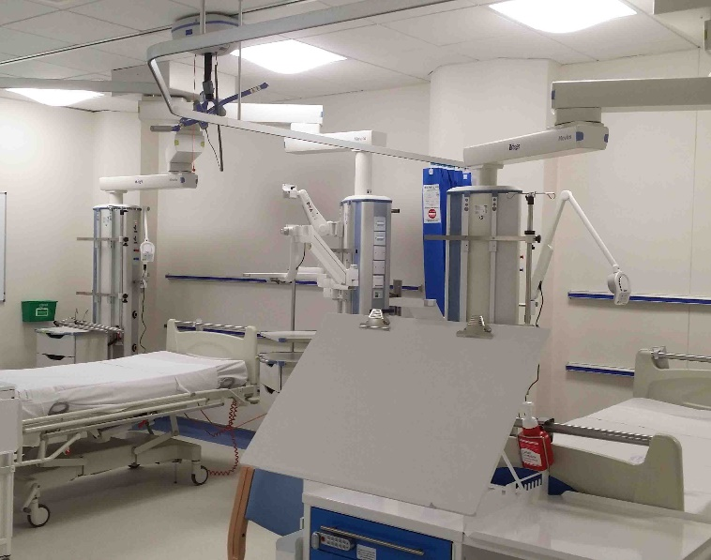
“The care I have received over the years has been excellent. They can’t seem to do enough for you – it’s great.”

Consultant cardiothoracic surgeon Mr Youhana still works in the Morriston centre, which now provides a regional service covering South West Wales.

Today it carries out around 750 heart operations a year along with thousands of other procedures.

Millions of pounds have been invested recently to ensure its facilities remain state-of-the-art using the very latest technology.

Consultant cardiologist Mark Anderson is another member of the team who has worked there since the day it opened its doors.

Dr Anderson said: “I can remember arriving here in September 1997 and it was just an empty building – all the beds were there but no people.

“It has been fascinating watching it develop since then. It has progressed and changed almost out of all recognition in many respects and the treatments have evolved greatly during that time.
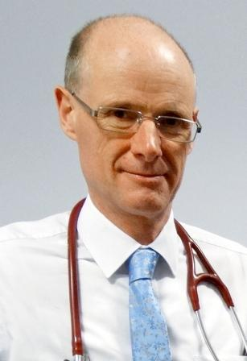
“For example, the way heart attacks are treated has changed radically since 20 years ago.

Left: Mark Anderson

“If you had a heart attack in Aberystwyth then, you would have been taken to Bronglais Hospital and given clot-busting drugs.

“Now, you will be brought straight here, and have an angioplasty instead of clot-busting drugs, which greatly improves your chances of surviving the heart attack.

“We do around 500-600 of these procedures every year now, something not even considered back in 1997.”

A heart attack is a blockage by blood clot in one of the arteries, damaging that area of heart muscle.

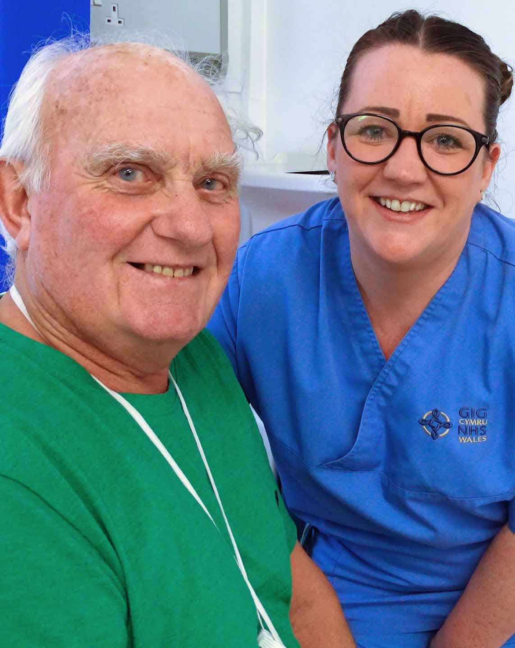
It’s treated through an angioplasty, which uses balloons and stents to open the blocked artery and restore blood flow to the heart muscle as quickly as possible.

Cyril Evans Ward patient Terry Morgan with staff nurse Emma Phelps

Over the years Morriston has carried out some 18,000 of them, along with 13,700 cardiac surgery procedures, and 9,800 pacemaker and defibrillator procedures.

From the initial small teams of three cardiologists and cardiac surgeons it now has a team of 12 cardiologists and five cardiac surgeons delivering these procedures.

The Cardiac Centre also provides thoracic services and undertakes urgent operations for patients with lung cancer – 4,400 of them since 1997.

Its performance has also been consistently high. In 2015, the Society for Cardiothoracic Surgery and the National Institute for Cardiovascular Outcomes Research ranked the Morriston centre sixth out 39 in the UK for survival rates.

This is despite the fact that these operations are particularly complex because the ABMU area has more severe levels of heart disease and other serious illnesses.

The individual performances of Morriston’s cardiac surgeons were also deemed excellent.

Twenty years ago Derek Morgan was a patient on Cyril Evans Ward. Two patients who have spent time on the same ward in the last few weeks also couldn’t praise the standard of care highly enough.

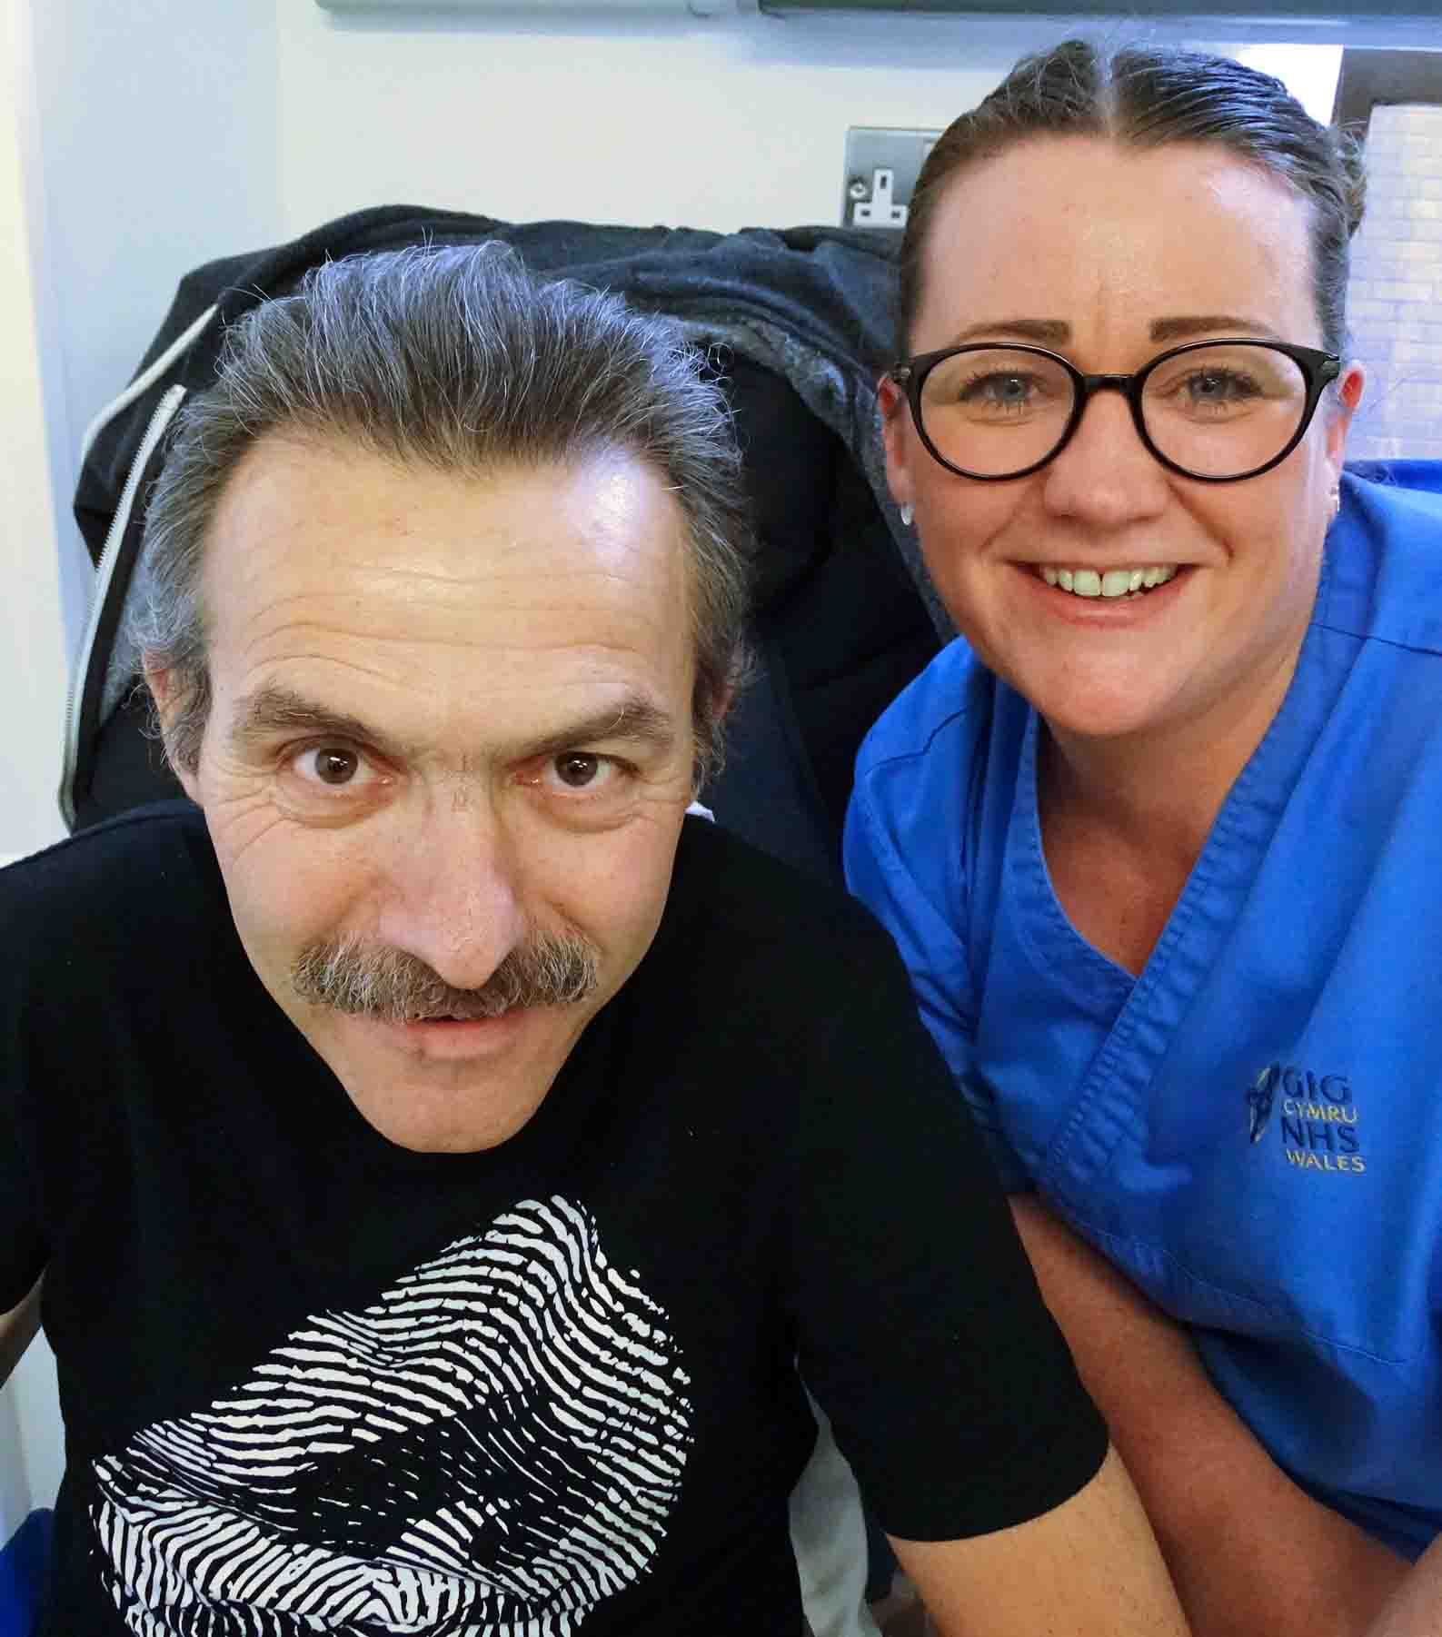
Mark Russ, aged 54, from Bishopston (pictured left with Emma Phelps), who had cardiac surgery in Morriston, said: “Having this centre right on my doorstep is fantastic.

“The staff are brilliant. The day is long but they’re always cheerful, always helpful. Whatever we want, we have.”

Terry Morgan, aged 74, has been on Cyril Evans Ward ready for his cardiac surgery. He said: “All the staff and the nurses are doing a fantastic job. They work really hard. I couldn’t be in better hands.”

In 2009, Morriston became the first hospital in Wales to undertake a procedure called a transcatheter aortic valve implementation (TAVI).

TAVI is a minimally invasive procedure for people with aortic valve disease but cannot have the valve replaced through conventional open heart surgery.

The cardiac centre has two dedicated surgical theatres along with two catheter labs – recently upgraded with a £2.43 million investment – where procedures such as angioplasties and TAVIs are carried out.

A third lab specialises in pacemakers, while other facilities include an expanded cardiac intensive therapy unit, which opened last year following a £6.6 million investment, along with wards and outpatient services.

Morriston also provides a full range of cardiac diagnostic services.

Cardiac Centre staff have already celebrated the anniversary when almost 300 of them gathered at Swansea’s National Waterfront Museum.

The evening included food and music, and speeches from Mr Yahouna and cardiologist Phil Thomas, who has also been with the centre from the start.

ABMU Interim Chief Executive Alex Howells said: “It is fantastic to mark the 20th anniversary of the Morriston Cardiac Centre and to reflect on all the benefits it has brought to patients in South West Wales.

“As Project Manager for the Cardiac Centre back in the mid-1990s I feel very privileged to have had the very rare opportunity to help develop a new service from scratch.

“It is particularly satisfying to see it going from strength to strength.

“We are very lucky to have such dedicated and committed staff and I look forward to seeing it continue to develop in the future.”

Source: Abertawe Bro Morgannwg University Health Board

