111 Wales going from strength to strength one year after launch
Wednesday, 4 October 2017
The 111 Wales telephone helpline for people needing urgent healthcare advice and support has gone from strength to strength since launching a year ago today. (October 4th)

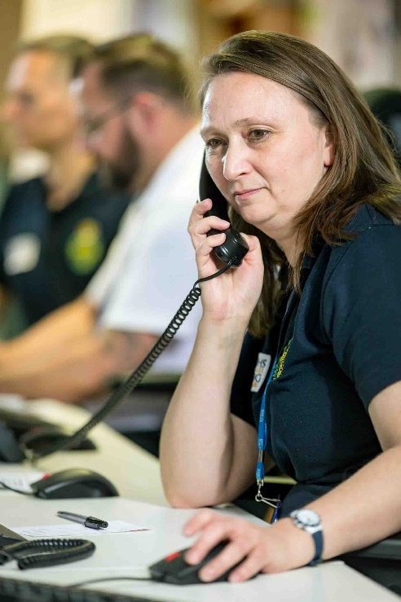
Tens of thousands of people have used it – and have been impressed with the service provided by the team of nurse advisors, GPs, pharmacists and trained call takers.

Here to help – 111 Wales senior nurse advisor Helen Neal

Rhydian Jones, a 21-year-old third year undergraduate at the London School of Economics, was home in Swansea when he became ill from a recurring gastric problem causing persistent vomiting.

He called 111 at 10pm and was asked a series of questions. He was then given an appointment to see a doctor in the out-of-hours GP centre in Morriston Hospital where he was examined and given medication.

Rhydian said: “Within an hour of ringing 111, I had seen a GP, taken the medication and was out of hospital. The service was excellent.”

111 Wales was piloted in ABMU from last October, initially in Bridgend and Neath Port Talbot, then Swansea. It extended into Carmarthenshire in May and it is hoped to expand the service further in the future.

Previously, residents had to ring different numbers to contact NHS Direct Wales or GP out-of-hours. Now they can call 111 to access both, making it easier to get the right advice, support or treatment.

111 Wales Programme Director Richard Bowen said it continued to go from strength to strength – and patient feedback had been extremely positive.

“In a survey we undertook, more than 94 per cent said they found the advice helpful and 98 per cent said they were treated politely and with respect.

“However, we are not complacent. More work is needed to ensure the service continues to deliver, despite increases in demand.

“I am extremely indebted to the NHS staff who have worked tirelessly to ensure 111 has met the local needs of our patients.”

Over the last year, almost 145,000 calls have been answered, with an average answering time of 81 seconds.

Around 84,000 callers were assessed as needing to speak to or be seen by the GP out-of-hours service. A further 11,000 were provided with health information advice, directed to a pharmacist or advised how to self-care.

Some callers were assessed as not needing urgent care and advised to contact their own GP practice.

Around 11,000 people were recommended to attend an emergency department or minor injury unit. More than 6,000 referrals were made to 999 – less than five per cent of all calls.
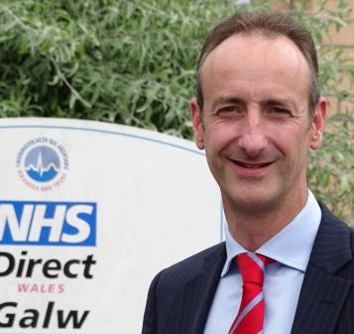
Within 111 is a clinical hub, a team of experienced GPs, nurses and pharmacists available during evenings and weekends to deal with calls involving complex healthcare needs. Health professionals such as paramedics can also access the hub for advice.

Mr Bowen (right) said: “This has resulted in fewer ambulances within the ABMU area taking patients directly to hospital – a 26 per cent drop in the six months of the evaluation.

“This supports the wider approach to provide care closer to or in people’s homes, and results in improved experience for patients.”

Welsh Ambulance Service Director of Operations Richard Lee said: “The development of the clinical hub has provided our paramedics with another alternative source of advice and referral to the wider system in cases where hospital is not the best destination.”

111 Wales is a partnership between Welsh Ambulance Service, ABMU and Hywel Dda university health boards and the Welsh Government.

Welsh Ambulance Service Chief Executive Tracy Myhill said: “As the hosts of 111 Wales we are extremely pleased by what has been achieved in the early stages through working with our partners, ensuring patients are signposted to the most appropriate health service for their needs.

“We look forward to building on the success of 111 to date.”

Alex Howells, ABMU Interim Chief Executive, said: “We are delighted with the success off 111 Wales. It is an important step towards a more modern approach to delivering urgent care.

“It provides an alternative to hospital services where appropriate, and further enhances our high-quality GP out-of-hours service.

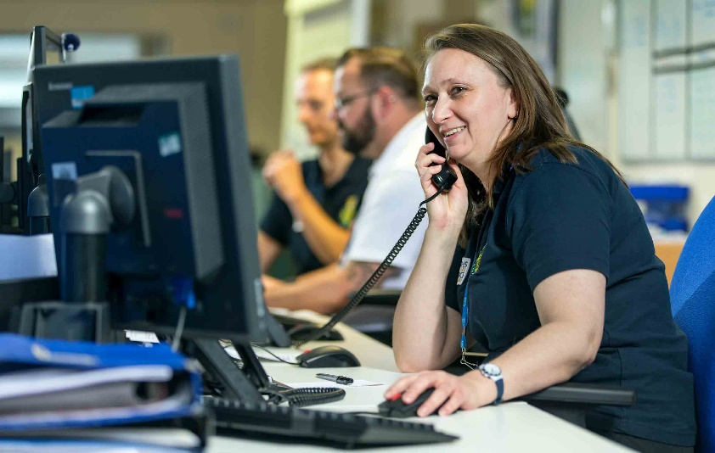
“I am really proud of the way in which NHS staff and independent contractors embraced what has been a significant change with such enthusiasm and commitment.”

ABMU Chairman Andrew Davies added: “It is significant that the vast majority of patients who have used 111 Wales agree it has improved access to urgent care.

“We want to provide the best services for all our patients and 111 Wales is helping us deliver them.”

Dr Richard Archer, Hywel Dda GP Out-of-Hours Lead for 111, said: “Since we launched 111 in May we’ve started to see more patients being directed to the right service for their needs, as well as an increase in the number of people being provided with GP advice over the phone.

“This is a really positive step forward for us because it has meant our experienced healthcare professionals have been able to prioritise calls to the GP out-of-hours service so the most seriously ill are seen to first.”

Joe Teape, Deputy Chief Executive and Director of Operations at Hywel Dda University Health Board, added: “The launch of 111 in Carmarthenshire means we’ve been able to deal with patients needing the out-of-hours service in a more coherent, joined-up way.

“As a health board we are particularly grateful to our hardworking GPs for taking on this extra responsibility and for their continued commitment to improving patient care.”

Further information about 111 Wales can be found here

Source: Abertawe Bro Morgannwg University Health Board

