Wellbeing champion launches gym area for staff
Tuesday, 20 November 2018
A health worker in Swansea is on a mission to encourage her colleagues to take part in regular exercise.

Sharon Taylor from the city’s Acute Clinical Team has transformed an area of Bonymaen Clinic into a fully-fledged gym for staff to enjoy, with equipment from her own home.

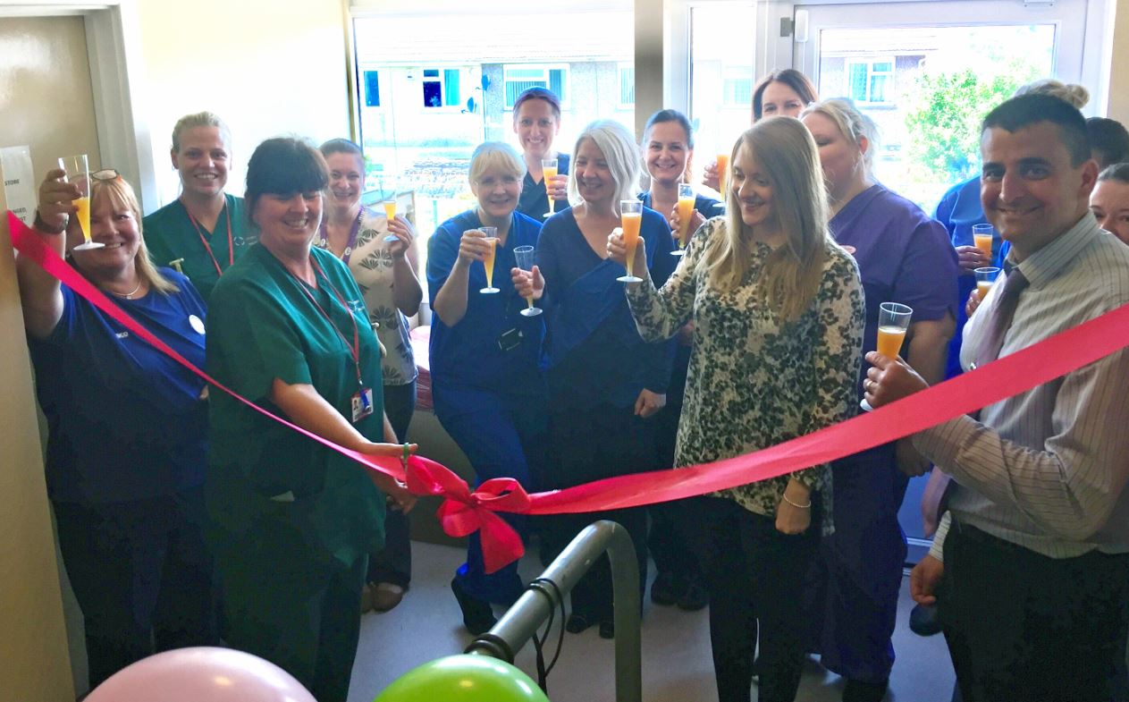
She hopes that even just five minutes of exercise a day will help to lift mood and improve the mental health of her workmates.

Sharon said: “We all know that exercise makes you feel better, so I thought why not?

Left: Sharon cutting the ribbon revealing the new gym area with the rest of the team

“I know that it’s hard for some people to fit in exercise with their work and personal life.

“So I thought if we had somewhere at work which staff could pop to in the morning, or at lunch, it would make such a difference.”

Sharon became a wellbeing champion with the health board earlier in the year.

Champions raise awareness of wellbeing initiatives within the organisation, and are a point of contact for colleagues who want to know more about the services that are available to them.

Her first project involved providing her team with fresh fruit.

She got in touch with Steve Carter, community champion in Tesco Llansamlet, and asked if the store could supply free fruit every week for four weeks – which it agreed to do.

Following on from the success of that venture, Sharon was keen to develop a new project and came up with the idea of the gym.

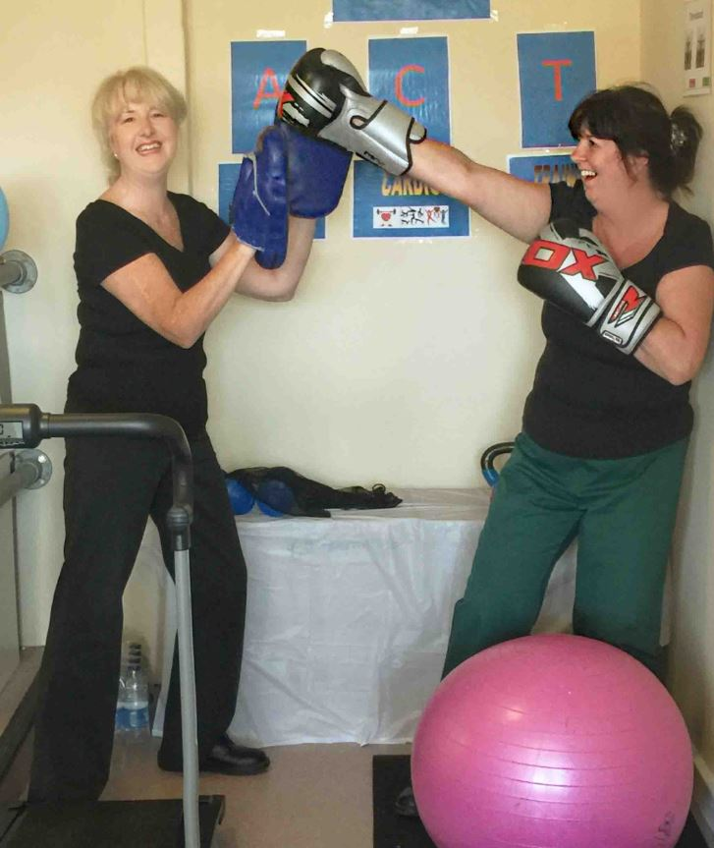
She said: “Our job is to care for others – but it’s very important to also take care of our own wellbeing which can sometimes be forgotten.

“If someone is having a particularly stressful day – it’s surprising how much their mood could lift by just doing five or ten minutes’ exercise.”

Right: Sharon and colleague Caroline making use of the gym area

The gym area has gone down well with colleagues, who have now followed Sharon’s lead and brought in equipment for others to enjoy.

They are officially known as the Acute Clinical Team (ACT), but now refer to themselves as the Abs, Cardio and Training Team.
Sharon said: “We have an exercise ball, ropes, boxing gloves, dumbbells – and even a trampoline, step machine and a treadmill.

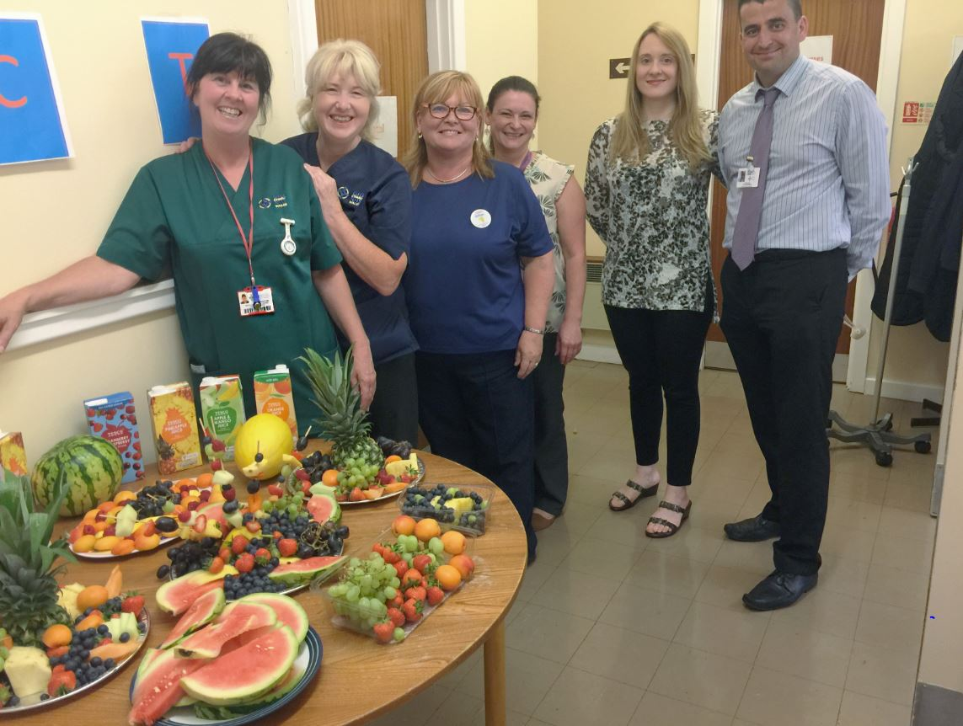
Left: The team with their donations from Tesco

“I’m so thankful for everyone who’s contributed to making it a great space to work-out and switch off.

“Tesco in Llansamlet have also kindly donated lots of fresh fruit, water and juice for the area – we are ever so grateful.

“The team has really embraced the gym area and it’s a social thing too.

“It is a great place to chat with colleagues in a less formal environment.

“It really has been a success in our team and I’d really encourage others to do the same if they are able to.”
Source: Abertawe Bro Morgannwg University Health Board

