Specialist role helps reduce cancer waiting times
Wednesday, 21 November 2018
A new specialist role at Princess of Wales Hospital has helped to reduce waiting times and speed up treatment for people with cancer.
The hospital was the first in Wales to appoint an advanced radiography practitioner in CTC (Computerised Tomography Colonography), a specialist examination of the large bowel.
This is a diagnostic technique that provides 3D images of the large bowel and rectum to help identify polyps and cancerous areas.

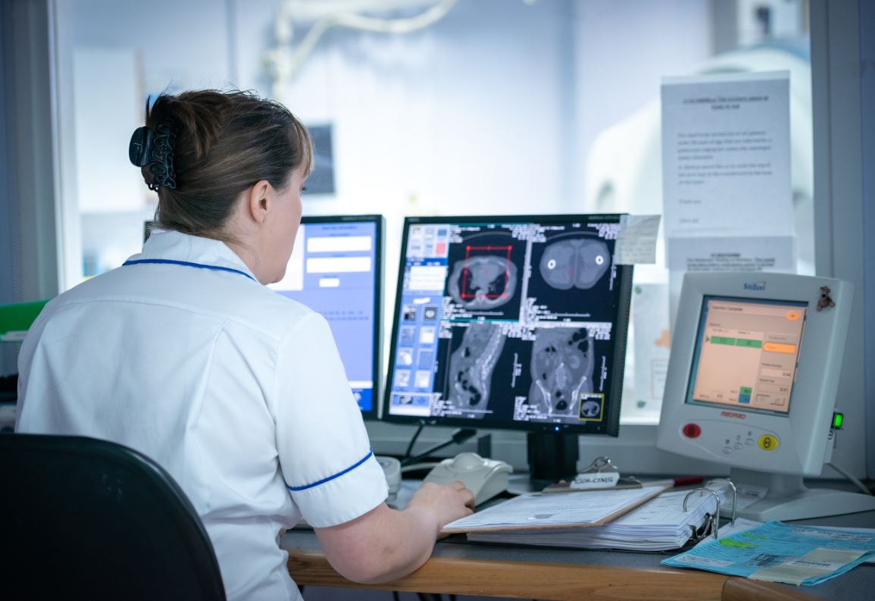
Left: Louisa Edwards, Advanced Radiographer Practitioner in CT

The new service saw the department shortlisted for a 2018 NHS Wales Award.

The advanced radiography practitioner role came about as a result of higher demand for CTC, which is a new diagnostic technique, without any additional resources.

This, coupled with a national shortage of qualified consultant radiologists, meant it was challenging to deliver a timely service for patients.

POWH Radiology Clinical Director Dr Sian Phillips obtained funding from the Cancer Innovation Fund, which is administered by the Wales Cancer Network and 1000 Lives.

This allowed Louisa Edwards, who was working as a senior radiographer in computerised tomography at POWH, to undertake postgraduate study to deliver the new role.

Louisa said: “I had expressed for some time how I’d like to progress further with CT Colonography.

“So I was really happy when we were able to secure the funding and I was told I would be a great fit for the role.

“I have worked in CT for 11 years, and have always enjoyed the imaging focus of the role and was really excited to learn even more.”

The funding allowed Louisa to study at Keele University alongside her job to prepare her for the role, and equip her with the formal postgraduate knowledge to translate into clinical practice.

She now oversees the team and their development, running training sessions to help improve their confidence and knowledge.

The training has given radiographers practical knowledge and confidence – and they can now carry out procedures independently.

Louisa is on hand if there are any problems, and to give advice during the scans – which is key to achieving the best image quality and to aid diagnosis.

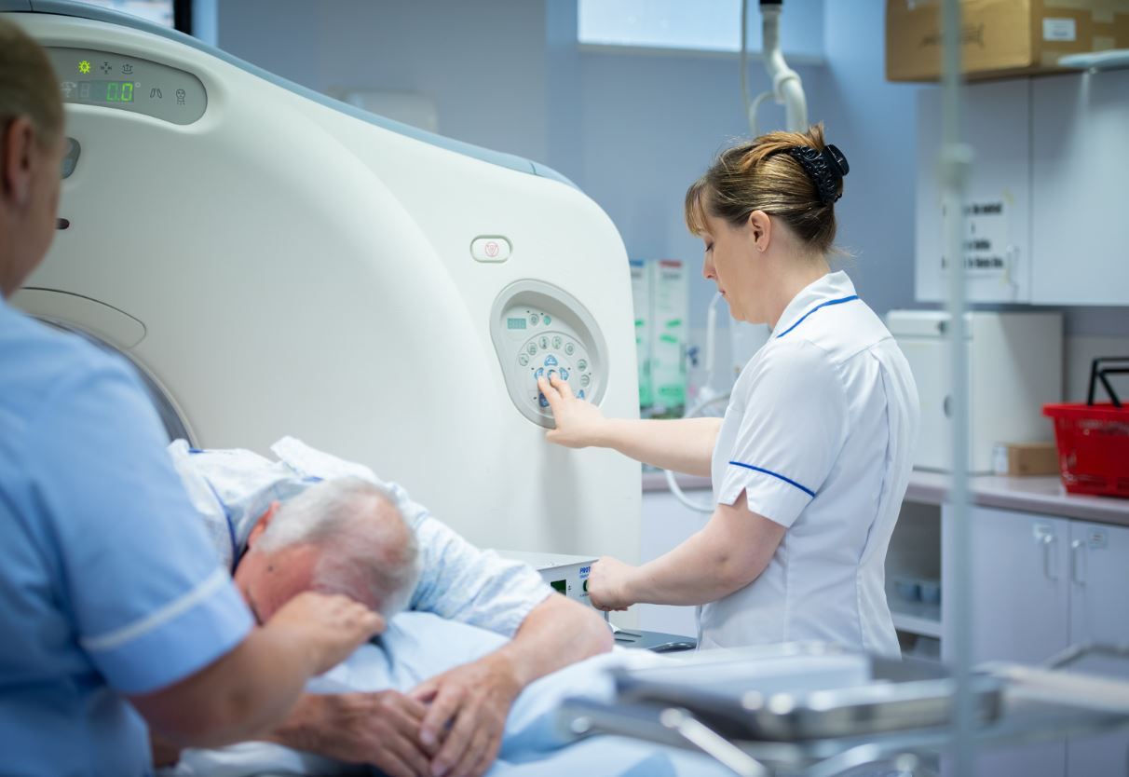
Right: Louisa Edwards, Advanced Radiographer Practitioner in CT with patient

“I have learnt so much which I’ve been able to bring back to the department and share with other radiographers,” Louisa said.

“The course helped me to better understand the required standards and experience expected of all staff in the team to enhance our overall service.

“Radiographers in the team have told me how invaluable the training has been for them.”

The longest waiting time for a CTC scan has also been reduced by 69 per cent at Princess of Wales Hospital.

Louisa has also provided CTC training and support for staff at Neath Port Talbot Hospital, which has seen its average wait reduced by 72 per cent.

Clinical Radiology Director Dr Sian Phillips said: “This role has significantly enhanced the imaging service for examination of the large bowel for the patients in this area.

“We hope to develop clinical roles in the future to promote and enhance the specialist skilled roles of radiographers.”

Source: Abertawe Bro Morgannwg University Health Board

