Social media crazes lead to rise in burns among teenagers
Thursday, 15 November 2018
Teenagers filming themselves doing stunts in the hope of becoming social media stars are ending up in hospital with burns instead.

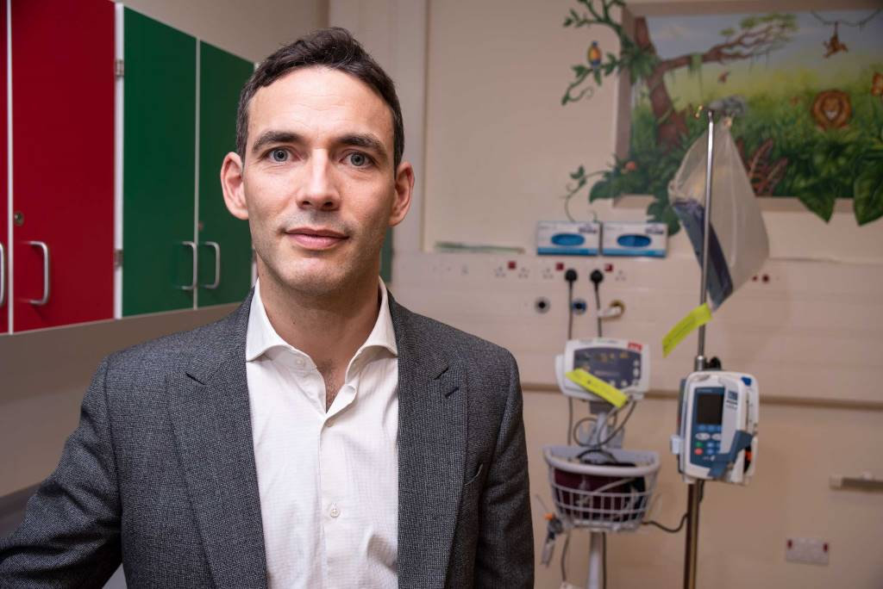
Specialist staff at Morriston Hospital have reported seeing a rise in the number of young people who have been burnt as a result of the so-called YouTube Challenge craze.

Morriston Hospital plastic surgeon Jeremy Yarrow (left) said: “I can understand there is pressure on young people to gain acceptance or boost their online profiles by doing such risky things as these challenges.

“But from the patients I see, the results can be very different, with some requiring life support treatment and many left with lifelong scars.”

There are various different challenges involving a variety of everyday substances doing the rounds. However, we are not providing details to minimise the risk of young people trying them.

Ana Biney, Dyfed Ward staff nurse in Morriston’s Welsh Centre for Burns and Plastic Surgery, said: “They copy them from social media and YouTube and call them YouTube Challenges.

“They film each other doing the challenges and then upload them in the hope they will become social media stars.

“We have definitely seen an increase in the number of teenagers who have suffered quite serious burns because of this.”

Mr Yarrow said most cases were treated as outpatients but would be admitted if they required skins grafts.

He added: “In some severe and sometimes life-threatening cases, they are admitted to hospital for long periods of time for complex surgery resulting in long term mental and physical issues.”

The advice from Burns Centre staff is to put the affected area under cool running water for 20 minutes which takes the heat out of the injury.

Call for help, which could be 999 or 111 or your GP.

If clothing is on fire, immediately drop to the floor and roll to put out the flames. Don't pat them out as this causes burns to the hands.

Cover the burn with cling film – never cotton wool – which protects the burn but allows doctors or paramedics to look at it.

Ana Biney added: “Good first aid is essential. If you do it right, it can have a massive effect on the burn.

“But of course the best thing to do is not to take part in these stunts in the first place. They may look exciting and spectacular on social media but the reality is very different.

“They could be killed or scarred for life.”

Source: Abertawe Bro Morgannwg University Health Board

