Patients benefit from generous donation
Thursday, 1 November 2018
Patients in a Swansea hospital can now enjoy their favourite programmes on two new TVs thanks to the generosity of a local community group.

They were bought out of the £578 raised through a fun day which took place in Parc Y Werin, opposite Gorseinon Hospital.

The Parc Y Werin Committee, which formed in November 2015, run a range of activities in the park to bring the community together.

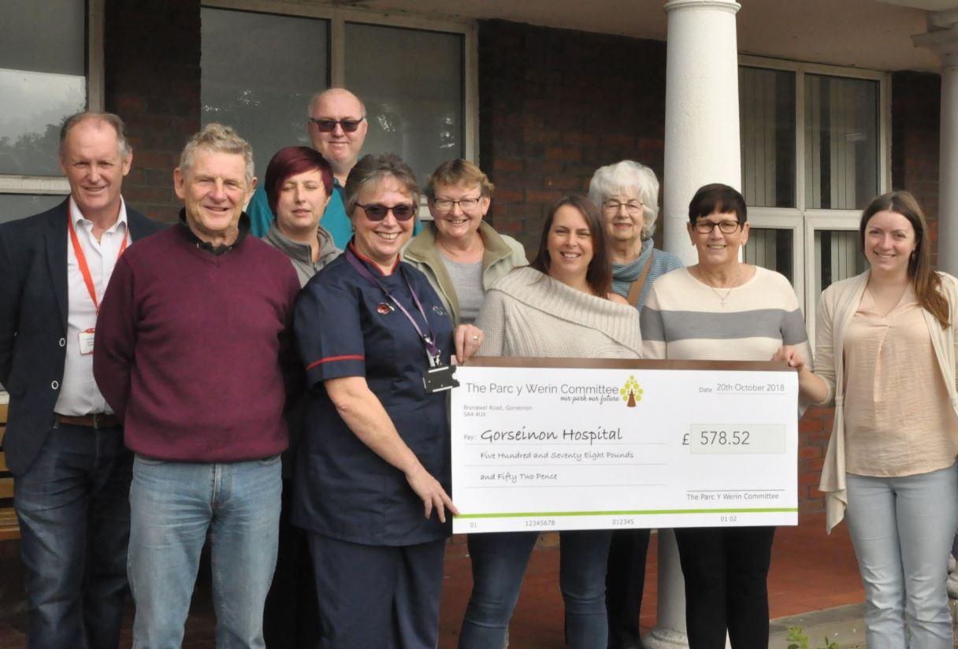
And they decided to dedicate the fun day to raising funds to give something back to their local hospital for the wonderful care they provide within the community.

Left: Parc Y Wern Committee members presenting the money raised to staff at Gorseinon Hospital.

Lead Nurse for Community Hospitals, Sarah Taylor, said: “We are overwhelmed by the support of the Parc Y Werin Committee.
“The hospital and it’s patients will benefit greatly from this contribution.”

The fun day included a fun fair and sporting events for all the family, with multiple stalls and games.

It also included a raffle, supported by generous donations from local businesses.

Sarah added: “We really wanted to purchase the screens for patients to feel more comfortable and more at home when they stay with us at the wards and day rooms.

“The rest of the money has been put into the hospital’s endowment fund for the future.

“We’d really like to thank the public for their generous donations on the day and of course Parc Y Werin Committee for all of their hard work.”

Source: Abertawe Bro Morgannwg University Health Board

