'Outstanding Team' award for specialist ante-natal clinic
Monday, 26 November 2018
A team that supports women with substance misuse and prescription drug issues through pregnancy has triumphed at the Zenith Global Health Awards in London.

Staff in ABMU's Substance Misuse Ante-Natal Clinic (SMANC), who were up against colleagues from across the NHS and private healthcare sector in the UK, scooped the Outstanding Team gong.

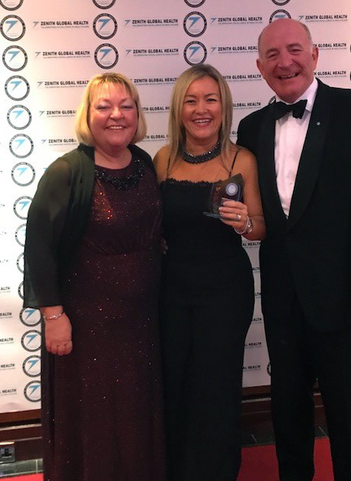
SMANC provides specialist ante-natal care for women who misuse illegal substances or are prescribed medication which could have a detrimental effect on their baby.

There have been year-on-year increases in attendance at SMANC, with a total of 4.6% of all babies born in the ABMU area in 2017 having mothers who attended the clinic.

The team has also established the Mental Health Ante-Natal Clinic (MHANC) to address the issues faced by pregnant women who need to take prescribed psychiatric medication and this won further praise from the judges.

They agreed that SMANC is truly a multidisciplinary service with the team encompassing midwifery, obstetrics, specialist prescribing service, Community Drug and Alcohol Team and external agencies including BAROD from Swansea, which supports anyone facing issues with drug and alcohol use, and the Welsh Centre for Action on Dependency and Addiction.

The SMANC team promotes consultant led ante-natal care and addresses the attitudes and needs of substance misusing pregnant women with a pastoral aspect.

For many women, and often their partners, pregnancy is their opportunity to engage with agencies and access care, which they have not done before, bringing stability to their lives in readiness for parenthood.

The service helps to improve the prospects of mum and baby, as well as the wider family.

Substance Misuse Specialist Midwife Ann Saunders said: “We believe inter-team communication and co-operation is the key to excellent working relationships and is vital to our success in improving outcomes for our patients and their families, as well as the palpable positive impact our service delivers.

"We are delighted to have received the award in recognition of our continued hard and unique work with these client groups."

The SMANC Team comprises:
Ann Saunders - Substance Misuse Specialist Midwife ABMU HB
Mr Rob Llewelyn - Consultant Obstetrician
Nicola Cook - Substance Misuse Specialist Nurse ABMU HB
Sian Phillips - Band 6 Midwife
Rebecca Eynon - BAROD Key Worker
Holly Gallagher - WGCDA Key Worker
Emma Adams - Substance Misuse Nurse

Source: Abertawe Bro Morgannwg University Health Board

