Getting animated to help reduce the risk of crippling condition
Thursday, 15 November 2018
People at risk of a crippling but often avoidable condition can protect themselves by getting animated in more ways than one.

There are concerns that people who become suddenly unwell or have a reduced ability to feel or move could be vulnerable to pressure ulcers.

Now ABMU has commissioned an animated film highlighting the importance of movement in reducing the risk.
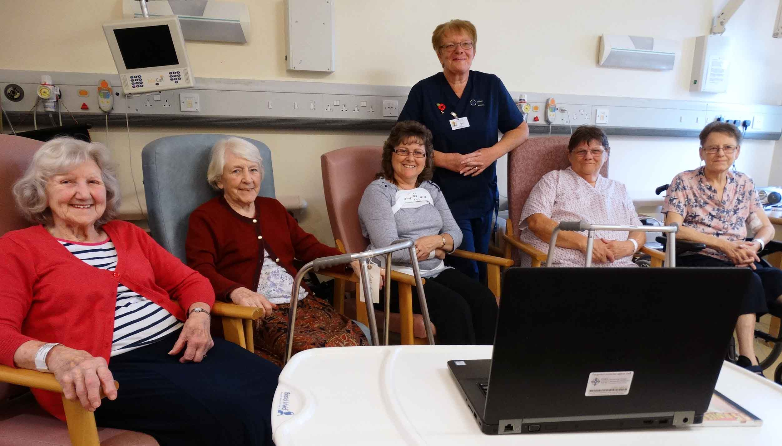
Ward E patients at Neath Port Talbot Hospital watched the video, which they found to be very informative and helpful. Seated l-r - Irene Cardy, Joyce Newman, Ann Williams, Marie Williams and Helen Evans. Standing – ward manager Christine Evans.

The two-minute educational video, Move A Little More, has been released to coincide with World Stop Pressure Ulcer Day today (Thursday Nov 15th).

This year the theme is raising public awareness – and the video is just the latest in a series of campaigns the health board has run to raise awareness in the community and in hospitals.

ABMU principal clinical scientist Dr Mark Bowtell, who worked on the film, said: “It’s all about how the public, carers and families can help prevent pressure ulcers.

“Some people can’t get up and walk, but can do small repositioning movements…little and often is key.

“Our skin and tissue need a good supply of blood flow and moving little and often helps ensure we protect vulnerable parts of the body.

“The film is also a great asset to our range of training resources for staff.”

Move a Little More was premiered during ABMU’s Stop Pressure Ulcer Conference this week.
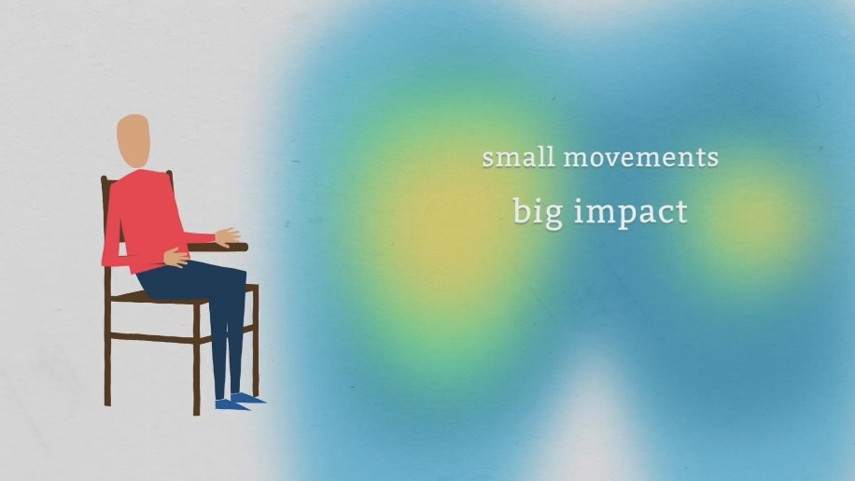
ABMU staff can use their iPads to show it to patients and carers when visiting them in their own home or nursing home.

Meanwhile, patients on Ward E in Neath Port Talbot Hospital who were given a preview of the video found it to be “very informative and helpful”.

Pressure ulcers are a common problem for people with limited mobility, who sit or lie in one position for long times.

With blood flow restricted by the pressure of their weight on parts of their body, there can be severe tissue damage.

The impact on the patient can be devastating and in some cases can lead to people needing major surgery.

ABMU tissue viability clinical nurse specialist Karen Kembery said there had been great success in reducing hospital-acquired pressure ulcers.

“However, there are many people in the community who may have mobility issues, or may be disabled, but are not in contact with any healthcare professionals.

“They could be at risk of pressure ulcers, especially during the winter when people get flu or become unwell, and their mobility reduces from what it is normally.
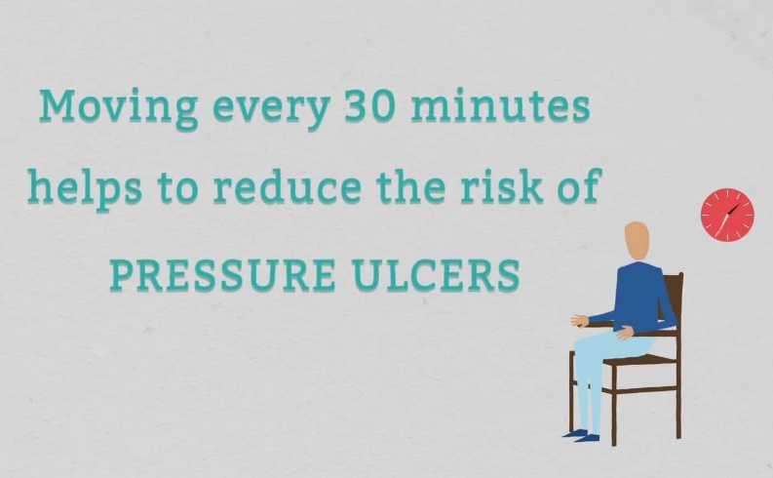
“People may not even know that potential exists, yet anybody can be at risk, particularly if their mobility suddenly declines.

“If they don’t move as often as they could, there’s a potential for them to damage their skin.”

Those who are less able to move regularly or are unable to feel pressure may be at risk. Damage can happen more quickly if they are:

• Elderly;
• Have circulation problems;
• Have difficulty keeping skin dry;
• Are not eating and drinking well enough; and
• Are unwell.

Looking out for the first sign, redness over a bony area, and seeking help could prevent deep ulcers developing.

Karen said that, while the elderly were more vulnerable to pressure ulcers, there were times when younger people could be at risk too.

“It’s all to do with the ability to move independently.

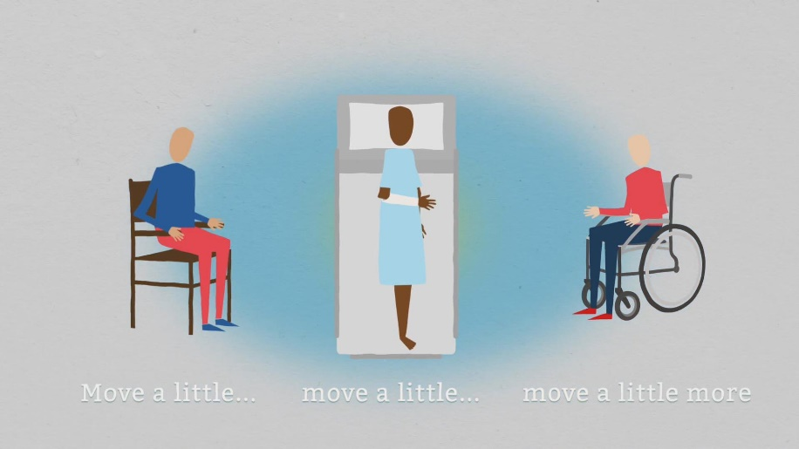
“You could be someone who is usually very fit and sporty but could have an injury that means you have to spend a lot of time in bed.

“You could then start to develop pressure areas on your heel or back and may not realise it.

“If anyone of any age is worried they could be vulnerable, if they are worried about their skin, or if they have concerns about a relative, they should contact their GP.”

Neath Port Talbot Hospital Nurse Director Lesley Jenkins said: “This short film tells an important message to people of all ages that small and frequent movement can significantly reduce their risk of developing pressure damage.”

You can watch the video below - double-click to watch full-screen.

https://www.youtube.com/watch?v=zx3zdHhnrx0

Source: Abertawe Bro Morgannwg University Health Board

