Careers day held to inspire next generation of speech and language therapists
Thursday, 1 November 2018
Speech and language therapists from ABMU Health Board hosted a careers day aimed at highlighting what the profession has to offer.
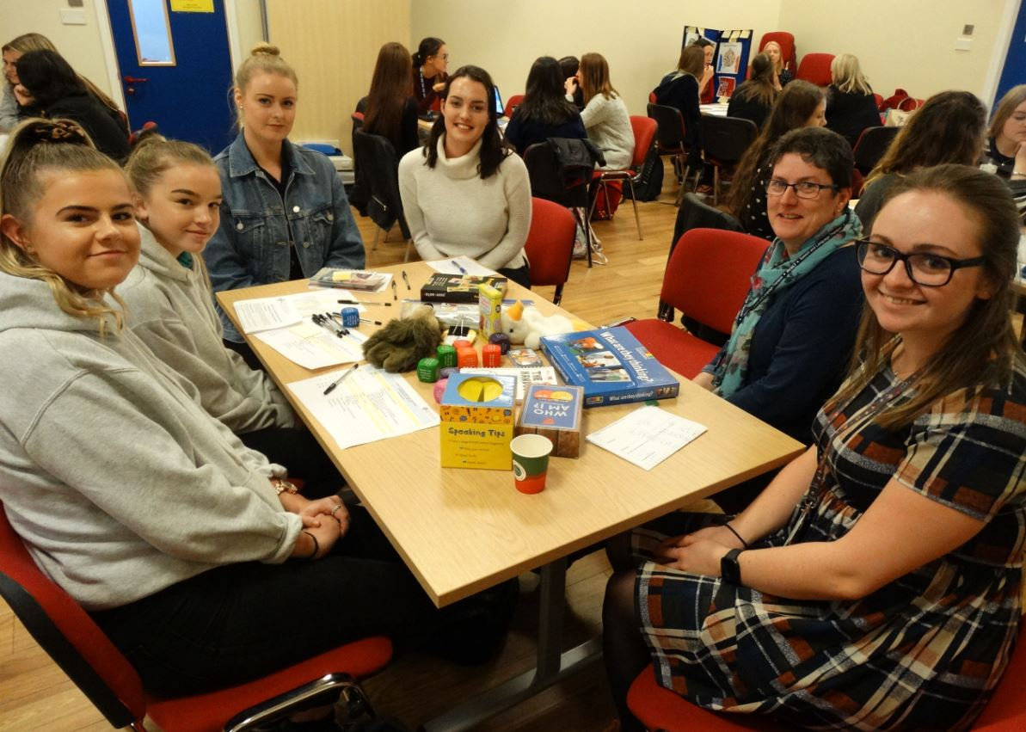
The event at Neath Port Talbot Hospital, consisted of various workshops, presentations and videos.

Speech and language therapist Lowri Roberts said: “The videos covered several areas of speech and language therapy including development and the role of prevention in the early years, dysfluency, cleft lip and palate, swallowing difficulties and the needs of stroke patients.”

Patient stories, covering a variety of groups across paediatric and adult services were also shown - with patients sharing their experiences of how they have benefitted from speech and language therapy.
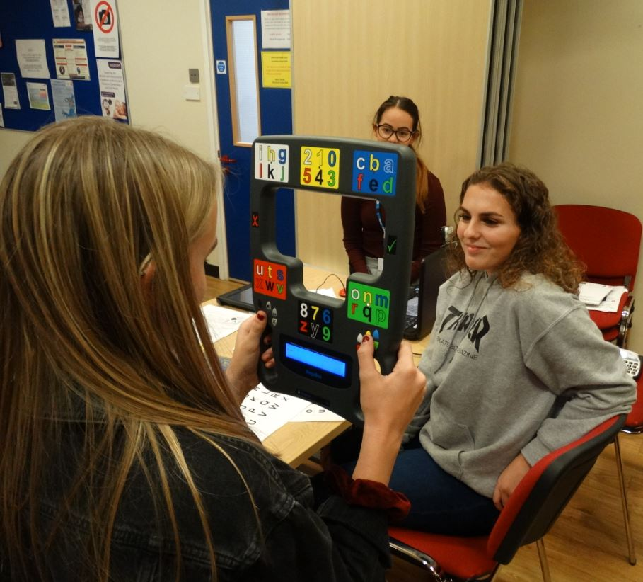
Attendees were given the opportunity to chat to newly qualified therapists to find out information covering as many aspects of their roles as possible.

A Cardiff Metropolitan University representative was also there to explain what the training involved.

Speech and language therapist Lauren Johnson said: “We are trained to assess, diagnose, treat, advise and support those who have difficulties with speech, language, communication and swallowing from birth to end of life.”

Therapists work across a variety of different settings, from hospitals and schools to care homes and clinics.

Speech and language therapist Jane Ahearne said: “The event was a great success and positive feedback was received from the attendees stating how informative the day was.

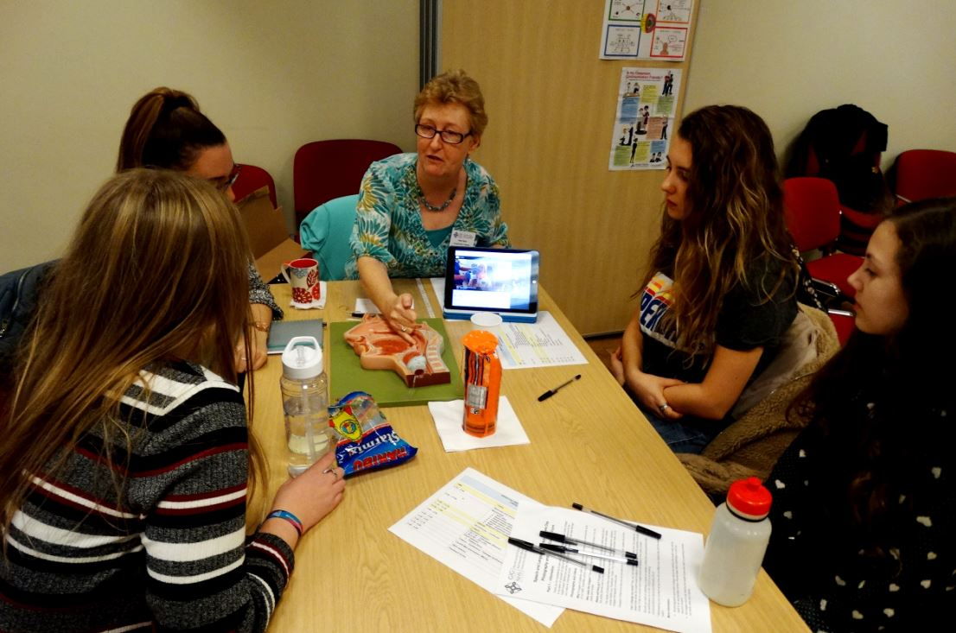
“They were inspired by our therapists’ specialist knowledge and passion for supporting those with speech, language and communication needs.

“Many of those who attended were previously unaware of the diversity of client groups and specialisms that can be pursued as a speech and language therapist.”

For more information about speech and language therapy as a career, visit the Royal College of Speech and Language Therapists website and NHS Wales Workforce, Education and Development Services

You can also view the ABMU speech and language therapy page

Anybody living within the ABMU health board area who is interested in next year’s event should contact Ann Williams/Arlene Harris on 01639 862718.

Source: Abertawe Bro Morgannwg University Health Board

