Surgical unit celebrates helping its 10,000th patient in just two years
Tuesday, 28 November 2017
An initiative to help speed up surgical waiting times at Morriston Hospital has marked its second anniversary by welcoming its 10,000th patient.

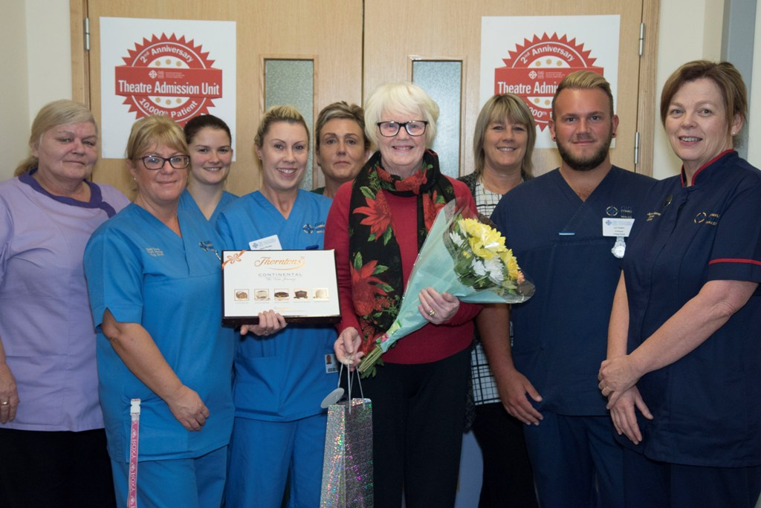
Staff at the Theatre Admission Unit (TAU), which deals with short-stay surgical patients, celebrated the double landmark with a presentation to Patricia Edwards, of Baglan, after she was admitted as a day case.

Patient Patricia Edwards with staff after being presented with her gifts as TAU’s 10,000th patient.

She said: “What a surprise being the 10,000th patient and receiving the lovely flowers, chocolates and wine. I was shocked but it really brightened up my day.”

Mrs Edwards arrived on the ward at 7am and was able to go home in the afternoon following her surgical procedure.

“I was so nervous coming in for surgery until I met all the staff, they made me feel so positive.

“It was wonderful to be able to be in and out in one day. Everyone who dealt with me was absolutely brilliant and I think the unit is excellent,” she added.

The unit initially opened as a six-month pilot project in 2015 to help reduce waiting times and cancellations for short-stay surgical patients who would be low clinical risk for admission.

Instead of requiring a temporary bed on a ward after a surgical procedure, patients return to TAU to recover until they are ready for discharge. This not only frees up beds on wards for more urgent cases, it also means a short-stay operation is unlikely to be cancelled if the bed has been needed for an emergency case.

The benefits of the project became clear almost immediately. Of the 4,462 patients admitted to the unit during its first year, just 807 patients were transferred onto the ward, the other 3,655 patients were discharged home directly from TAU.

Based in the hospital’s former fracture clinic, TAU is managed by charge nurse Lyn Hopkin and overseen by matron Jayne Morris. It has senior nurse cover 13 hours a day, as well as reception cover to support patient admission, transfer and discharge.

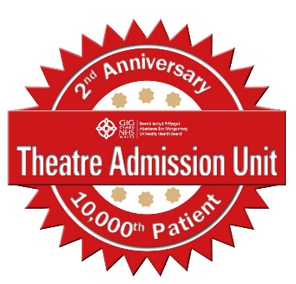
It is open to all surgical specialties at Morriston for their planned short-stay patients and also provides additional capacity for diagnostic procedures and unscheduled minor surgery for:
• Patients who require elective short stay/day surgery;
• Patients having interventional radiology procedures who need a recovery period following their test or who are visiting from another hospital for their test; and,
• Patients who require minor procedures following an emergency admission – where procedures can be undertaken quickly and the patient discharged without the need for a traditional ward bed admission, such as minor trauma.

The delighted team say feedback has been overwhelmingly positive. In the Family and Friends survey which is offered to all in-patients to allow them to comment on the treatment they have received, the unit has been ranked first not only for Morriston but for all sites across ABMU.

One patient wrote: “From start to finish in this service care was exceptional. They were well organised, efficient and genuinely seemed to care for my welfare.

“I was also fully informed of what was planned and entailed. Very pleased, thank you” while another added: “The unit is obviously well run and efficient – a good advert for the NHS.”

The unit has also proved very popular with staff from various specialties whose patients have used it.

Consultant plastic surgeon Sarah Hemington-Gorse said: “The unit is incredibly efficient, the patient journey smooth and from the point of admission to discharge I could not be happier with the care that my patients receive.

“The development of TAU has, in my opinion, been a fabulous step forward in day surgery care and now that we have it I’m not sure how we ever managed without it.”

Lung cancer specialist nurse Tracey Kowalski added: “The care given to our patients is impeccable and the staff always treat our patients with sensitivity and dignity.

“TAU has proved to be an incredible asset with all our patients so there is no delay in awaiting diagnosis which often causes distress.

Jayne Morris said: “We are very proud of the way TAU has continued to support the scheduled care patients for surgery in Morriston throughout its second year of operation.

“I look forward to starting our third year and hope that TAU continues to go from strength to strength, providing excellent care by its team of nurses.”

Source: Abertawe Bro Morgannwg University Health Board

