Star shows a little love for hospital to say thanks for gran’s care
Thursday, 2 November 2017
Singer songwriter Bright Light Bright Light may have swapped Neath for New York but he hasn’t forgotten his roots.

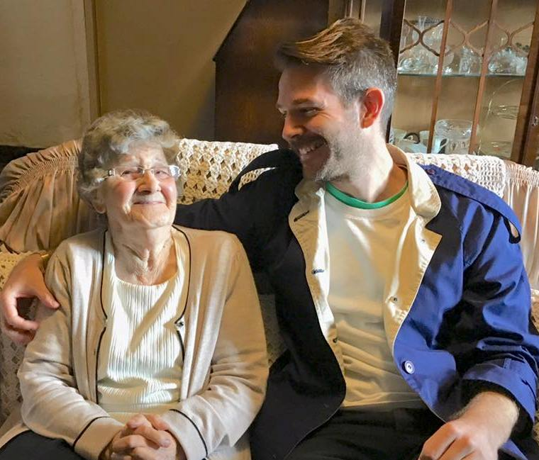
The performer – real name Rod Thomas – works closely with Elton John and Scissor Sisters, is set to tour with Erasure next year and is now in demand as a DJ and producer.

However, his latest project is inspired by someone very close to his heart – his gran Joyce Davies, of Aberdulais.

Rod Thomas with his gran Joyce Davies.

To say thank you for the care she received 20 per cent of the profits from his next single will go towards the Elderly Day Unit at Neath Port Talbot Hospital which looked after Mrs Davies.

The release sees Rod join forces with Nerina Pallot for a cover of Put A Little Love in Your Heart, best known for the version by Al Green and Annie Lennox used in the film Scrooged.

“I feel really strongly about the NHS and how important it is to us.

“My grandmother had wonderful care when she was at the unit and I wanted to do something to say thank you and show my support for the hospital,” he said.

Hospital Director Claire Birchall said she was very touched by Rod’s plans.

She said: “We are delighted that Rod has decided to do this in recognition of the care and compassion our Elderly Day Unit staff give to patients such as Mrs Davies.

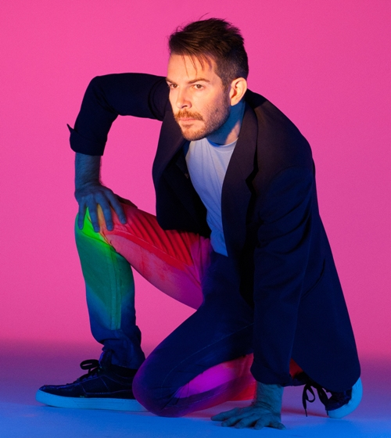
“The unit adds great value to a patient’s health and wellbeing, particularly the frail elderly. Its contribution is sometimes overlooked so we are over the moon that it is getting this respect and appreciation. ”

Rod won over thousands of new fans after a high-profile appearance on The Graham Norton Show alongside Elton John when he performed his single All in The Name last year.

Rod is returning to the UK in the new year as part of Erasure’s European tour and he is hoping to be able to take the opportunity to come to the hospital to meet the staff who looked after his grandmother.

“I would love to pop back in and say a thank-you to everyone. I am very grateful and just happy I can do something practical to help support the team’s hard work,” he said.

The single is available to buy and download from Friday, 3rd November – go to http://www.brightlightx2.com/charity

Source: Abertawe Bro Morgannwg University Health Board

