Phyllis keeps smiling now she's had her flu vaccination
Monday, 6 November 2017
Great grandmother Phyllis Powell’s motto in life is to keep on smiling, despite her ill health.
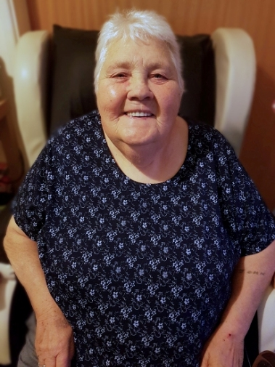
With COPD and diabetes Phyllis, aged 67, (right) knows she has to take care of herself, particularly as the weather get colder and we head into winter.

That’s why she always ensures she has her free flu vaccination.

“The doctor’s surgery always reminds me about it and I don’t argue, I go along and get it,” she said.

And she does her bit to encourage her friends and neighbours at Ty Twyn Teg in Caewern, Neath to do the same.

“I want to make sure I have anything that will help me stay well and I advise anyone else – particularly if they have got health problems like me – to make sure they do too.”

Phyllis admits she didn’t always realise how much protection the vaccination could offer.

“For many years I didn’t bother to have it myself but now with my diabetes I would never take the risk of going without it. It is really important.

“I love spending time with my great grandchildren, I want to be around to spoil them.”

Because of her various on-going health problems Phyllis is among one of the high-risk groups health teams are eager to target when it comes to flu vaccination.

“The last thing I want is to have flu on top of everything else. I want to stay well and keep smiling,” she said.

The virus spreads easily and can cause severe symptoms in healthy people but for those with chronic health conditions like Phyllis, the very young, the elderly and pregnant women the consequences can be very serious and even life-threatening.

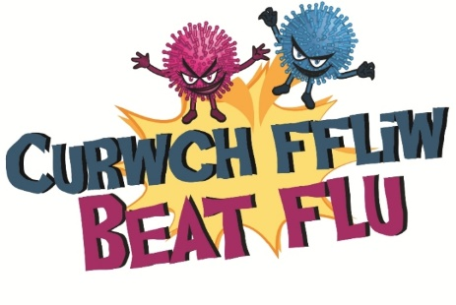
She added: “The jab has saved my life, I know it has. I have been so ill that I nearly died and if I had contracted flu on top of it that it would have finished me off for sure.

“I always tell people who don’t like having jabs to go for it – be strong and have the vaccination because it will make you stronger in the long-term.”

All those in the at-risk groups can arrange to have their free flu vaccination at their GPs surgery.

For more information go to www.abm.wales.nhs.uk/flu

Source: Abertawe Bro Morgannwg University Health Board

