New Zealand hospitals join Morriston team's life-saving research
Tuesday, 21 November 2017
Experts at Morriston Hospital have formed a new partnership with New Zealand as part of research aimed at reducing the number of deaths from chest injuries.

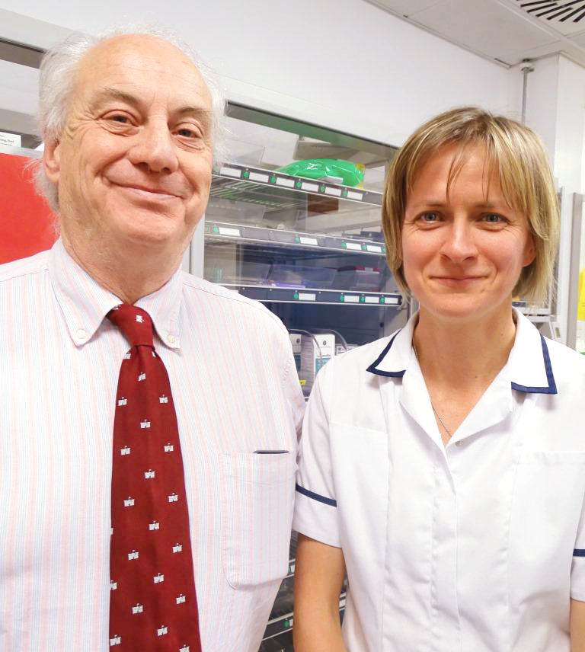
It is being led by Morriston’s Dr Ceri Battle and is part of the hospital’s academic emergency medicine research programme.

Several UK hospitals are already taking part in a feasibility study in readiness for a large-scale trial.

Professor Adrian Evans and Dr Ceri Battle of Morriston Hospital

Now four hospitals in New Zealand have signed up for the study. It focuses on patients with chest injuries which, while being relatively minor, can lead to serious, potentially fatal complications.

Often, these complications do not emerge for several days, leading to people returning to hospital as emergency cases.

The research at Morriston Hospital resulted in the creation of a risk factor-based diagnostic tool that can identify from the start which patients are most at risk of developing complications.

Consultant physiotherapist Dr Battle, who leads the epidemiology division of the academic emergency medicine research programme, said: “We worked out the risk factors that are important for developing complications.

“These are age, the number of rib fractures, whether the patient has chronic lung disease, whether their oxygen saturations are low when they come in and whether they’re on anticoagulants.

“They get scored on these risk factors and the score tells you where the patient should go – home, to the ward, or to ITU.”

The risk score was fully developed and validated in a large UK-wide study.

A large-scale trial involving thousands of patients will now be required to test whether the screening tool works in clinical practice.

Dr Battle has worked on the project for 10 years, and the early stages in Morriston Hospital eventually developed into her PhD project.

Last year she secured a £230,000 Research for Patient and Public Benefit Grant from Health Research Wales for a feasibility study, known as STUMBL.

This is effectively a scaled-down version of the forthcoming larger trial – to be called STUMBL 2.

STUMBL started earlier this year and involved around 200 patients from hospitals in Salford, Manchester, Taunton and Newport.

The link with New Zealand was established by Professor Adrian Evans, who heads the Morriston academic emergency medicine research programme, while he was on a lecture tour there.

The hospitals which have joined the trial are located in Auckland, Christchurch, Tauranga and Whakatane.

Dr Battle said: “We know the risk score works in the UK but we haven’t validated it yet overseas.

“The sites in New Zealand are going to validate the score for us. Then, once we have progressed to STUMBL 2, the NZ centres will participate in that so it will be an international collaboration.

“But there is no point us testing the tool in NZ until we know it is valid for use there.”

The results of STUMBL are expected next year. Dr Battle said STUMBL 2 would involve up to 20 UK sites, plus those in New Zealand. Subject to a successful grant application it could start in 2019.

Professor Evans said the hospitals in New Zealand had been very keen to become involved with the trial.

“Their demographics are very similar to ours, as is their healthcare service.

“They were very impressed with the work done so far and they really want to develop their research potential as well.

“They have quite a large research network and are very keen to link in with ours. So this is now a truly international collaboration – the first of many between us and New Zealand.”

Source: Abertawe Bro Morgannwg University Health Board

