Hospital staff say thank you to Port Talbot League of Friends
Thursday, 16 November 2017
Youngsters attending the children’s centre at Neath Port Talbot Hospital are among the many people to benefit from the tireless work of a group of local fundraisers.

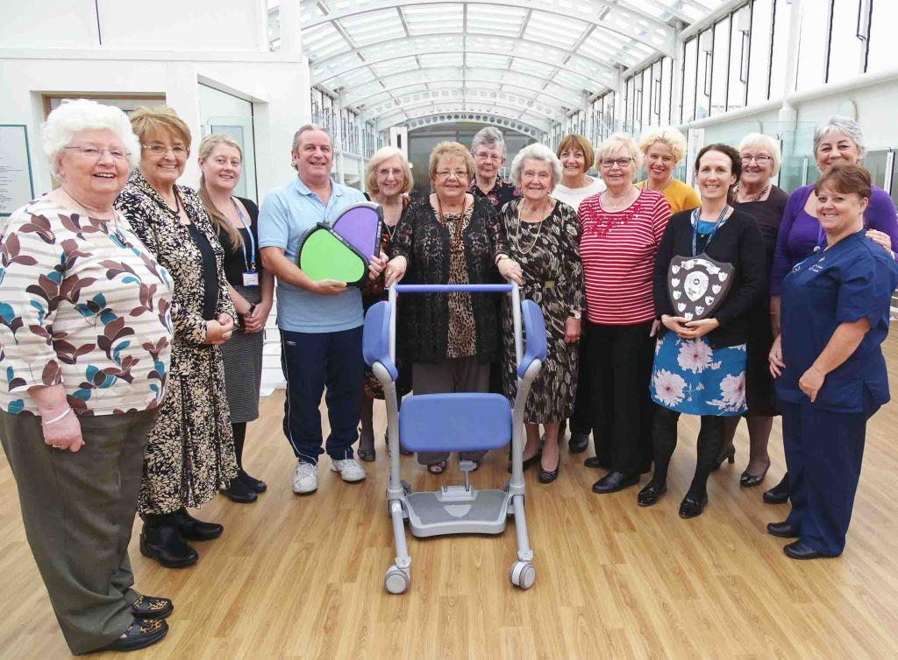
Port Talbot League of Friends has been supporting patients in the town for more than 60 years.

Port Talbot League of Friends members (including the group’s chair Vicky Weekes pictured centre with one of the standing aids) are joined by staff during their visit to Neath Port Talbot Hospital

The biggest event in its calendar is the annual fete which has taken place in the grounds of Neath Port Talbot Hospital for 15 years – and in the old Port Talbot General Hospital before it closed every year since 1969.

This year’s fete was the most successful yet, generating a record-breaking £23,915. That takes the group’s fundraising efforts to £573,164 since 2002 after Neath Port Talbot Hospital opened.

Among the equipment bought in the last year were electronic illuminated Treax pads, which are used in the children’s centre for balance, coordination exercises and assessment.

Representatives of the Port Talbot League of Friends were given a demonstration of the pads when they visited the hospital for a personal thank-you from senior staff.

They were also shown a standing aid, which is used during by patients during rehabilitation to regain their mobility.

The group has funded the purchase of four of these aids in the last year.

Vicky Weekes, who chairs the group that her father Roy Hamer founded in 1953, said: “The hospital tells us what they need and as long as we have enough money we buy it.

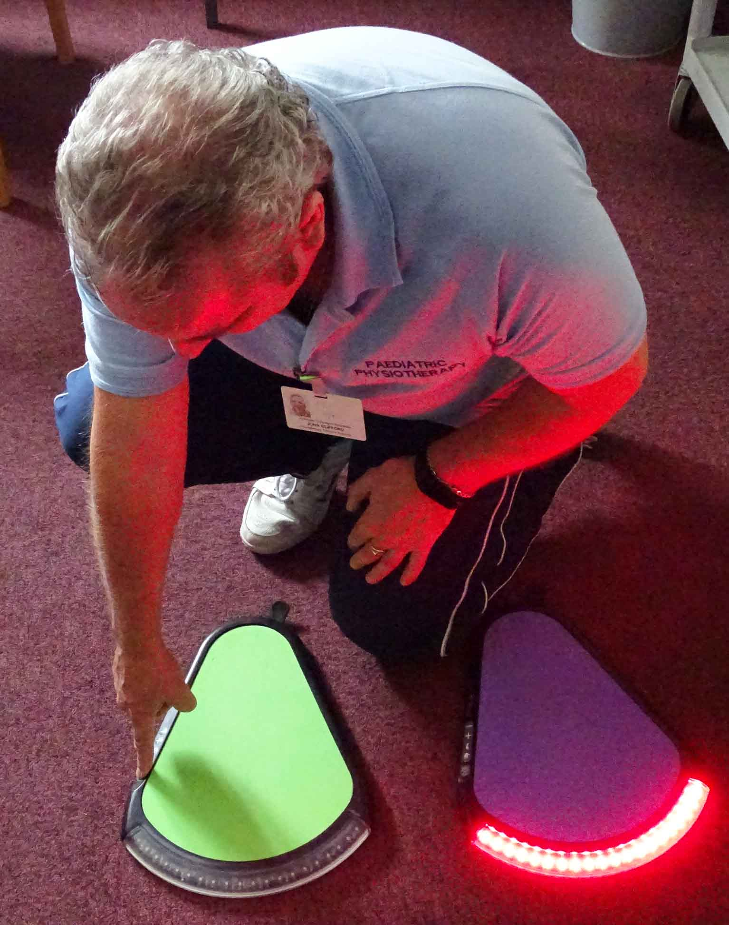
“The fete is the big event but we do fashion shows, raffles, collections and lots more. We have around 20 people who do all the work and without them it wouldn’t be possible.

“We always have fantastic support from the people of the town and we hope that will continue in these difficult times

Left: Children’s Centre paediatric physiotherapy technician John Clifford demonstrates the pads; and right: A demonstration of a standing aid by Neath Port Talbot Hospital sister Anthea Quirolo

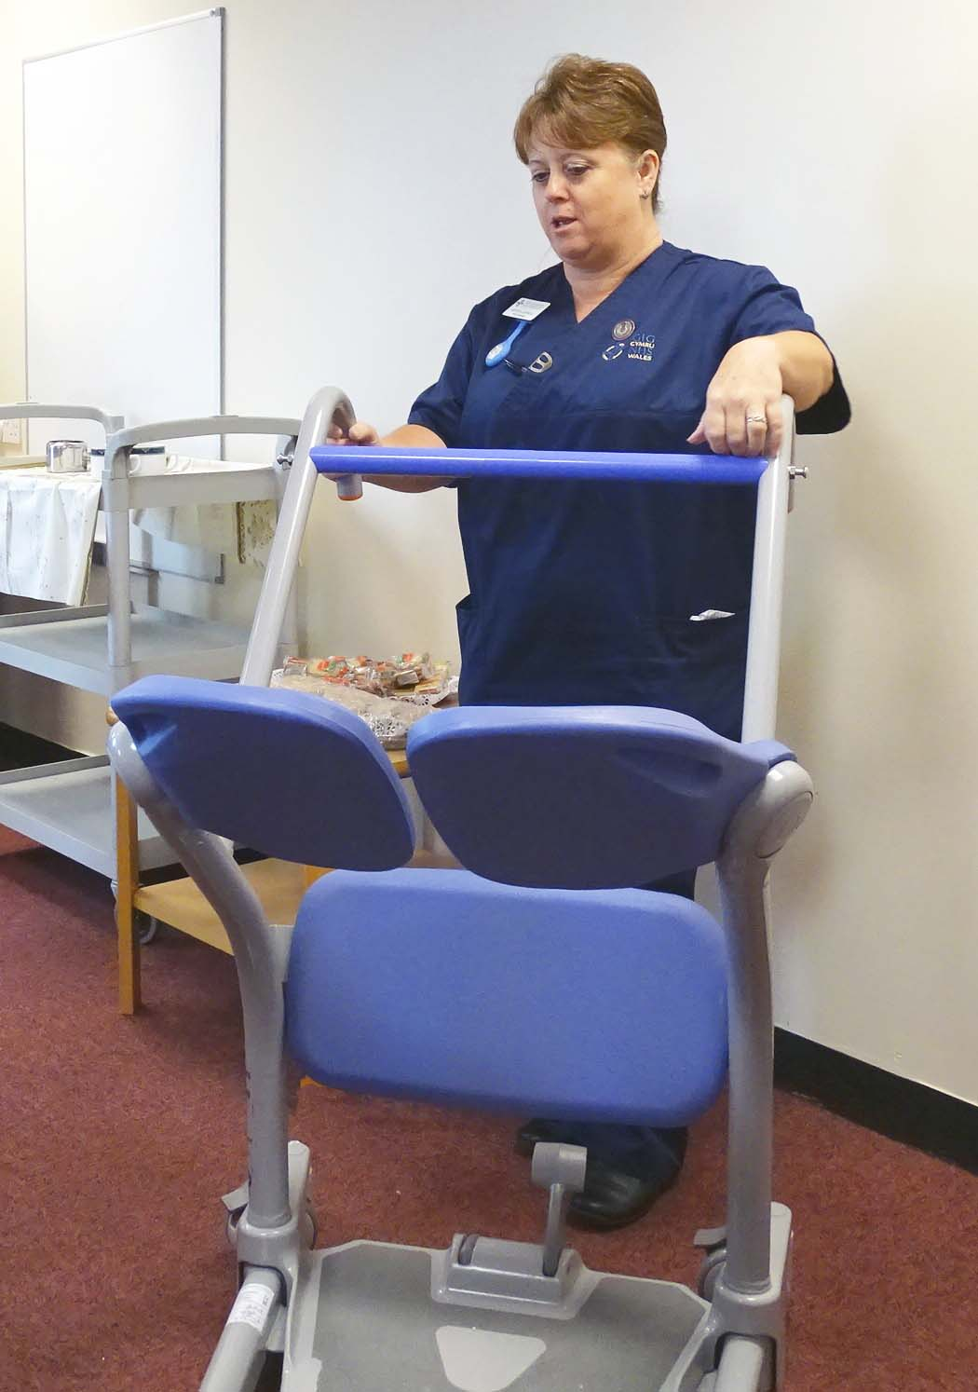
While they were at the hospital, the League also presented the commemorative shield to the department which raised the most money at the annual fete.

The Children’s Centre retained the shield it won last year, raising an impressive £740 during the 2017 fete.

Neath Port Talbot Hospital Unit Director Claire Birchall said: “It’s great to celebrate another year of working closely with our colleagues in Port Talbot League of Friends.

“We are so grateful for their ongoing support and commitment which provides such a wonderful contribution to the patients, relatives, visitors and staff in Neath Port Talbot Hospital.”

Source: Abertawe Bro Morgannwg University Health Board

