Health chiefs support fight to keep antibiotics working and saving lives
Friday, 10 November 2017
Two of ABMU’s most senior doctors are standing shoulder to shoulder with healthcare colleagues in the fight against antibiotic resistance.

Antibiotics are well known for saving lives by killing bacteria which cause infections such as pneumonia and meningitis.

But what many people don’t realise is the more we use antibiotics in people and animals the more the bacteria adapt and become resistant to the antibiotics, allowing the bacteria to continue growing and spreading.

Resistant bacteria can pass on their resistance to other people and to other types of bacteria too.
Every year, over 25,000 people in Europe die from infections that have become resistant to antibiotics and cannot be treated and this number is rising fast.

It isn’t possible to stop antibiotic resistance but it is possible to slow it down by only using antibiotics when absolutely necessary.
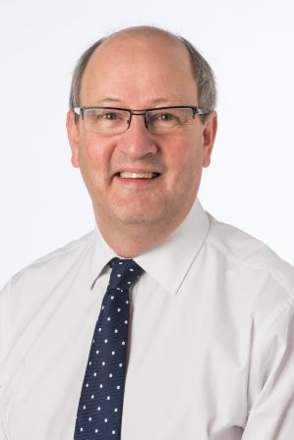
Next week (13th – 19th November) is World Antibiotic Awareness Week, and healthcare professionals from across Bridgend, Neath Port Talbot and Swansea will be out and about raising awareness of antibiotic resistance and what everyone can do to help slow it down and save lives.

ABMU Medical Director Professor Hamish Laing, and Associate Medical Director for Primary Care, Dr. Alastair Roeves are also lending their support to colleagues and encouraging members of the public to join them in the fight against antibiotic resistance.

Professor Laing (pictured left) explains: “Antibiotics are amazing; when used correctly they save lives. What is worrying is, when used incorrectly, such as when you don’t really need them, the bugs in your body can learn to stop the antibiotic working for infections you or your family might get in future.

“If we carry on taking antibiotics when we don’t need them, and resistance keeps getting worse, things we take for granted now such as having chemotherapy for cancer, major surgery and even intensive care, could become too risky to have in the next few years. Your children, your grandparents and the sickest people will be most vulnerable. We must act now.”

“Dr Roeves and I fully support our medical colleagues in following the latest clinical evidence that antibiotics should only be prescribed when absolutely necessary. To assist them, we’ve issued guidance on when an antibiotic may be helpful or when it might not; which type of antibiotic to prescribe if one is needed and how long for.”

But isn’t just about healthcare professionals following the latest guidance.
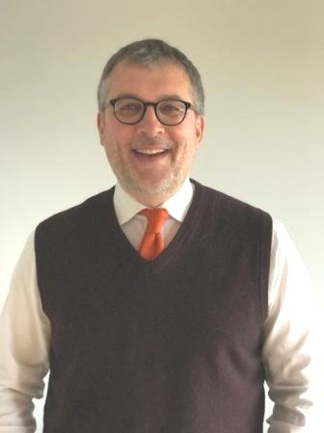
“Everyone of us has an important role to play in helping slow down antibiotic resistance and saving lives,” said Dr Roeves (pictured right).

“If your doctor doesn’t prescribe you antibiotics, please respect their decision. We expect your GP ill have followed our guidance when they assessed you and felt you didn’t need them, even just in case.

“When your doctor does prescribe you antibiotics it’s very important you finish the course regardless of if you feel better halfway through. This is because we need to make sure the antibiotic has worked against the bug. You shouldn’t have any left-over antibiotics, but if you do, please don’t take them at a later date, but return them to your pharmacy.”

As part of World Antibiotic Awareness Week there will be stands at a number of local GP surgeries, pharmacies and hospitals providing information on how to save lives by slowing down antibiotic resistance. Information is also available at www.abm.wales.nhs.uk/antibioticresistance

Source: Abertawe Bro Morgannwg University Health Board

