Get up and go! - why too much bed rest can be bad for patients
Thursday, 23 November 2017
One of Wales’ busiest hospitals has launched a campaign aimed at keeping people as mobile and independent as possible when they come into hospital. (with video)

Research shows that too much bed rest weakens elderly patients, and keeping them up and about instead can make the difference between going home; or going into a home.
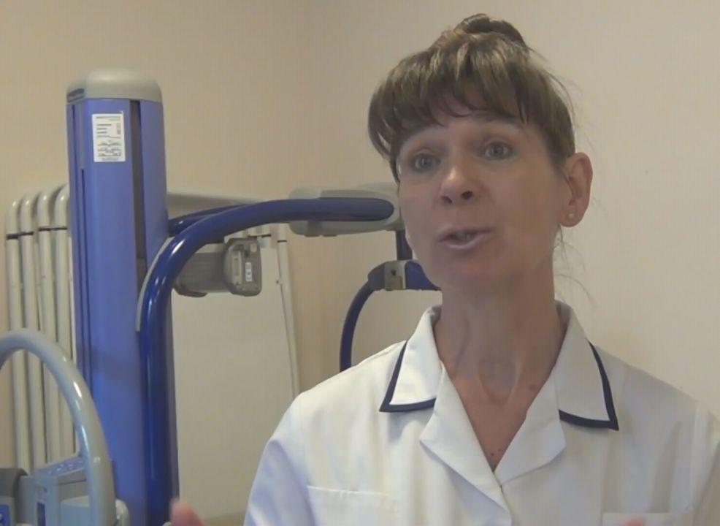
Morriston Hospital in Swansea has launched its Get up and Go! campaign to help patients and their families understand why staff are encouraging patients to get out of bed and get dressed while they are still on the ward.

Physiotherapist Sharon Maggs (pictured) said:

“There is research which tells that with the elderly, 10 days in bed can mean they lose up to 10 years of muscle strength. That’s astonishing.

“We know that being in bed really isn’t always the best thing for patients. We want to get the message out to patients, relatives and visitors when they come into hospital not to be surprised when myself, or my colleagues, encourage patients to get up, get washed and get dressed.

“We want them to be themselves, be normal. That’s the best rehabilitation.”

Occupational therapist Sarah Morse added:

“What we want people to do when they come into hospital is get up, choose what you want for breakfast, put your own clothes on, walk to the bathroom and have a wash.

“These are day to day things that you would normally do at home. This will keep you well, keep you strong and keep you active.”

Patient Wilf Pitman, aged 81, from Gorseinon, is an enthusiastic advocate for Get up and Go! He has been up and about in his day clothes and going for walks with his physiotherapist assistant Mark Joseph, in the hospital grounds. (Both pictured)

Wilf, a founder member of Loughor Inshore Rescue, said:

“As I told my doctors, you do your part in treating my lungs, and I’ll do my part in keeping the legs going and keeping mobile while I’m here in hospital. Although the physios are doing their job, people have to help themselves as well. Do your part as a patient.”
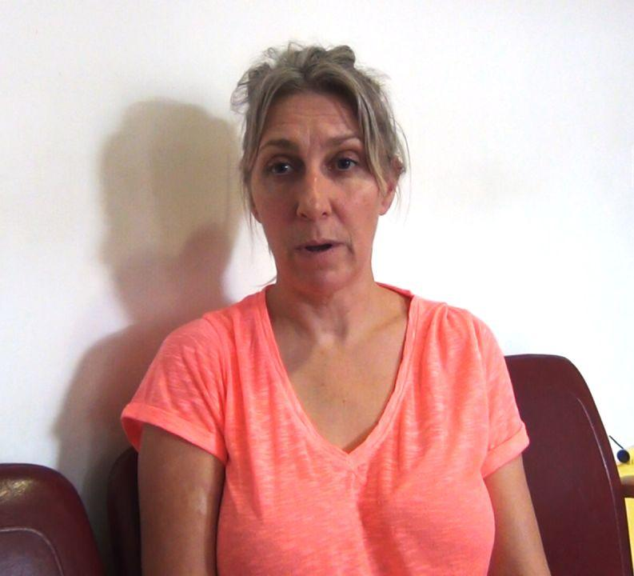
Patient Tracey Stubbington, aged 50, from St Athens, said:

“I think it’s really helpful to get up. When you’re in bed you’re just laying down. You just feel so ill and helpless. If you just push yourself to get up and get out, it starts to make you feel better, quicker.”

Nicola Williams, Morriston’s nurse director, said:

“We all know the saying ‘they are in the right place’ when someone is admitted. If a patient is acutely unwell then that’s fair enough. But if they are not kept as active as possible while they are in hospital, or they kept in too long, then we could actually be doing them more harm than good.

“Another popular saying is ‘there’s no place like home’ and our patients tell us daily that’s where they want to be. Evidence shows that patients recover better in their own homes. They are in familiar territory, back in their own bed and they have everyday reasons to get up and about building strength. Keeping them in hospital an extra day ‘just in case’ may not be in their best interests.

“Patients want to go home and we want to help them to do this, so our Get up and Go! campaign is all about making sure they keep up their strength and mobility and are able to go home when the time is right for them.”
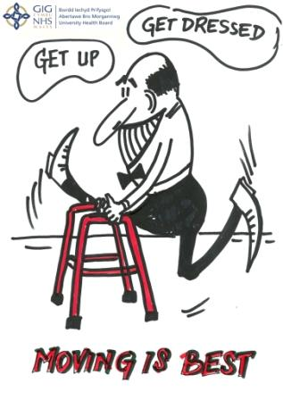
To support the campaign, a series of posters have been designed by artist Beata Sejboth-Zaleska, the sister of Morriston physiotherapist Lukasz Sejboth. They will be going up around the hospital to remind people about why they need to keep active.

Quick facts:
- At home an older person may walk 5,000+ steps a day, but in hospital that can easily drop to under 1,000
- Elderly patients in a bed begin to weaken one day after admission
- After just 24 hours bedrest, 2-5% of muscle power is lost
- 10 days bed rest can lead to up to 10 year’s loss of muscle mass
- Bed rest contributes to the risk of:
  - Thrombosis (blood clots)
  - Delirium
  - Infection (pneumonia)
  - Depression and loss of confidence
  - Constipation
  - Incontinence
- Often patients can get around at home, but after a hospital stay are too weak to walk. That’s not surprising, as their physical activity can drop 90% when they’re in hospital
- Impaired mobility is the reason for 4/10 care home admissions
- But the vast majority of patients really want to return to their own homes – and we want to help them do that

https://www.youtube.com/watch?v=mf7O8xcfNms

Source: Abertawe Bro Morgannwg University Health Board

